Spokane Register of Historic Places
Nomination

Spokane City/County Historic Preservation Office, City Hall, Third Floor
808 Spokane Falls Boulevard, Spokane, Washington 99201-3337

1. Name of Property
Historic Name: Historic Name of PropertyHotel Collins
And/Or Common Name: Collins Hotel, Collins Apartments
2. Location
Street & Number: 202-212 South Wall Street (701-705-1/2 West Second Avenue)
City, State, Zip Code: Spokane, WA 99201
Parcel Number: 35192.2204
3. Classification
Category Ownership Status Present Use
☒building ☐public ☐both ☐occupied ☐agricultural ☐museum
☐site ☒private ☒work in progress ☒commercial ☐park
☐structure ☐educational ☒residential
☐object Public Acquisition Accessible ☐entertainment ☐religious
☐in process ☒yes, restricted ☐government ☐scientific
☐being considered ☐yes, unrestricted ☐industrial ☐transportation
☐no ☐military ☐other
4. Owner of Property
Name: SDS Realty, Inc., Attn: Steve Schmautz
Street & Number: 108 North Washington Street
City, State, Zip Code: Spokane, WA 99201
Telephone Number/E-mail: 509.939.6260/Steve@sdsrealty.com
5. Location of Legal Description
Courthouse, Registry of Deeds Spokane County Courthouse
Street Number: 1116 West Broadway
City, State, Zip Code: Spokane, WA 99260
County: Spokane
6. Representation in Existing Surveys
Title: DAHP 2018-02-01189 and 2022-09-06494
Date: 7/30/2018, 9/28/2022 ☐Federal ☒State ☐County ☐Local
Depository for Survey Records: Spokane Historic Preservation Office; WISAARD

7. Description
Architectural Classification Condition Check One
☐excellent ☐unaltered
☒good ☒altered
☐fair
☐deteriorated Check One
☐ruins ☒original site
☐unexposed ☐moved & date ______________

Narrative statement of description is found on one or more continuation sheets.

8. Spokane Register Categories and Statement of Significance
Applicable Spokane Register of Historic Places category: Mark “x” on one or more for the categories that qualify the property for the Spokane Register listing:

☒A Property is associated with events that have made a significant contribution to the broad patterns of Spokane history.
☐B Property is associated with the lives of persons significant in our past.
☒C Property embodies the distinctive characteristics of a type, period, or method of construction, or represents the work of a master, or possesses high artistic values, or represents a significant and distinguishable entity whose components lack individual distinction.
☐D Property has yielded, or is likely to yield, information important in prehistory history.
☐E Property represents the culture and heritage of the city of Spokane in ways not adequately addressed in the other criteria, as in its visual prominence, reference to intangible heritage, or any range of cultural practices.

Narrative statement of significance is found on one or more continuation sheets.

9. Major Bibliographical References
Bibliography is found on one or more continuation sheets.

10. Geographical Data
Acreage of Property: Less than 1 acre (0.18)
Verbal Boundary Description: The nominated area is located in the SE ¼ of the NE ¼ of the NW ¼ of Section 19 Township 25 North, Range 23 East in Spokane County, Washington, and legally described as Lot 5 of Block 34 of the plat of the Railroad Addition, City of Spokane, Washington recorded January 20, 1881, volume “D” of Plats, page 82, Records of Spokane County, State of Washington. It is otherwise identified as within and all of tax lot 35192.2204.
Verbal Boundary Justification: Nominated property includes entire parcel and urban legal description.
11. Form Prepared By
Name and Title: Katie Pratt, Co-founder, and Spencer Howard, Co-founder
Organization: Northwest Vernacular, Inc.
Street, City, State, Zip Code: P.O. Box 456 Bremerton, WA 98337
Telephone Number: 360.813.0772
E-mail Address: spencer@nwvhp.com
Date Final Nomination Heard : 8/21/2024
12. Additional Documentation
Additional documentation is found on one or more continuation sheets.

13. Signature of Owner(s)

________________________________________________________________________

________________________________________________________________________

14. For Official Use Only:

Date nomination application filed: ___________________________________________

Date of Landmarks Commission Hearing: _____________________________________

Landmarks Commission decision: ___________________________________________

Date of City Council/Board of County Commissioners’ hearing: ___________________

I hereby certify that this property has been listed in the Spokane Register of Historic Places based upon the action of either the City Council or the Board of County Commissioners as set forth above.

Megan Duvall Date
City/County Historic Preservation Officer
City/County Historic Preservation Office
Third Floor – City Hall
808 W. Spokane Falls Blvd.
Spokane, WA 99201

Attest: Approved as to form:

City Clerk Assistant City Attorney

SUMMARY STATEMENT
The Hotel Collins is a three-story, two-part block form building with an L-shaped plan. The plan insets from the west property line to provide a light well and rear doorways for first floor commercial spaces. The light well does not extend through to West Second Avenue, creating the L-shaped plan. A stone foundation supports the first story cast iron post and beam (north and east facades) and the unreinforced brick masonry structure. There is an added metal fire escape at the south end of the building. Storefronts extend along the east and north facades. The building features a flat roof with perimeter parapets. Window openings have vinyl replacement sash with brick arches and subsills. The interior layout consists of first floor commercial space. A full basement provides mechanical and storage space. Apartments occupy the second and third floors. Vertical circulation consists of a central stairway (from South Wall Street) and a northwest stairway (from West Second Avenue) for apartment access, both of which are directly accessible from street level. The northwest stairway also provides roof access.
The floor layout is identical on both the second and third floors. Each floor has a main double loaded hallway, placed west of center, extending the length of the floor. A short east-to-west hallway connects to the northwest stairway. Along the east side of the main hall, unit doorways are set back at the ends of short branch hallways. At the center of each floor, the open space from former shared men’s and women’s bathrooms remains west across the main hallway from the central stairwell.
Significant features include the exterior facades; stone, cast iron, and brick construction; original storefronts at the south end of the east facade; fenestration; flat roof with parapet; central and northwest stairways including wood newels, balusters, steps, stringers, and railings; central, connecting, and branch hallways; apartment unit layout; interior upper floor finishes that include Douglas fir flooring, tall wood base, wainscot cap, corner moldings, wood doorway and window casings, and plaster wall and ceiling finish. The building remains in good condition and retains a high level of architectural integrity. Original design, materials and workmanship remain evident throughout the building interior and exterior, reflective of the period of construction and conveying the original single room occupancy (SRO) function. The building remains in its original location. The front east and north facades, direct walk-up stairways, and second and third floor layouts convey the key aspects of original design, association, and feeling, communicating how and why the building was used.
DESCRIPTION OF PROPERTY
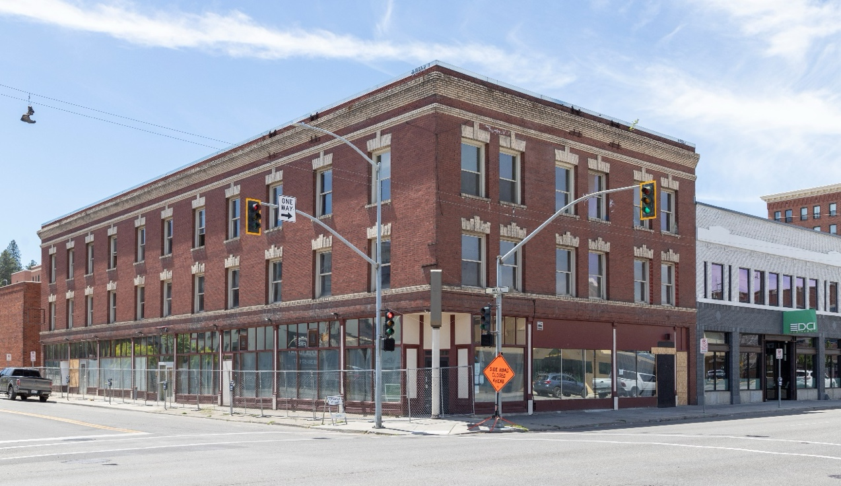
The building faces north and east. The site is a single corner tax lot enabling two front street-facing facades. Most of the rear west facade is inset (4 feet 10 inches) from the property line. This provides a light well and forms the building’s narrow L-shaped plan. West Second Avenue extends along the front north side of the property, with South Wall Street along the front east side. A paved alley runs along the rear south side between South Wall Street and South Post Street. The Doran Building (built 1920, City of Spokane Register listed) at 707 West Second Avenue abuts the property’s west side. Sidewalks extend along the north and east sides of the building. Small areaways, near the middle of the north and the east facades, extend below the sidewalk. Replacement steel framing supports the sidewalk at these locations.
Figure 1. Northeast corner.
The site’s setting is within a narrow commercial strip located south of Spokane’s central business district. The strip is bounded on the north and west by the railroad lines. North of the nominated property, the railroad lines lie between West Second and West First avenues. Interstate 90 defines the south edge. South of the nominated property, the interstate is generally between West Third and West Fourth avenues. This setting includes other similar residential and mixed-use buildings. There is a residential only apartment building (ca. 1908) across the street at 225 South Wall Street. There are several mixed-use (first floor commercial and upper story residential) buildings within a block of the nominated property. These include the apartments at 224 South Howard Street (ca. 1908), Metropole Apartments at 1781/2 South Howard Street (ca. 1901, Spokane Register listed), 608 West Second Avenue (ca. 1906), 174 South Howard Street (ca. 1923), the Boothe-McClintock Building at 165 South Post Street (ca. 1899, Spokane Register listed), and the Bump Block-Bellevue House-Hawthorne Hotel at 206 South Post Street (ca. 1890, Spokane and National Register listed).
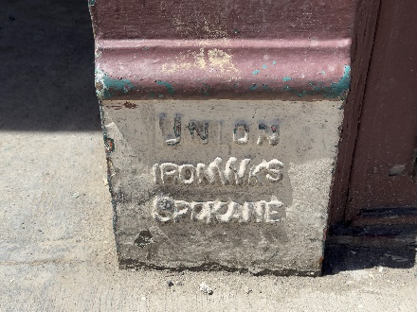
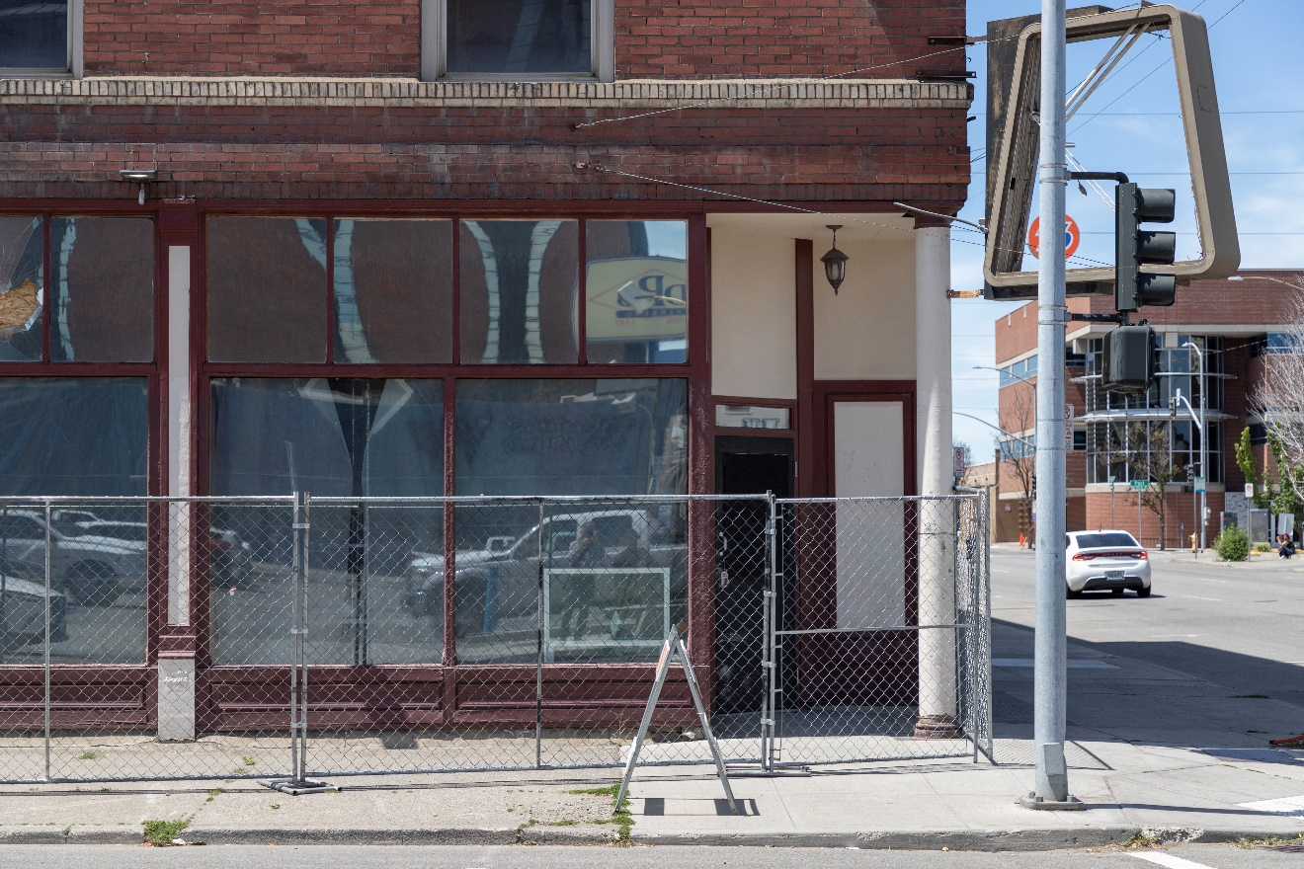
A perimeter rubble basalt stone foundation supports the three-story cast iron and load-bearing brick masonry structure. Spread footings support the interior wood post and beam structure. Cast iron post and I-beam framing (manufactured by Union Iron Works, Spokane) comprises the first story structure along the building’s east and north facades. There is a single cast iron column at the northeast corner. Load bearing brick masonry comprises the south, west, and upper stories of the east and north facades. Brick wall thickness decreases from 20 inches at the first story, stepping in approximately a brick’s width (4 inches) at each story. South and west walls are common bond (tan-yellow color bricks), with the bond bricks every seventh course. East and north facades have an outer wythe of veneer brick (dark red and white) over the inner common bonded brick (red-salmon and tan-yellow colors, bond course spacing varies). Decorative brick corbeling projects at the first to second story transition (belt course) and at the parapet on the east and north facades, with returns on the south alley facade at the southeast outer building corner. The parapet consists of a frieze and projecting cornice. The belt course consists of row lock upper cornice, central raised panel, and lower row lock band. Projecting bricks at both the belt course and parapet are white. Alterations include the added metal frame at southeast corner and northeast corners for former signage; added data cables and surface-mounted conduit; the added metal fire escape with second and third story landings, a connecting metal stairway, a cantilevered lower stairway, and a metal ladder to the rooftop. The fire escape is through-bolted to the masonry wall.
Figure 2. Cast iron pedestal detail showing factory stamp.
The cast iron posts have tall pedestals (matching bulkhead height) with a tall recessed upper panel, and a narrow capital and architrave at the top of each post. The unfluted column (Tuscan order or similar) has a plain base and capital. This column supports the outer ends of the steel beams. The design of the posts and column spacing prioritizes the equal spacing of eight (east facade) and three (north) bays (16 to 17 feet). Due to the cast iron I-beam that they carry, for load-bearing purposes the alignment between the posts and the upper story brick masonry sections is not needed. Wood posts and beams support the interior wood joist floor framing. The cast iron posts and the column remain intact.
Figure 3. East facade, cast iron post (left edge of photo) and cast iron column (right edge of photo) view.
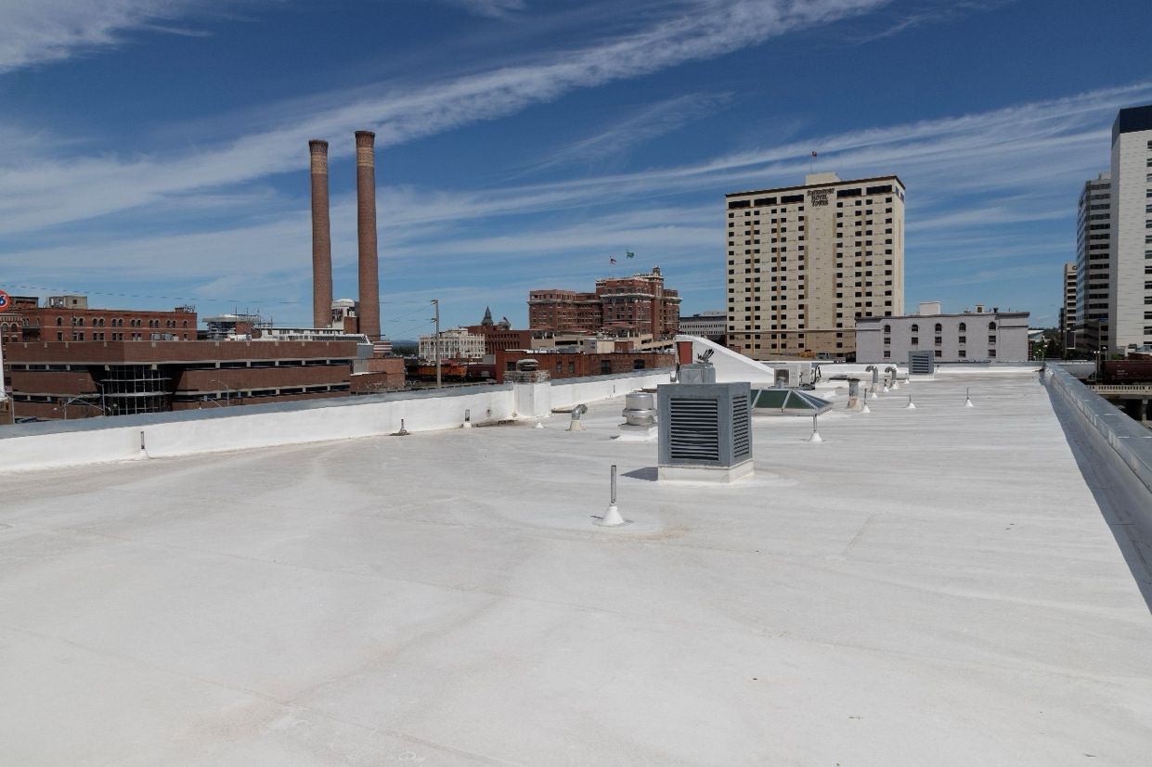
A flat roof with perimeter parapets shelters interior spaces. There is a 3-to-4-foot tall, insulated crawl space between the third-floor ceiling and the roof. Composite sheet type roofing covers the roof and extends up the inner parapet face. Sheet metal coping extends along the top of the parapets. Multiple mechanical and plumbing vents extend up through the roof. A hipped roof replacement skylight covers the third-floor light well at the central stairway. A plywood cover with a domed replacement skylight covers the former north lightwell that extended down to the second floor. Added mechanical systems extend up through this light well. A wood frame northwest stairway enclosure above the parapet is clad with the same roofing material. A flush panel replacement metal door on the south side provides interior access. Alterations include new roofing; multiple added rooftop mechanical units and vents; a new skylight; and enclosure of the former north light well.
Figure 4. Roof, looking northwest.
Fenestration consists of regularly spaced windows on each facade and storefronts along the east and north facades. All sills consist of a cement cap applied to the rowlock brick. Interior finishes at the second and third story apartment and hallway windows consist of wood casings, stool with horns (extensions beyond casings), apron, and a header with a lower fillet and projecting cap molding.
The front north and east facades each feature windows at the second and third stories. Second story openings each have a flat jack arch header comprised of white bricks with a prominent central key and alternating brick heights along the top of the header. There is an interior row lock segmental relieving arch behind each jack arch. The upper projecting rowlock brick band on the belt course serves as a continuous sub sill. Third story openings each have the same header as the second story but with a continuous height along the top of the header. Row lock, white brick lug sub-sills project at each opening with white brick corbels below the sub-sill at the outer edges of the masonry opening to provide a visual extension to the brick moldings. Replacement vinyl 1:1 sashes are recessed within each masonry opening. Vinyl, square profile brick moldings extend along the jambs and soffit at each opening. Alterations include replacing windows and brick moldings with vinyl.
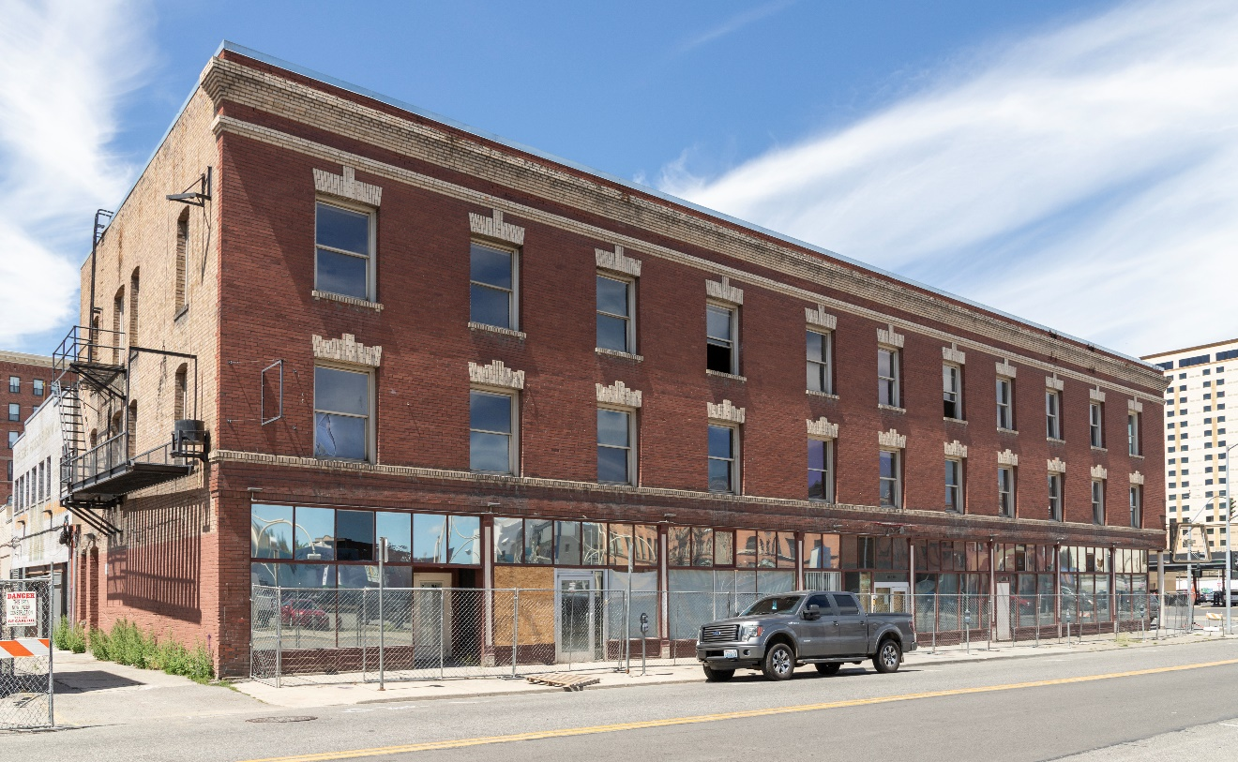
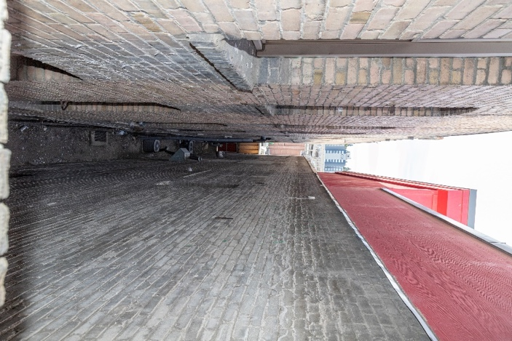
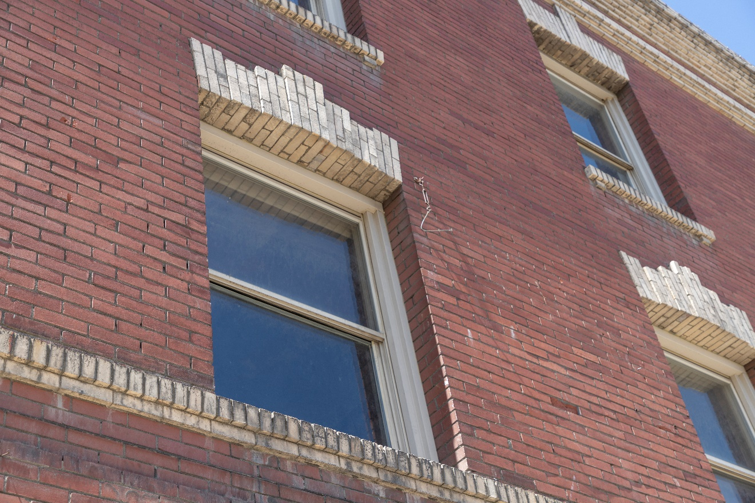
The south facade consists of a single first story window opening flanking the south entrance, with multiple second and third story windows (along the alley and within the areaway). Openings have segmental arched, row lock brick headers. Row lock slip sub-sills project at each opening. Plywood infills the first story opening, which is also missing part of the brick sub-sill and wall below the opening. Within the upper story windows, replacement vinyl 1:1 sashes are recessed within each masonry opening. Vinyl, square profile brick moldings extend along the jambs and soffit at each opening. Alterations include replacing windows and brick moldings with vinyl and infilling the first story opening.
Figure 5. Southeast corner.
Figure 6. Second and third story windows detail.
Figure 7. Light well, looking south from the third floor.
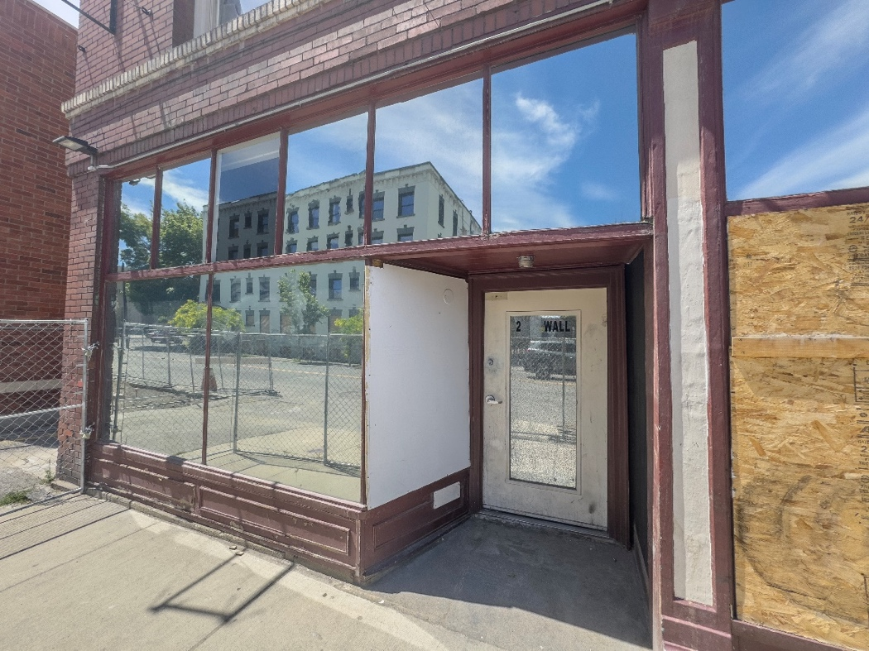
The west facade consists of multiple basement, first, second, and third story windows within the light well. Basement sashes are four-light, wood awning sashes with a thumb latch closure. First through third story openings have segmental arched, row lock brick headers with interior arched wood blocking infilling above window headers. Row lock slip sub-sills project at each opening. Plywood infills the first story openings. Within the upper story windows, replacement vinyl 1:1 sashes are recessed within each masonry opening. Vinyl, square profile brick moldings extend along the jambs and soffit at each opening. Alterations include replacing windows and brick moldings with vinyl, installing mechanical systems through and infilling basement openings, infilling the first story openings, installing interior privacy glass panels at the former shared bathroom window locations on the second and third floors, and removing interior casings and stools at first story openings.
Commercial storefronts within each bay on the north and east facades consist of low bulkheads, display windows, entrances, and transoms. Wood bulkheads at the south three bays (212, 210, and 208 storefronts) have flat fields bordered by narrow top and bottom moldings. Horizontal panels within each bulkhead are defined by narrow raised moldings. Outer bulkhead corners have corner moldings. A thick, rectangular cross section sill extends along the top of the bulkheads below the display windows. Wood bulkheads at the 206 storefront have wood stiles and rails around panel with beveled edges leaving the center raised. Wide sills extend above these panels. Wood bulkheads at the north four bays on the east facade and the easternmost north facade bay have been rebuilt with wide raised moldings to create the panels and wide trim boards around each panel. The two west north facade bays have replacement stucco clad bulkheads.
Figure 8. 212 South Wall Street storefront, showing original design.
The interior bulkhead faces mostly consist of flush plaster. The 206 entrance has raised wood panels matching those on the exterior. Display windows consist of plate glass and replacement insulated glazing units with wood stops and thin wood mullions having a raised center bead. A narrow wood transom bar extends across each bay, with six transom lights (four at the northeast corner storefront) separated by slender wood muntins. Recessed entrance enclosures occur at 212 and 210 South Wall Street and 701 and 705 West Second Avenue. Alterations include added light fixtures mounted above each cast iron post on the east facade and associated surface-mounted conduit; the infilling of transoms and rebuilding of bulkheads and display windows at the 703 and 705 storefronts; the rebuilding of bulkheads at the four north bays on the east facade and the 701 storefront; installation of temporary protection at some display windows; replacing plate glass with insulated glazing units at some units; and replacement mullions at 208.
Primary entrances consist of the apartment and storefront entrances and are listed below, starting with the north facade:
- 701 West Second Avenue: The recessed northeast corner entrance; a replacement single unglazed metal door with a narrow transom. A concrete walkway leads to the doorway. The canted entrance sides consist of low replacement bulkheads with replacement stucco clad upper panels. Stucco covers the soffit and upper wall portions above the transom bars. A pendant light fixture provides illumination for the entrance.
- 703 West Second Avenue (former): Alterations infilled this former doorway with display windows and a low bulkhead.
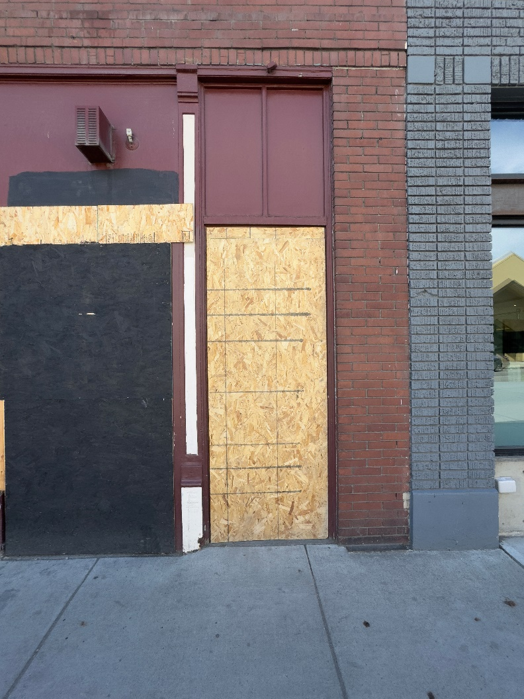
- 705 West Second Avenue: A recessed, canted entrance with a single replacement door. Temporary protection covers the entrance.
- 705 1/2 West Second Avenue: A replacement single glazed metal door with a square upper light. The original paneled transom bar remains above the doorway, along with the original two-light wood transom. Narrow wood brick moldings wrap the exterior opening. Alterations installed temporary protection over the doorway and painted out the transom.
Figure 9. 705-1/2 West Second Avenue entrance.
- 202 South Wall Street: A replacement single unglazed metal door with a narrow transom.
- 204 South Wall Street: A replacement single glazed anodized aluminum door and two-light side light. A replacement fixed transom spans the doorway and side light.
- 206 South Wall Street (former): Alterations infilled this former doorway with display windows and a low bulkhead.
- 208 South Wall Street (former): Alterations infilled this former doorway with display windows and a low bulkhead.
- 210 South Wall Street: A replacement single glazed anodized aluminum door and single light side light. The recessed wood frame entrance enclosure remains on the interior, behind the added door and side light.
- 212 South Wall Street: A recessed, canted entrance with a single glazed metal replacement door and a V-groove board soffit. Added T1-11 above an original baseboard is the exterior finish on the north side of the entrance. A concrete walkway leads to the doorway.
Secondary entrances consist of doorways from the alley and light well providing service access to commercial spaces.
- The alley entrance consists of a replacement unglazed metal door set in a replacement wood frame. Original wood brick moldings wrap around the doorway. The transom has been infilled. A concrete step transitions down to the alley. The masonry opening has a row lock brick segmental arch header. There is an added metal security door on the interior and an added exterior light above the doorway.
- Service access entrances to commercial spaces consist of paneled wood doors with transoms. Some doors are glazed and others unglazed. Each masonry opening has a row lock brick segmental arch header. Transoms have all been infilled with mechanical ducting or solid fill. Glazing at doors has been replaced with wood sheeting. Most casings have been removed. An added wood frame enclosure at the south end of the light well consists of a single door with T1-11 clad infill above to limit unauthorized access to the light well space.

Vertical Circulation
Circulation between floors within the building consist of two primary stairways, the central and northwest stairways.
- The central stairway provides access from the basement to the third floor. A direct walk-up flight, with intermediate landings, ascends from South Wall Street to the second floor. A quarter-turn stairway continues from the second to third floor. A quarter-turn stairway descends from the first floor to the basement. These flights of stairs are stacked above one another. The basement and first floor stairwells are enclosed with plaster finished walls. The second to third floor is open with paneled newels and an open
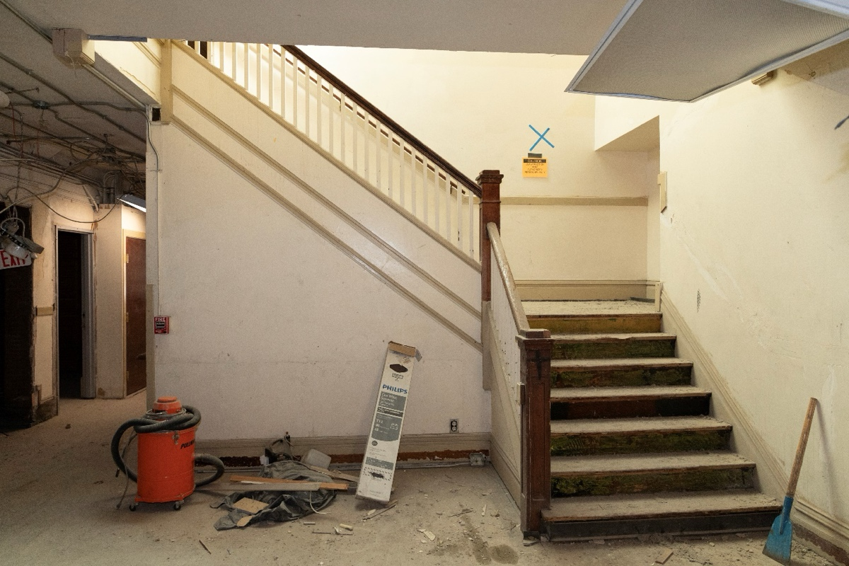
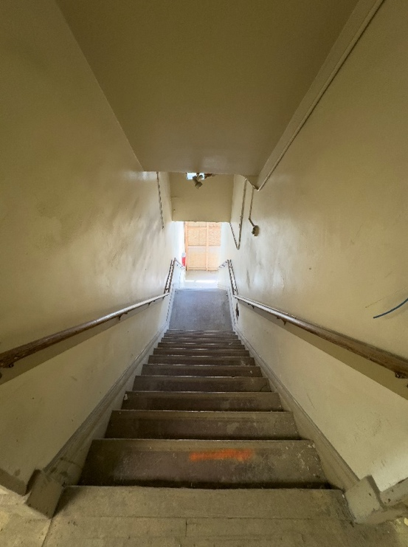
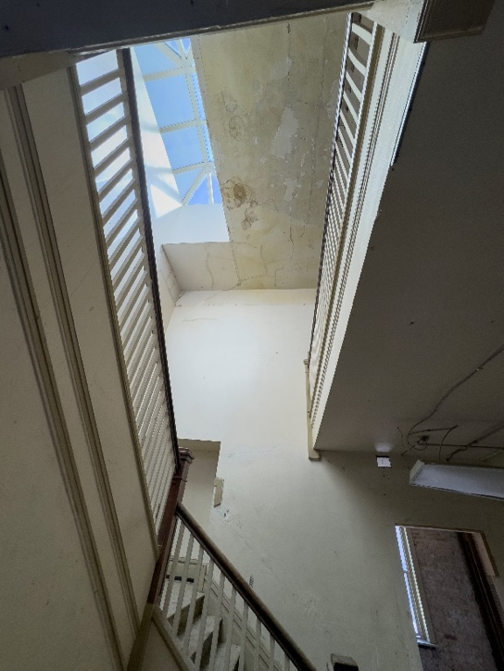
Figure 10. Central stairway, second floor, looking north showing original materials.
Figure 11. Central stairway looking up from the second floor at the sky light.
Figure 12. Central stairway, looking down from the second to the first floor.
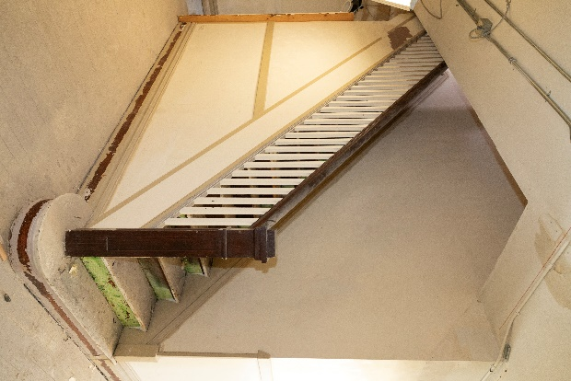
baluster railing. Stringers match the baseboard design and treads and risers are wood. Round wood hand railings extend along both sides of the stairwells. Alterations cut off the end of the circle end starting step at the first floor; added a surface-mounted conduit within the stairwell; and added composite coverings over the risers and treads
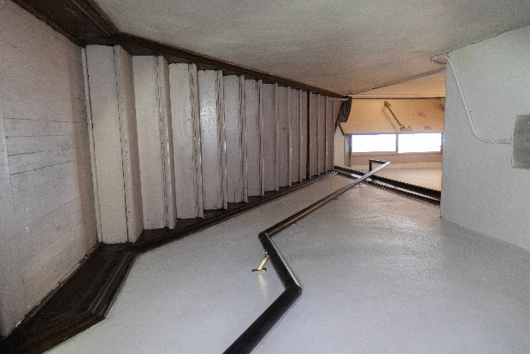
- The northwest stairway provides access from the first floor to the roof. A quarter-turn stairway with intermediate landings and winders at the upper direction change provides access from West Second Avenue to the second floor. A direct flight ascends from the second to third floor. A quarter-turn flight with winders at the upper direction change provides access from the third floor to the roof. The lower flights from West Second Avenue to the second floor are placed along the building’s outer west edge. The upper flights are offset west of and perpendicular to these, along the north side of the east to west hallway on each of the upper floors. These upper flights are stacked vertically. The first-floor stairwell is enclosed with plaster finished walls. The second floor, third floor, and roof access stairwells are open. Each has paneled newels, an open baluster railing, a circle end starting step, and a closed stringer.
Figure 13. Northwest stairway looking up from the second floor (right).
Secondary connections between the first floor and basement include the following:
Figure 14. Northwest stairway, looking up from the 705-1/2 West Second Avenue entrance
- Freight lift and short flight of stairs at the south end of the former 705 West Second Avenue space. Wood framing supports the freight lift, which has an elevator pit and cable pulley system for operation. The lift descends to a wood frame flooring area originally used for storage. A door in the first floor originally opened to a steep set of open riser stairs that descended to this portion of the basement. Alterations have closed off the door and installed mechanical ducting through the space.
- Direct flight of replacement wood stairs descending from the 212 South Wall Street commercial space to a basement storage area. Replacement wood stud and gypsum board finishes enclose the stairwell at the first-floor level.
- Two direct flights of replacement wood stairs descending from the 202 South Wall Street commercial space to the basement. These are both open riser wood stairs. Alterations have closed off the openings at the first-floor level.

Basement
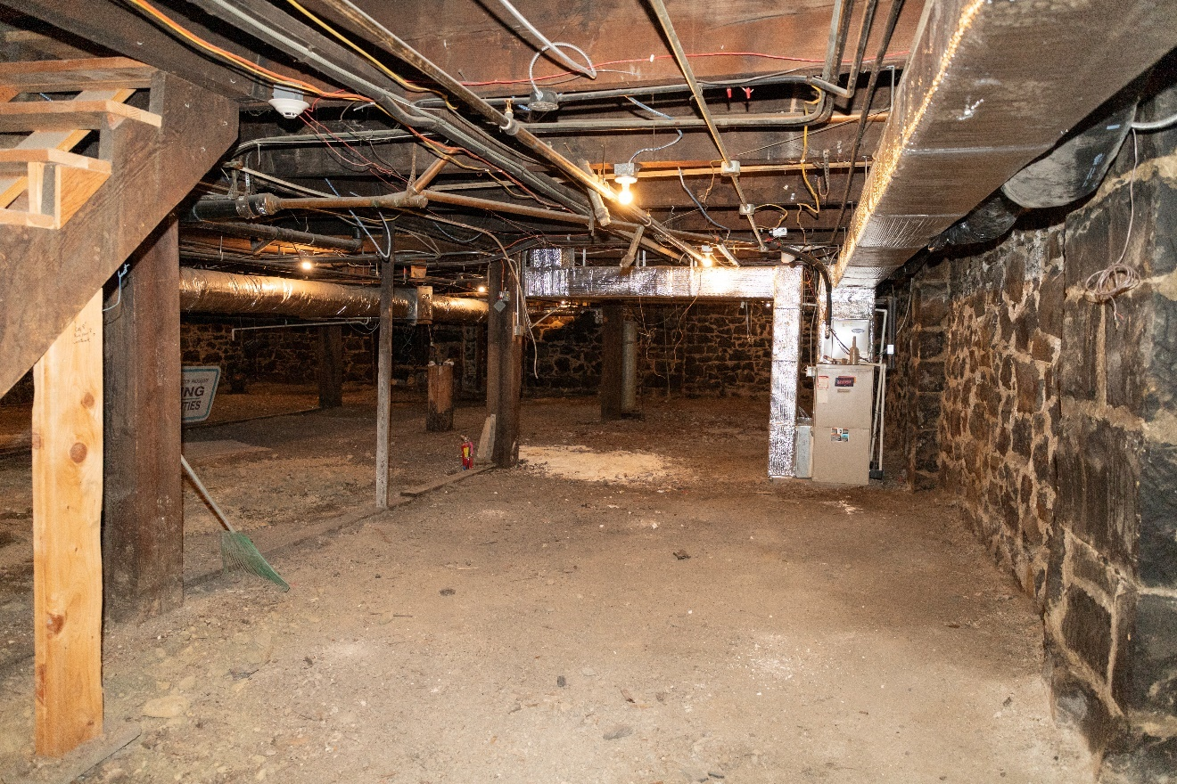
Interior layout consists of a central L-shaped space enclosed with rubble stone walls with general storage volumes extending to the north and south. The central stairway descends into the L-shaped space. The building’s mechanical systems are located within the north portion and electrical systems in the south portion. The mechanical space has a concrete floor, with exposed soil in the remainder of the basement. Sections of wood flooring are built out over the soil below the 212 South Wall Street and part of the 705 West Second commercial spaces. The foundation and floor structure are exposed throughout the basement. An added wood frame partition wall with horizontal board finishes separates the 212 South Wall Street storage area from the rest of the basement. Ducting and plumbing systems run throughout the basement below the first-floor framing.
Figure 15. Basement, northeast corner, looking north.

First Floor
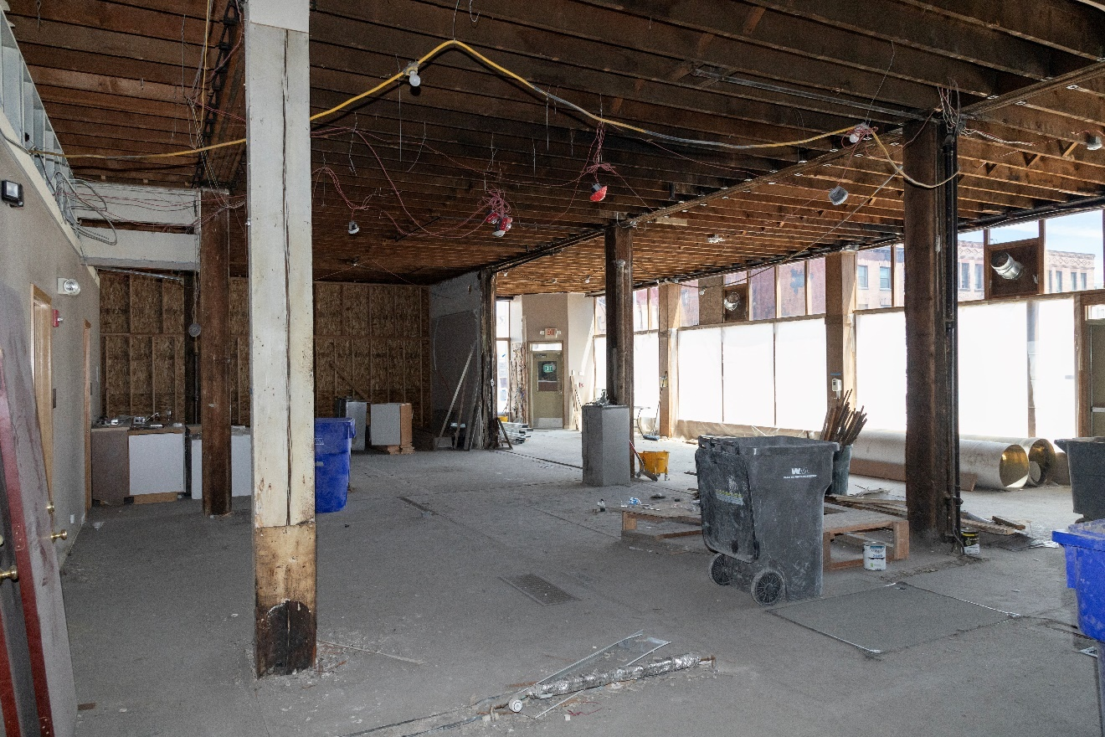
Interior layout consists of a central rectangular entrance lobby with commercial space volumes extending to the north and south. The central volume is one bay wide and two bays deep, defined by the central stairway and the structural column layout. Wood frame, plaster-finished walls enclose the central stairway’s upper flight. Replacement gypsum board wood stud walls enclose the lower flight descending to the basement. A wood frame plaster finished wall extends along the half the length of the space’s south side. The north commercial volume is four bays wide and three bays deep. Added partial height offices (four) extend along the south end of the west wall. An added oriented strand board wood stud wall extends along the westernmost two storefronts at the north end of the space. The south commercial volume is three bays deep and wide, with a single bay extending along the west side of the central volume. Added restrooms occupy the southwest corner, enclosed with gypsum board finished wood stud walls. Matching walls enclose a small added staff and kitchenette space off the east side of the restrooms. A ramp descends from these spaces to the north. Alterations installed multiple flooring overlays; added a surface-mounted conduit; removed the plaster ceiling; added the restrooms and offices; and added mechanical ducting.
Figure 16. First floor, looking northeast.

Second Floor
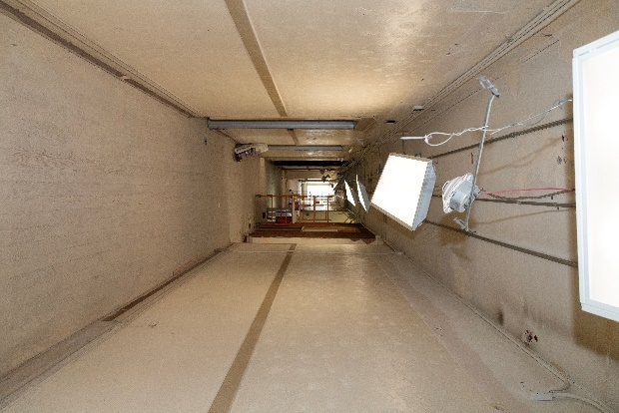
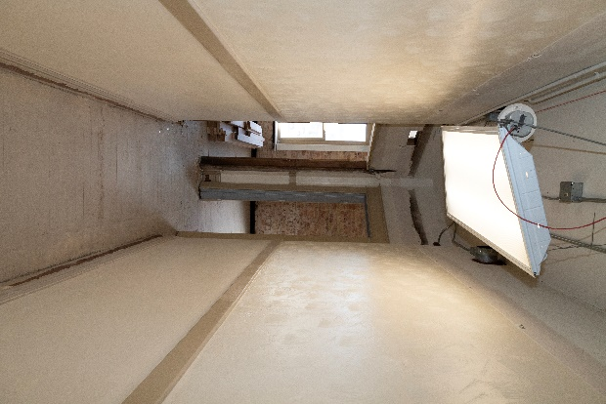
Interior layout consists of a double-loaded main hallway (6 feet -2 inches wide), placed west of center, that extends the length of the floor (140 feet). A short (15 feet- 4 inches) east-to-west hallway connects to the northwest stairway. Along the east side of the hallway, unit doorways are set back from the hallway. Short (11 feet) and narrow (3 feet 6 inches) branch hallways between the units connect to the doorways from the main hallway. All but one of the hallways angle outward at the east end to create a small diamond-shaped foyer space at the two doorways. The hallway along the north side of the central stairway has a unit door at its west end and another at its east end, without a foyer space. Within the center of each floor, the open space from former shared men’s and women’s bathrooms remains west across the main hallway from the central stairwell. Hallway (main, connecting, and branch) finishes consist of Douglas fir flooring, painted plaster walls and ceiling, tall wood baseboards, and a wood wainscot cap. Doorways off the hallways have plinths, casings, and cornice moldings. Wood corner beads (to wainscot cap height) protect outer wall corners. Alterations include an added electrical panel enclosure (1 foot by 7 feet) on the north side of the hallway; a surface-mounted metal conduit along the walls and ceiling; added fluorescent lighting fixtures; holes in the wall from a former drop ceiling and mechanical equipment additions within the space; added metal frames at some doorways; painting of the originally stained wood trim and casings; and added textured plaster above the wainscot cap up to the former drop ceiling height.
Figure 17. Second floor typical branch hallway.
Figure 18. Second floor, main hallway.
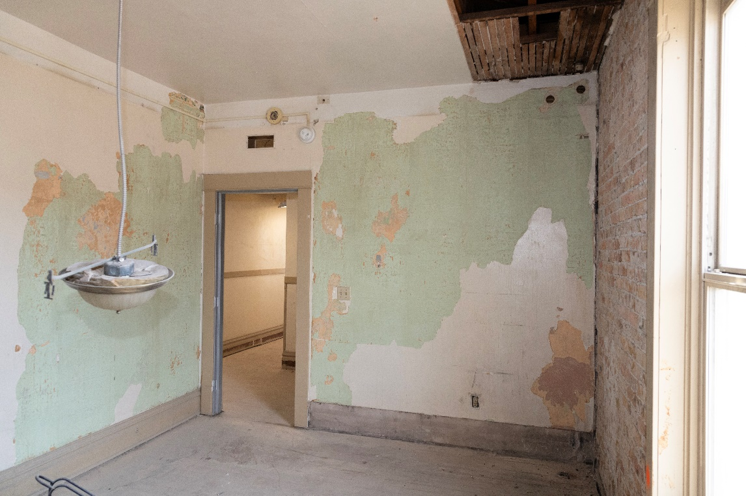
Apartment units are deeper (around 25 feet vs. 15 feet) and wider (around 12 feet vs. approximately 10 feet) on the east side of the floor. There are 22 units on the floor. The two east side units in the northeast corner are oriented towards the north facade rather than the west facade, due to the northwest stairway placement. East side units have a main front living space along the east windows, with a rear (west) bedroom and bathroom space along main hallway wall. West side units are a single studio volume without a bathroom. Unit finishes consist of Douglas fir flooring, painted plaster walls and ceiling, and tall wood baseboards. Doorways to the main and branch hallways have plinths, casings, filet strip and header trim (without the cornice used on the hallway side). Alterations include the removal of some plaster, exposing the wood stud partition and brick masonry exterior walls; removal of some baseboard sections; removal of some casings at doorways; added flush-mounted ceiling lighting fixtures; added surface-mounted conduit at the ceilings and walls; infill of some doorways between units; and added sinks and vanities in some units; .
Figure 19. Second floor, showing typical unit finishes.

Third Floor
Interior layout matches the second floor. Finishes and alterations also match the second floor.
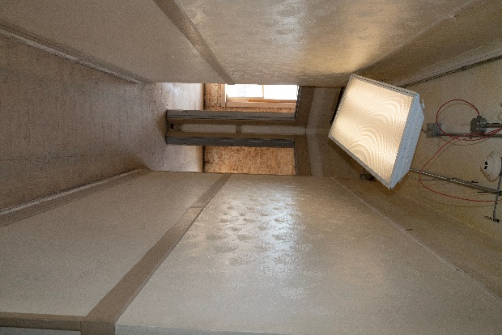
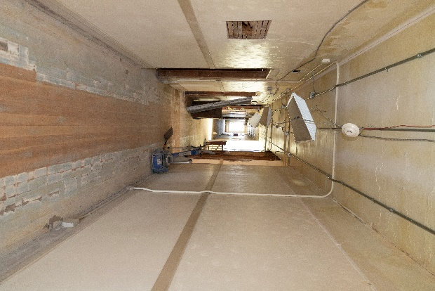
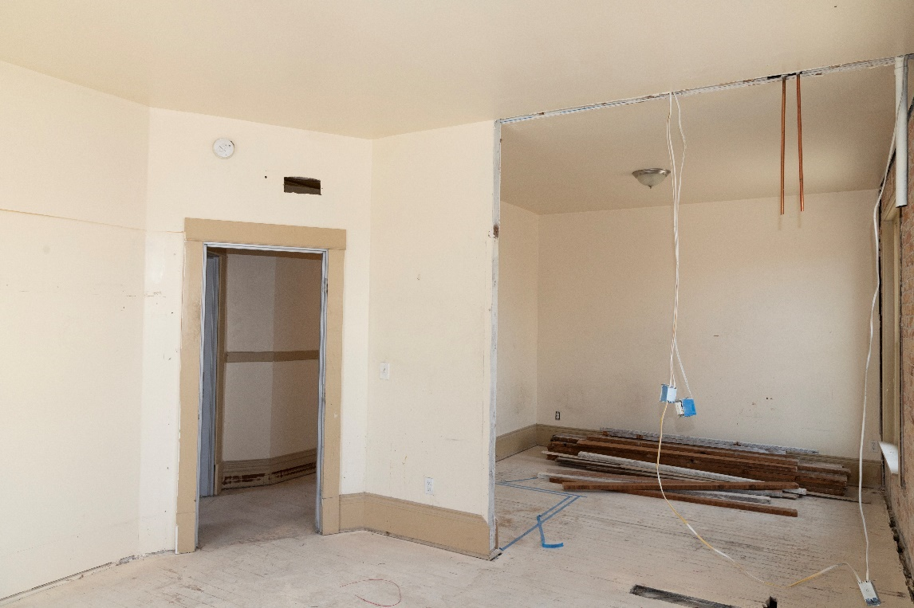
Figure 20. Third floor, main hallway.
Figure 21. Third floor, showing typical unit finishes.
Figure 22. Third floor, typical branch hallway.

ALTERATIONS
The following includes known changes to the building:
- Undated, previous alterations had combined apartment units on the east side of the main hallway to create the larger one-bedroom units, conversion of units to an office and a commons area; and conversion of one unit on the west side of the main hallway to a shared laundry room. The east side conversions involved closing off of doorways to branch hallways and opening new doorways between units. By 1998 each floor had only 19 apartments compared to the 31 units on each floor originally.
- Ca. 1956, Kirishian Carpets owner Morton Hatch hired a builder to undertake interior alterations valued at $2,500 at the 703–705 West Second Avenue commercial spaces (permit nos. 34574, B35098). The rebuilding of the storefronts at this location is attributed to this work, which was extant by 1971 based on a historic photograph.
- 1970, the Hide Out Tavern, operating out of the 701 West Second Avenue commercial space, installed (permit B75847) plywood, T1-11, wood shingles, and small fixed windows over the northeast corner entrance and over the storefronts (transoms, display windows and bulkheads) along West Second Avenue (easternmost bay) and South Wall Street (north four bays).
- 1971, based on a historic photograph, the storefront transoms along South Wall Street had been painted out.
- 1972, the Hide Out Tavern installed new bathrooms and a dishwasher (permit no. P-1117).
- 1972, owner John Burya had the transoms and hallway windows replaced with sheet rock per Fire Department requirements (permit no. B-2872).
- 1975, south fire escape installed. This fire escape was relocated from the American Legion Building, but the lower counterbalance stairway was not installed until 1984.
- 1982, owner John Ha installed three 40-gallon Rheem gas water heaters.
- 1983, the building was reroofed by G. & L. Roofing, Inc.
- 1984, owner John Ha installed a Cleaver Brooks model three steel boiler and 100 feet of 2-inch piping.
- 1993, the Spokane Kiwanis Charities, Inc. owned the building, which had 39 low-income apartment units with ground floor commercial spaces. The upper floor apartments were rehabilitated including new electrical, plumbing, floor covering, and painting work. The uncovering and reopening of storefronts and removal of paint at the other transoms is attributed to this work, based on observation of materials and the change in first floor functions. The installation of a drop ceiling in the second and third floor hallways, along with associated mechanical equipment and the painting of stained trim, is attributed to this work. A 1982 photograph showing a former resident in one of the hallways shows the former radiators, stained trim, and plaster ceiling as being extant at that time.
- 1998–2001, remodel of the first-floor commercial space to support program offices for SNAP (homeless assistance program). Construction of the four offices on the first floor and reconfiguring of the first floor layout. This work also included relocation and rebuilding of the first floor to basement stairway in the 212 South Wall Street commercial space; closing off of windows and doors along the light well at the first floor; and installing the metal framing at the areaways.
- 2004, remodeled the northeast, 701 West Second Avenue entrance.
- 2004 remodel of the front entrance for 212 South Wall Street.
- 2015 reconfiguration of the reception, waiting, and office workstations for SNAP at the 212 South Wall Street commercial space. This work removed existing walls and relocated lighting. The first-floor southwest bathrooms and associated staff space, and enclosure of the stairway to the basement at this location, are attributed to this work based on materials and location.
- 2014 remodel of the first-floor office spaces for ongoing use by SNAP.
- 2023, cleanup of the entire building, removing previously added first floor partitions from prior office functions, and removal of the former laundry and restrooms on the second and third floors.

SUMMARY STATEMENT
The Hotel Collins in Spokane, Washington, is a well-executed example of a Single Room Occupancy (SRO) hotel and was constructed during a period when numerous SROs were built to house a growing working-class population in the city. Completed in 1910, the Hotel Collins is significant under Category A in the area of significance of Commerce for its association with the broad patterns of commercial development in downtown Spokane. It is also significant under Category C in the area of significance of Architecture as a representation of the SRO property type. The Hotel Collins was built to provide lodging for workers and retains the characteristics needed to convey its historic use as an SRO. According to the Multiple Property Document, “Single Room Occupancy Hotels in the Central Business District of Spokane, WA, 1900-1910, SROs are,
[U]nreinforced masonry structures of two or more stories, with commercial bays on the ground or street level, and the upper floors consisting primarily of single rooms without baths, with a limited number of rooms with baths.
The hotel’s period of significance begins and ends in 1910 when the building was constructed.
HISTORIC CONTEXT
The Hotel Collins is located in the Central Business District of Spokane, WA. This neighborhood was established by the 1880s, but grew significantly with new, masonry development after the Great Fire of 1889 between 1890 and 1910.

Central Business District and the 1900s Building Boom
The area that is now known as the City of Spokane has been home to the Spokane Tribe of Indians, an Interior Salish speaking tribe, for thousands of years. The area’s rivers, notably the Spokane River, were key to their way of life as they provided both food and transportation. They lived in the upper Columbia Plateau, along the shores of the Spokane and Columbia rivers and their tributaries within a territory spanning approximately 3 million acres. They hunted, fished, gathered, and traded within their lands, living a semi-nomadic lifestyle following a seasonal cycle for subsistence. They wintered along the rivers and then set up temporary residences during the other seasons as they traveled. The arrival of White Euro-Americans in the region profoundly impacted their lifeways, particularly once the American Corps of Discovery traveled through the region in 1806. White fur traders, seeking to expand the Canadian fur trade in the West, then arrived in 1810 and established a fur trading post, Spokane House, at the confluence of the Spokane and Little Spokane rivers. The Spokanes, along with other tribes, participated in trade at this post. Spokane House closed in 1825 and operations were shifted northwest near Kettle Falls in 1826.
As more White traders, followed by missionaries and settler-colonists, arrived in the region, the U.S. Government sought to acquire more land for Americans. The Donation Land Claim Acts encouraged White settlers to move West and Territorial Governor Isaac Stevens began to negotiate with area tribes to extinguish Native title to the area’s land. The Spokane Tribe was referenced but not included in the Nez Perce Treaty of 1855. After a series of armed conflicts between the U.S. Army and the Spokanes (with their allies), U.S. Army Colonel George Wright entered into a treaty with the Spokanes in exchange for cessation of all hostilities. But the treaty did not include any cessation of land and the Spokane Tribe continued to live on their ancestral land. But then in 1881, U.S. President Rutherford B. Hayes established a reservation for the Spokane Tribe through Executive Order in a location northwest of the present-day city of Spokane.
Amidst these political maneuvers, White Euro-Americans moved into the region in the 1870s, establishing a sawmill and later a gristmill at the Spokane Falls with a general store opened in the late 1870s. These early beginnings of a town attracted other White settler-colonists and soon the town became a key supply and distribution point for area mining, lumber, and agricultural operations. Other stores, saloons, hotels, banks, schools and churches followed and contributed to a bustling commercial district. Spokane was then incorporated (as Spokane Falls) in 1881 with a population of 1,000. A railroad connection via the Northern Pacific arrived in 1883, cementing Spokane’s status as the financial center of the Inland Empire as goods poured into the city from area mines, timber stands, and farms.
The downtown district of Spokane was originally constructed of wood-frame buildings—commercial buildings, warehouses, and lodging. An 1889 fire gutted almost the entirety of the city’s downtown core (32 blocks). Rebuilding efforts prioritized masonry materials and a significant building boom swept through downtown. Historian Linda Yeoman describes the efforts:
Plain no-frills brick masonry constructed single room occupancy hotels were quickly erected side-by-side along downtown streets to house the influx of immigrants and people who flocked to Spokane to find jobs. In contrast, other brick and stone buildings were designed and erected as prominent, high-style commercial/business blocks, upscale apartment buildings, and luxury hotels.
With this building boom, workers—including laborers, carpenters, and other tradespeople—flooded the city as construction projects meant employment opportunities. And those workers needed housing with numerous lodging and boarding houses and hotels (including SROs) constructed in the rebuild. According to historian Craig Holstine, “Nearly all of the city’s lodging facilities were lost in the Great Fire of 1889.”
The construction boom in the first decade of the 20th century, according to Holstine, “accelerated property appreciation in the CBD, resulting in the sale to speculators of marginally profitable residential properties, chiefly boarding and lodging houses.” This aligns with the increasing property value of the Hotel Collins property, even prior to its construction, discussed in a subsequent section. The growth of various lodging properties in this time frame are outlined in the table below, compiled from the MPD.
Table 1. Lodging Options in the Spokane Central Business District, 1900-1910
Year | No. of Lodging Houses | No. of Boarding Houses | No. of Hotels
1900 | 46 | 15 | 21
1905 | 37 | 14 | 56
1910 | 68 | Approximately 19 | 126

Although not all hotels catered to working class populations, most of the hotels were SROs, according to the MPD.
Figure 23. 1952 Sanborn Fire Insurance Map.
Despite the sheer volume of SROs built and used during the early 20th century, as a property type, they have experienced significant change since World War II. Many, along with apartment buildings, were renovated during the war as increased housing was needed for the defense industry workforce supporting nearby Fort Wright, Fairchild Air Force Base, Velox Naval Supply Depot, Baxter Hospital, and the Mead and Trent Kaiser Aluminum Company plants. SROs, in particular, were modified to add bathrooms and connect single rooms to form multiple-room apartments. Additionally, significant changes to the downtown landscape occurred in the early 1970s in preparation for the 1974 world’s fair hosted in Spokane, “Exposition ’74.” Many SROs, which had fallen into disrepair, in the central business district were leveled or else had closed. The MPD cites a 1972 survey of 197 hotels, apartments, and other residences that had once operated in the central business district. Of the 197 hotels, 44 had closed and an additional 38 had been demolished. Another survey in 1973 reported that 71 hotels and apartments (some likely SROs) had been demolished. The Hotel Collins remains as one of the extant SROs within the central business district and retained its SRO use under various ownership and management groups well into the 21st century.
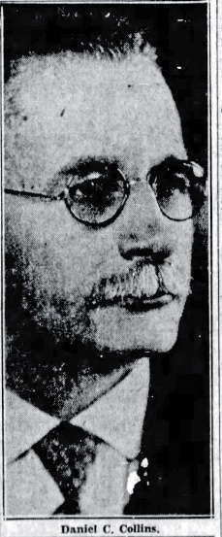
STATEMENT OF SIGNIFICANCE

Daniel (D. C.) Collins
Daniel C. Collins was born in Dunmanway, County Cork, Ireland, on August 7, 1868. He immigrated to the United States as a young man and arrived in Spokane in 1884. He soon became involved in real estate development, particularly after the fire of 1889 that burned much of downtown. During the 1889 fire, he served as a volunteer firefighter and continued as a professional firefighter for a number of years, rising to the rank of captain with the Spokane Fire Department. In 1891, he became a U.S. citizen. He married Anna (Annie) Burke, also an Irish immigrant, in 1892. Although the 1900 census records state that Anna did not immigrate to the United States until 1899, her obituary says she arrived in Spokane Falls at the age of 16 (ca. 1887). The couple had three children: Ellen, Marie, and Daniel, Jr.
In the early 1900s, Collins shifted careers away from firefighting to real estate investing and owning rental property. By the time of his death, he owned a number of properties in Spokane, including the Hotel Collins, the St. Helens Apartments, and apartments on Browne Street. In addition to his professional work, Collins was known for his athletic skill as an amateur boxer, even serving as a boxing instructor at Gonzaga University. He was a member of the Elks Lodge, Knights of Columbus, and St. Augustine’s Catholic Church.
Figure 24. Photograph of Daniel Collins. Spokane Chronicle, July 21, 1933, 3.

Hotel Collins
Built in 1910, the Hotel Collins operated as a Single Room Occupancy (SRO) hotel in downtown Spokane, under various management, well into the 2000s.
The site on which D. C. Collins had the Hotel Collins building constructed had previously been known as the Drumheller Site and had sold a number of times in the preceding decades. D.M. Drumheller had acquired the property and built a residence on it by 1885, but then sold it to Clara Price for $5,500 in 1888. The property was then sold again in 1889 for $16,500 before A. S. Jerard purchased it in June 1909 for $37,500. Collins purchased the property on Second and Wall for $50,000 from a Union Trust Company trustee. It had only just sold 10 days prior to Collins’ purchase—showing the tremendous value of downtown Spokane land—with A. S. Jerard selling it to a Union Trust Company client for $45,000. An article in The Spokesman-Review announcing the sale also commented on the value of property in the area, stating,
The sale to Mr. Collins is another evidence of the sensational progress made by Second [A]venue property during the year, that section of the city having been unusually active, being on the market almost weekly during 1909. Building construction has followed a number of sales and the indications are that before the year closes Second avenue will be thickly dotted with substantial buildings, representing an expenditure of from $25,000 to $100,000 in each case.
That newspaper coverage also indicated that Collins already had plans for the site when he purchased it, with plans to build a 4-story building at a cost of $60,000, with a design by architect C. Harvey Smith. Collins had previously owned and operated the Palace Hotel on Washington Street between Front Avenue and the Spokane River. That property was purchased from Collins for $80,000 through a settlement with the Milwaukee Railroad. Shortly after purchasing the property, Collins received approval on his permit to build a 3-story brick building.
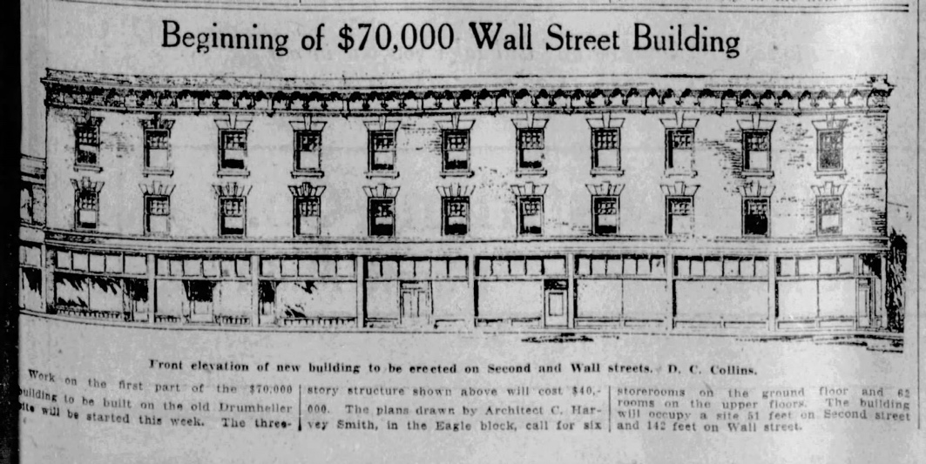
By April 1910, Collins’ plans for the Drumheller site had solidified and The Spokesman-Review printed C. Harvey Smith’s sketch of the planned 3-story building. The intent for the site had also changed to eventually house a 5-story (versus the initial four stories) building but start with a 3-story building and add the additional two stories later. The plans were outlined as follows,
Figure 25. Drawing of the Hotel Collins. Spokane Chronicle, October 12, 1910, 15.
The brick to be used in the structure will be pressed brick, and for the present a temporary cornice will be used. A terra cotta cornice will be used when the two additional stories are built.
Construction costs for the new building were estimated at $70,000. The building was planned to have six storefronts with two floors of hotel above containing 62 rooms. Advertised features for the forthcoming building were hot and cold water taps in each room and two separate stairways. Newspaper coverage also indicated that the former Drumheller residence on the site had been removed and excavation for the new structure was underway by April of 1910. The plans to add the upper two stories to the building (floors 4 and 5) were planned for 1911. Contractor George Groshoff managed construction on the building.
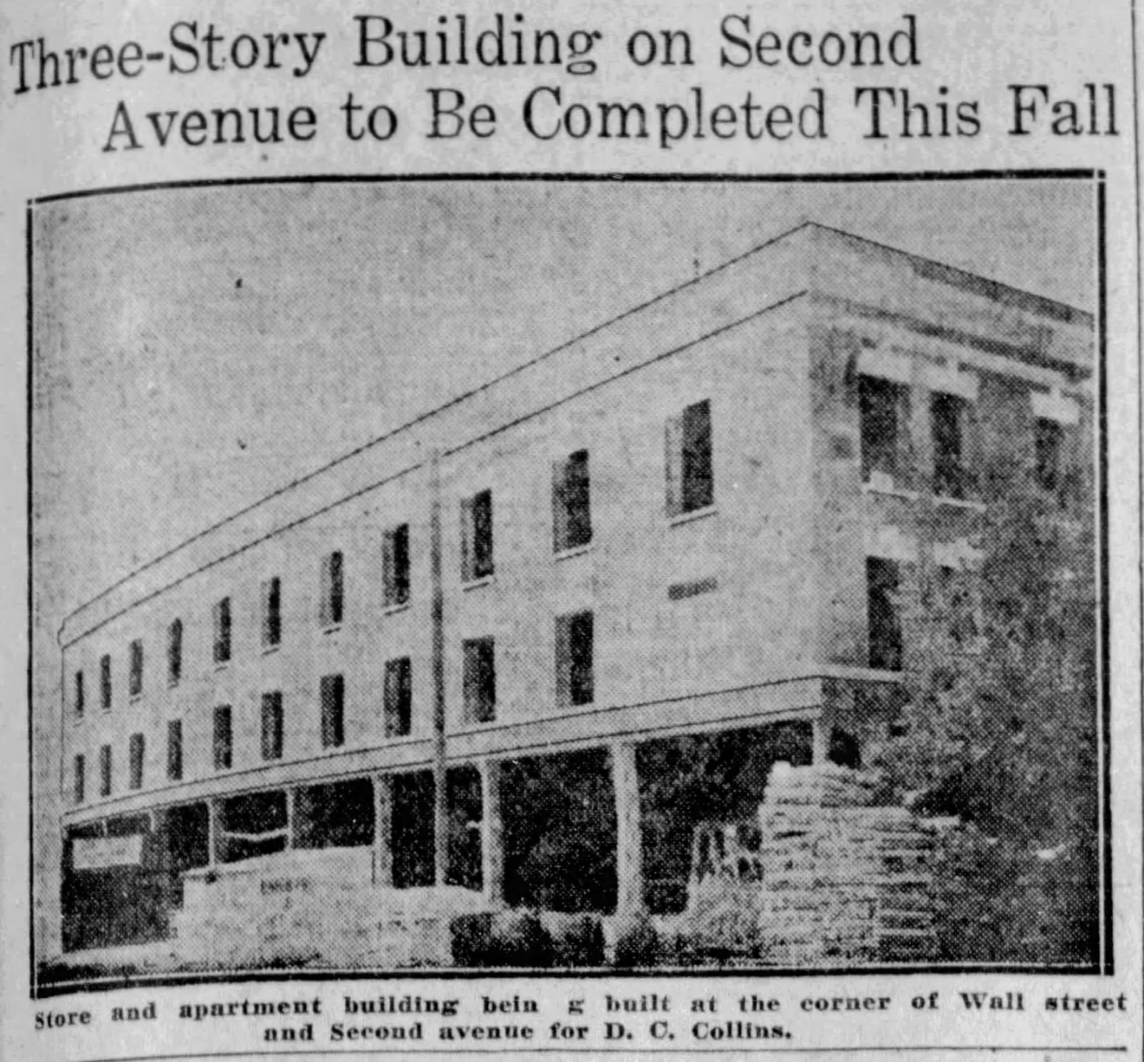
The building’s construction was well underway in August 1910, with a photograph of the building shell appearing in The Spokane Chronicle. Plans at that time were to still add the upper two floors some time the following year, citing “the demand for additional room in Spokane’s business district.”
Figure 26. Photograph of the Hotel Collins. Spokane Chronicle, August 23, 1910, 17.
Advertisements to rent out rooms, as well as the storefronts, in the new building began to appear in newspapers by October 1910. And it appears the building was completed in late December 1910. The planned additional two stories were never constructed. By 1915, advertisements in the local papers declared the “Hotel Collins” newly furnished and remodeled and under new management. Rates were listed as $2.50–$5.00 a week.
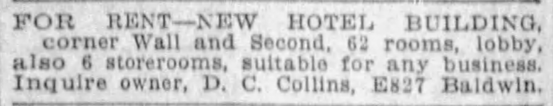
Figure 27. Newspaper advertisement for the Hotel Collins. The Spokane Review, October 12, 1910, 15.
Despite some interior changes, the building still exhibits much of its original hallway and room configuration on the upper floors. Where changes have occurred, the original configuration remains evident. The primary interior change has been the reduction in the number of individual rooms as units were modified over the years in alignment with trends in lower income housing. Although not a requirement under the MPD, the Hotel Collins building also retains much of its storefront character, including its distinctive original inset entrances at 212 and 210 South Wall Street and the cast iron column and inset placement of the corner storefront (previously rebuilt) at West Second Avenue and South Wall Street.
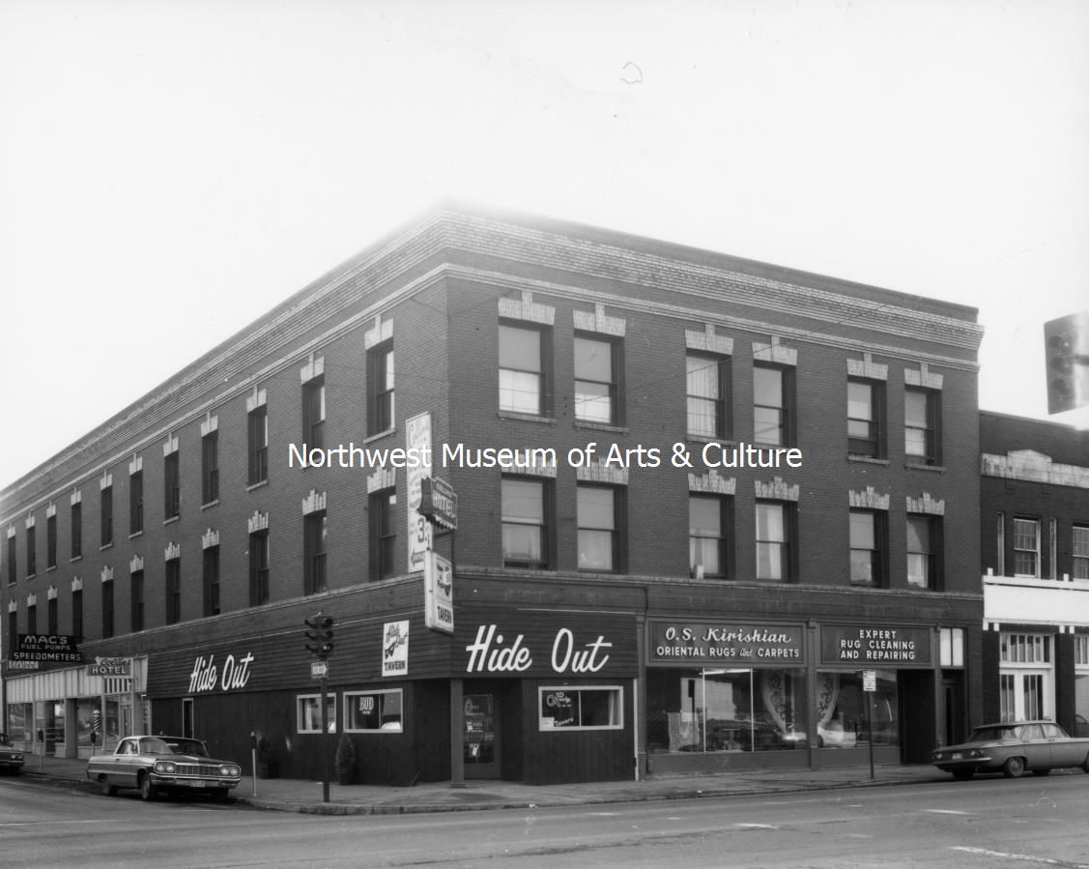
Figure 28. 1971 northeast corner view. Northwest Museum Arts + Culture, image L87-1.151-71, also published in The Spokesman Review, January 24, 1971, 24.

Ownership
Daniel C. (D.C.) Collins owned the Hotel Collins property from the time he purchased it in 1910 (with plans to build the 3-story building) until his death in 1933. After Collins died, ownership of the building passed to his wife, Anna Collins. After she died in 1936, her estate sold the property to E. A. Houston of Montana in 1938. Houston purchased the hotel, which was listed as having 58 rooms, and became its operator.
It is unclear when Houston sold the property or when the real estate firm Galland & Hagood, Inc., acquired it, but by 1968 the new firm was the owner of the hotel building. Richard and Lucille G. Eoff purchased the property from Galland & Hagood, Inc., in 1968 for $50,000. The Eoffs then sold the property in 1971 to Anthony B. and Monica Arneson for $72,000.
John S. and Mary Burya sold the building to Pacific National Capital Company in 1974; the building was included as part of a larger sale with two other parcels for $260,000. In 1979, John and Min Ha purchased the building for $235,000.
In 1991, Spokane Kiwanis Charities purchased the property, then a 37-unit apartment complex, with plans to renovate it and offer rents ranging from $110 to $150 per month. The Kiwanis purchased the building for $380,000 and all the apartment units were fully leased. The Kiwanis sold the building to Spokane Neighborhood Action Programs (later known as Spokane Neighborhood Action Partners). The current owners, Steve and Tresa Schmautz (alongside the Schmautz Family LLC) acquired the property from the nonprofit organization in 2023.

Occupancy
The building has two distinct categories of occupancy history—the commercial tenants that operated out of the ground floor storefronts and the residents who rented the SRO rooms on the upper floors.

Residential
As the building functioned historically as an SRO, which catered to a working class, and often itinerant, population, leases were frequently shorter time, with rooms available to rent by the day and even week. While this is not a complete occupancy history of the building, this summary identifies general demographic information of who lived in the SRO at the time of each census between 1920 and 1950. The number of residents listed does not necessarily indicate the number of rooms within the hotel, rather just which rooms were occupied and were available when the census taker visited the building. Census sheets are included in the additional documentation section of this nomination. Over the years, the hotel has been known as Hotel Collins/Collins Hotel (1910-1920, 1934-ca. 1970, 1991-present), Marion Hotel/Hotel Marion (1921-1926), Hotel Grant/Grant Hotel (1927-1933), Collins Hotel (1934-ca. 1970), and Arneson Apartments.

The 1920 Census lists 34 individuals living in the hotel, with 31 listed at 206 South Wall Street and 3 at 208 South Wall Street. All residents were White with 21 men and 13 women. Over three-quarters of the residents were single (including those widowed and divorced), with the rest married. The age of the residents ranged from 19 to 66, with most in their 20s and 30s. One exception was May Carp, the 14-year-old daughter of Samuel and Ida Carp who were listed at 208 South Wall Street. A Jewish Russian immigrant family, the Carps owned their own tailor shop. While most residents were born in the United States, there were several, in addition to the Carps, that were immigrants. Places of origin include Germany, England, Norway, and Italy. Residents were primarily part of the working class and represented a broad range of occupations and industries. They worked in local shops (e.g., bakeries, retail), restaurants, industry (e.g., railroad), sales, and agricultural labor.
The 1930 Census lists 56 individuals living in the hotel. All residents were White and the majority of them were male (43) with only 13 women living in the building. Nearly 80 percent of the building’s occupants were single (including divorced or widowed). The ages of the residents ranged from 19 to 69, with most in their 20s, 30s, and 40s. Once exception was Genevieve Cochran, the 16-year-old daughter of George and Edythe Cochran. Most residents were born in the United States with a few born in other countries, including England, Canada, Italy, and Greece. Residents primarily had working class occupations and there were a range of industries represented within the building, including trades, sales, restaurant work, bookkeeping, service (e.g., barbers), and labor (with no specific industry listed).
The 1940 Census lists 48 individuals living in the hotel. Of the 48 listed, 43 were lodgers and 5 were guests. All residents were White and roughly split between men (25) and women (23). Most were single (including widowed and divorced), with a few married; three married couples lived in the building. The age of residents ranged from 20 to 75, with most in their 20s, 30s, or early 40s. All lodgers were born in the United States. Two of the five guests were born outside of the United States (Norway and Canada). All residents were part of the working class, with restaurant work the number one industry listed.
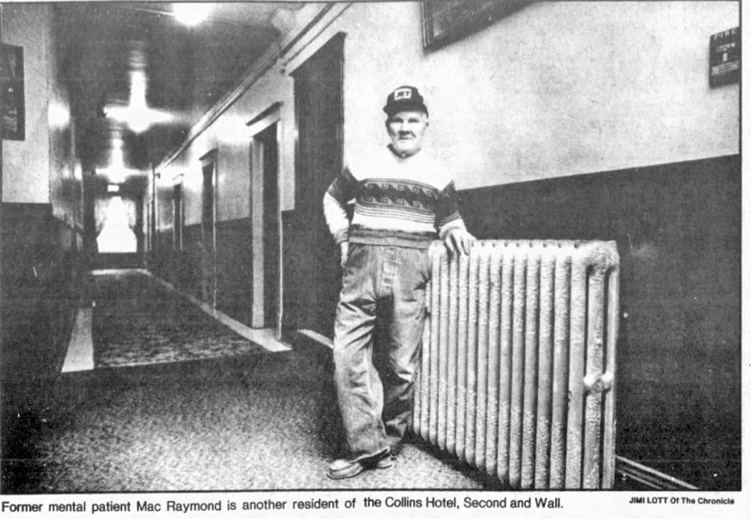
The 1950 Census lists 62 individuals living in the hotel. Niles Giliger and his wife, Janice, are listed as the managers of the hotel. Together with their widowed daughter, Dorothy J. Brennan, they occupied rooms 7, 8, 9, and 10 in the building. All residents were White. There was a notable increase in male residents in this census record, with 48 men living in the hotel compared to only 14 women. Most residents were single (including widowed, divorced, and separated) with only a few married. The age of residents ranged from 23 to 75. All but four lodgers were born in the United States, with two from Greece, one from Russia, and one from Yugoslavia. All residents were mostly part of the working class, with a broad range of industries listed, included restaurants, service work, transportation (drivers), sales, and the trades (e.g., plumbing, auto mechanics). There were a few white-collar employees living in the building, including one high school English teacher and two stenographers (all women). There were also several older residents who were retired or unemployed.
Figure 29. 1982 interior view. Spokane Chronicle, March 2, 1982, 6.

Commercial
The following commercial occupancy summary stems from newspaper articles, building permits, and Pok City Directories. Reverse directories in the Polk City Directories start in 1929. The north facade of the building along West Second Avenue historically had three storefronts: 701, 703, and 705. The east facade of the building along South Wall Street historically had five storefronts: 202, 206, 208, 210, and 212. The 204 South Wall Street address was largely associated with the hotel use on the upper floors, although 206 South Wall Street was also used on occasion.
The first known occupant of the 701 West Second Avenue storefront was a grocery store, operated by Charles Eden between 1917 and 1926 and then operated as LaFace and LaFace grocery beginning in 1927. By 1935 the business also included LaFace Confectionary. The grocery was operated by Carmen and Joseph La Face. One of the members had previously worked as a confectioner in 1924 at Laface & Bombino at 802 West Second Avenue, just a block to the west, before Carmen and Joseph opened their grocery ca. 1927. From 1936 through 1938, three years after prohibition ended in Washington State, the business was listed as both a grocery store and a beer parlor. Between 1939 and 1945, Joseph LaFace operated a restaurant and beer and wine parlor from the space. Shorty’s Tavern then operated from the storefront between 1947 and 1960, followed by the Hide Out Tavern between 1970 and 1986. Then in 1997, SNAP (Spokane Neighborhood Action Programs) moved into building and remodeled the commercial spaces for office use and a senior meals program.
The first known occupant of the 703 West Second Avenue storefront was a restaurant in 1921, known as the McLeod and Dordon. Then in 1927, M.J. Badner, a tire dealer and repairer operated from this space. A tire store continued in the building until 1931, becoming the W. S. Melcher Tire Store, owned by Walter S. and Myrtle M. Melcher, in 1928. The Second Avenue location was their second store. In 1921 it was listed as Melcher Manufacturing Company. The space was listed as vacant between 1932 and 1936. Between 1937 and 1943, the Melcher Manufacturing Company operated from the space making rubber goods, sharing the space with Full Circle Retread Shop. In 1954, the space was combined with the 705 storefront.
The first known occupant of the 705 West Second Avenue storefront was the Neilson Company in 1914, followed by the Hiline Tire Shop in 1918. The storefront shifted to restaurant use by 1923, with Thomas Keane running a restaurant in the space. The restaurant operators shifted over the years, with Robert Masse in 1924, Clarence E. and Emma R. Skelton in 1925, and Frank Grovenor (a resident of the hotel upstairs) in 1928. Ideal Café opened in the space in 1930, then the Maple Café in 1931, and then it was relisted as the Ideal Café between 1932 and 1933. Between 1940 and 1954, the Davis Electric Company operated from the space. They started with electric motors, expanded to Delco-Lights (generators and associated battery systems for electric lighting), and lighting systems, and by the 1950s were doing commercial refrigeration. By 1954 the business had expanded into the 703 West Second Avenue space as well. Then in 1956, a new long-term tenant moved into the combined 703-705 storefront, Kirishian Carpets. Onnig S. Kirishian operated the business and sold oriental rugs and carpets.
The first known occupant of the 202 South Wall Street storefront was Ted Olson, who ran a barbershop in the space between 1931 and 1941. The space continued to operate as a barbershop for decades with William H. Glassford operating it between 1942 and 1943 and then it branded as Bill’s Shop between 1945 and 1960.
The first known occupant of the 206 South Wall Street storefront was D.C. Collins’ real estate office in 1911. The space was vacant for a number of years, with the Fifer Brothers operating a business from the space in 1932. In 1936 it turned into a commercial laundry business, operating under various business names: American-French Hand Laundry (1936), Collins Cleaners (1937), and Wall Street Cleaners (1938). Independent Paper Company, a wholesale paper company, moved into the space in 1939 and stayed until 1943. A range of businesses operated from the space in subsequent years, including Kreshel and Owes, a floor coverings business (1945), R. A. Hunt Advertising Company (1947-49), Ekholm Sign Company (1952), and Rawleigh Products (1958-59).
The first known occupant of 208 South Wall Street was Spokane Typesetting, which operated out of the space between 1930 and 1950. Then the Armstrong Mailing Service was listed at the address between 1952 and 1960. By 1954 the company was listed as the Armstrong-Hamilton Mailing and Advertising. By 1958 the company was listed as just the Hamilton Mailing and Printing company.
The first known occupant of the 210 South Wall Street storefront was the Brown and Tooke stationery business between 1918 and 1919. They were loose leaf specialists, and provided office supplies, wedding stationery, and engraving and embossing services. The business was listed as Brown Printing Company between 1924 and 1931. A variety of businesses operated from the space in subsequent years, including Wall Street Electric company, providing electric supplies operated from the space (1937), Curtiss Insulating Company and the Johns-Manville Sales Corporation (1938-49), Dante B. Tye Insurance Company (1952-56), Beneficial Life Insurance Company and Merton D. Cook (1956), Wall Street Cleaners (1959), Spot Beauty Shop (1966), and Don Firshing (1978).
The first known occupant of the 212 South Wall Street storefront was Century Press, owned by Frank V. Brown, between 1913 and 1916. Then John Bonhan and Company was in the space in 1919, followed by C. E. Modesitt in 1920. Harry R. Kendall ran a bottler’s supply business in the storefront between 1925 and 1929. A long-term tenant moved into the space in 1929, Diamond Glass Company (glaziers), which stayed until 1960. The Clean-O-Mat Company was then listed at the address in 1971.

Architectural Context
The building was designed by Spokane-based architect C. Harvey Smith and constructed by contractor George Groshoff. Its design reflects the SRO property type.

Charles (C.) Harvey Smith, Architect
Charles Harvey Smith—known professionally as C. Harvey Smith—was born in Ottawa, Kansas, on May 7, 1868, to parents Hugh Andrew Smith and Rosalind (Minor) Smith. He grew up in Bethany, Illinois, and briefly worked for his building contractor father after he finished high school. By the late 1880s he had moved to Spokane, though, and worked as a carpenter. He married his wife, Laura Walker, ca. 1889, and they had six children: Russell, Eva, (Rosa) Gretchen, Hugh, Estella, and Ada. By 1903 he advertised his services as an architect, aligning with the period of intense rebuilding for the central business district. He formed a brief partnership with W. W. Hyslop, then with James S. Arnot, before moving into independent practice by 1907.
Smith’s work was prolific in Spokane and the surrounding region, even in neighboring Idaho. He designed numerous residential projects in Spokane as well as larger-scale commissions like the Hotel Collins, Stanton Block, and Foulner Apartments. Other projects included high schools in Chewelah, WA; Mullen, ID; and Post Falls, ID; along with the county courthouse in Twin Falls, Idaho. He died in 1942 at the age of 74.

George Groshoff, Contractor
George Groshoff worked as a contractor and brick mason in Spokane and the surrounding region. Born in Indiana in October of 1865, Groshoff arrived in Spokane in 1889 via St. Paul, Minnesota. He started building residences, including his own, in the Peaceful Valley neighborhood of Spokane, with three on West Main Avenue (1607, 1604, and 1608). After the 1889 fire—and the need for masonry construction—Groshoff got work building the Spokesman-Review Building and the County Courthouse. After opening his own contracting business, he built the Armory, Sacred Heart Hospital, Our Lady of Lourdes Cathedral, the Colonial and Del Rey buildings, the Hotel Collins, as well as buildings at the Washington State College (now University) and in nearby Oakesdale and Sandpoint, Idaho. He was married to Catherine, and they had two children: George P., Jr., and Lawrence J. He died in 1921.

SROs as a Property Type
According to the MPD, “Single room occupancy hotels were, for many years after the turn of the century, one of the most common building types in Spokane’s CBD [Central Business District].” SROs ware typically unreinforced masonry buildings, typically with red or buff bricks, and usually range in height from 3-5 stories. Built to provide affordable housing for a variety of individuals, SROs featured a stairway from street-level at the front of the building to provide direct access to the lodging on the upper stories.
There was typically a small waiting area or a manager’s office at the top of the stairs at the second floor. Hallways run the length of an SRO’s street-fronting facade and some SROs may have additional or connecting hallways if the building is on a corner lot (like the Hotel Collins) or have lightwells to provide more daylighting. Rooms open into the hallways and there were often transoms above the doors to provide additional ventilation.
Most SROs provided single rooms for lease, but a few had some multiple-room units. They typically did not have private baths, instead there were shared facilities on each floor. Some SROs, like the Hotel Collins, provided sinks with hot and cold running water in each room. The single rooms did not have a kitchen, instead residents would eat at the restaurants within the commercial district within a short walk of the hotel. Furniture was included with the unit, usually a bed and a wardrobe or armoire.
In Living Downtown: The History of Residential Hotels, Paul Groth outlines the nuanced history of SROs in contrast to other residential hotels. SROs differed from palace hotels and mid-priced hotels, which catered to the upper and middle classes, respectively, but also from the lodging and boarding houses that were much smaller and often located in someone’s home. SROs, often over generalized as homes to itinerant workers or single men working blue collar jobs, provided affordable housing for temporary or low-income workers, but also others seeking to live downtown or find freedom not available in shared housing. The Hotel Collins reflects the range of individuals who chose to live in SROs as the occupancy history demonstrates the hotel housed multiple generations, both men and women, with a variety of occupations.

Conclusion
The Hotel Collins is eligible for listing in the Spokane Register of Historic Places under Category A for its association with early SROs in the Spokane Central Business District and the rapid development of downtown and the surrounding city, as well as the need for increased housing options for the growing workforce. The property operated as an SRO for much of its history.
The Hotel Collins is eligible for listing in the Spokane Register of Historic Places under Category C as a representation of the SRO property type. Designed and built as an SRO, it retains a largely intact upper floor configuration, exterior architectural detailing, fenestration patterns, and intact direct walk-up stairways, and some storefronts. The alterations that have occurred (i.e., infilling upper floor transoms, removal of some original partition walls; adding some doors; changes to ground floor interior spaces; and window and storefront changes) are to be expected on this building type according to the MPD.

BIBLIOGRAPHY
Arksey, Laura. “Spokane -- Thumbnail History.” In Historylink.Org, September 4, 2005. https://www.historylink.org/file/7462.
Burya, John S. and Mary, to Pacific National Capital Company. “Real Estate Contract: 7407110281,” June 15, 1974. Vol 200, Pages 1301-1306. Spokane County Assessor.
Family Search. “Charles Harvey Smith (1868–1942).” Accessed July 23, 2024. https://www.familysearch.org/tree/person/details/LW5B-X6V.
Galland & Hagood, Inc., to Richard and Lucille Eoff. “Real Estate Contract,” December 20, 1968. Spokane County Assessor.
Groth, Paul. Living Downtown: The History of Residential Hotels in the United States. Berkeley, CA: University of California Press, 1994.
Guilfoil, Michael. “Oriental Rug Business Remains Staple among Spokane Retailers.” The Spokesman-Review, October 27, 2013. https://www.spokesman.com/stories/2013/oct/27/imported-comfort/.
Holstine, Craig. “Single Room Occupancy Hotels in the Central Business District of Spokane, WA, 1900-1910.” National Register of Historic Places Multiple Property Documentation, 1993. https://npgallery.nps.gov/NRHP/GetAsset/fdabf127-daf0-4116-9773-1eb3a0abbf8f.
Houser, Michael. “C. Harvey Smith.” Washington State Department of Archaeology & Historic Preservation (DAHP), October 2011. https://dahp.wa.gov/historic-preservation/research-and-technical-preservation-guidance/architect-biographies/bio-for-c-harvey-smith.
Nisbet, Jack and Claire. “Spokane House, First Fur-Trading Post Constructed in the Future State of Washington, Is Closed on April 7, 1826.” In Historylink.Org, February 22, 2017. https://www.historylink.org/File/20296.
Richard Eoff and Lucille Eoff to Anthony B. Arneson adn Monica B. Arneson. “Sale Agreement | Escrow No. 13406,” January 15, 1971. Vol 200, Pages 1309. Spokane County Assessor.
Spokane City Directory. Vol. IV. Spokane, WA: R. L. Polk & Co., Publishers, 1893.
Spokane Tribe of Indians. “The Spokane Tribe of Indians’ Comments on the Proposed Revision to 25 C.F.R. § 151, Fee to Trust Regulations,” July 2, 2018. https://www.bia.gov/sites/default/files/dup/assets/as-ia/raca/pdf/59%20-%20Spokane%20Tribe.pdf.
Spokane Tribe of Indians Historic Preservation Office. “Spokane Tribal History.” Spokane Tribe of Indians. Accessed July 22, 2024. https://www.spokanetribe.com/resources/dnr/preservation/history/.
The Spokane Chronicle. “A Busy Day.” August 12, 1891.
———. “Collins Block Nearly Finished.” December 27, 1910.
———. “Daniel Collins Taken by Death.” July 19, 1933.
———. “New Three-Story Apartment House.” February 18, 1910.
———. “Rushing Work on Collins Building.” September 10, 1910.
———. “Three-Story Building on Second Avenue to Be Completed This Fall.” August 23, 1910.
The Spokane Evening Review. “Morsels.” August 11, 1885.
The Spokane Press. “City Briefs.” February 18, 1938.
The Spokesman-Review. “Drumheller Site Sells for $50,000.” February 8, 1910.
———. “Hold Harvey Smith Funeral Today.” May 16, 1942.
———. “Modern Building on Landmark Site.” April 3, 1910.
———. “Montanan Buys Hotel.” February 19, 1938.
———. “Mrs. A. Collins Funeral Monday.” December 20, 1936.
———. “St. Helen to Have $11,000 Addition.” February 19, 1910.
United States Department of Commerce. Bureau of the Census. “Seventeenth Census of the United States, 1950.” Washington, D.C.: National Archives, 1950. Ancestry.com.
United States of America, Bureau of the Census. “Fifteenth Census of the United States, 1930.” Washington, D.C.: National Archives and Records Administration, 1930. Ancestry.com.
———. “Fourteenth Census of the United States, 1920.” Washington, D.C.: National Archives and Records Administration, 1920. Ancestry.com.
———. “Sixteenth Census of the United States, 1940.” Washington, D.C.: National Archives and Records Administration, 1940. Ancestry.com.
———. “Thirteenth Census of the United States, 1910.” Washington, D.C.: National Archives and Records Administration, 1910. Ancestry.com.
———. “Twelfth Census of the United States, 1900.” Washington, D.C.: National Archives and Records Administration, 1900. Ancestry.com.
Yeoman, Linda. “Ridpath Hotel.” National Register of Historic Places nomination, 2013. https://npgallery.nps.gov/NRHP/GetAsset/9f0bbd56-0e12-4cac-bac1-e50aa9bef7b8.

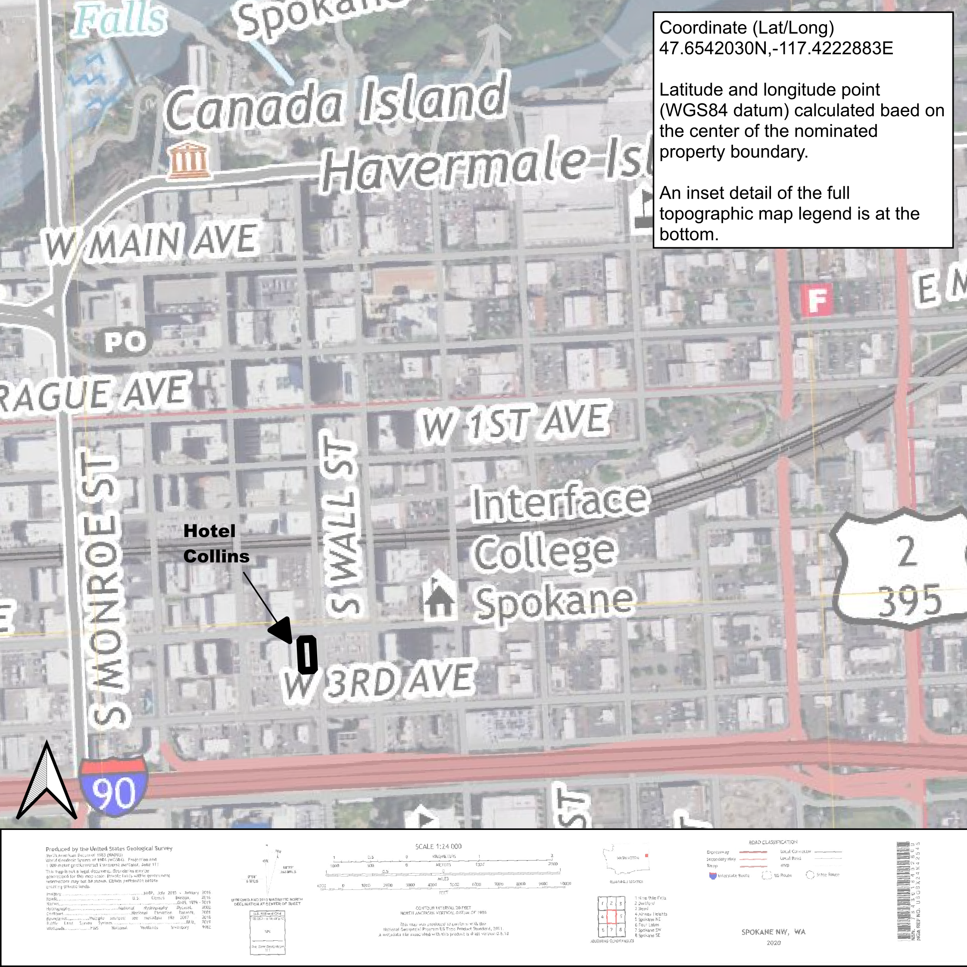
Figure 30. USGS Topographic Map.
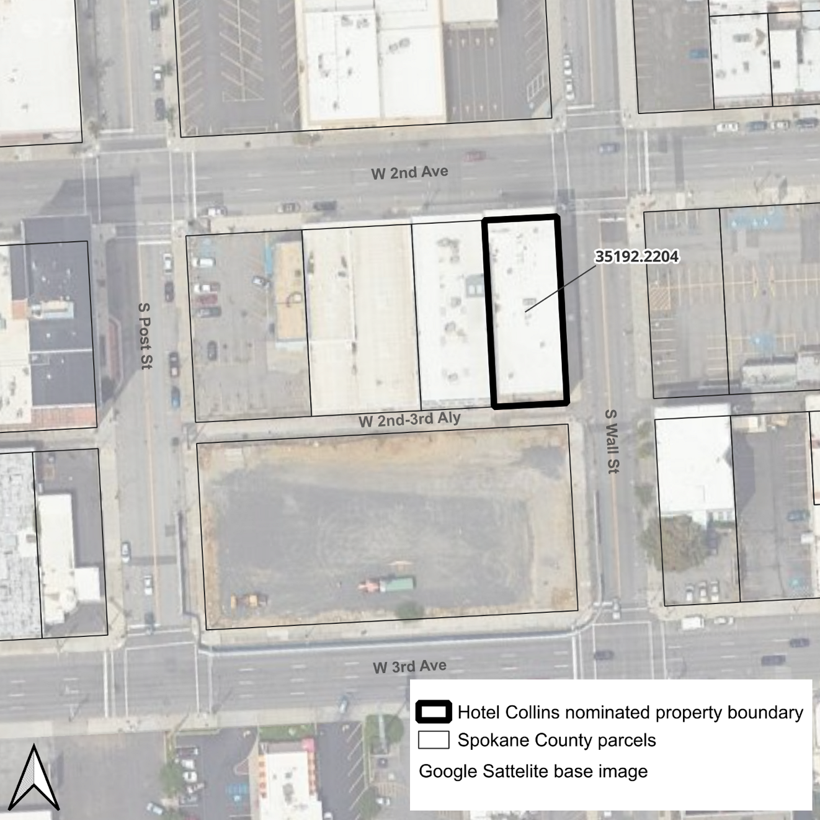
Figure 31. Parcel Map
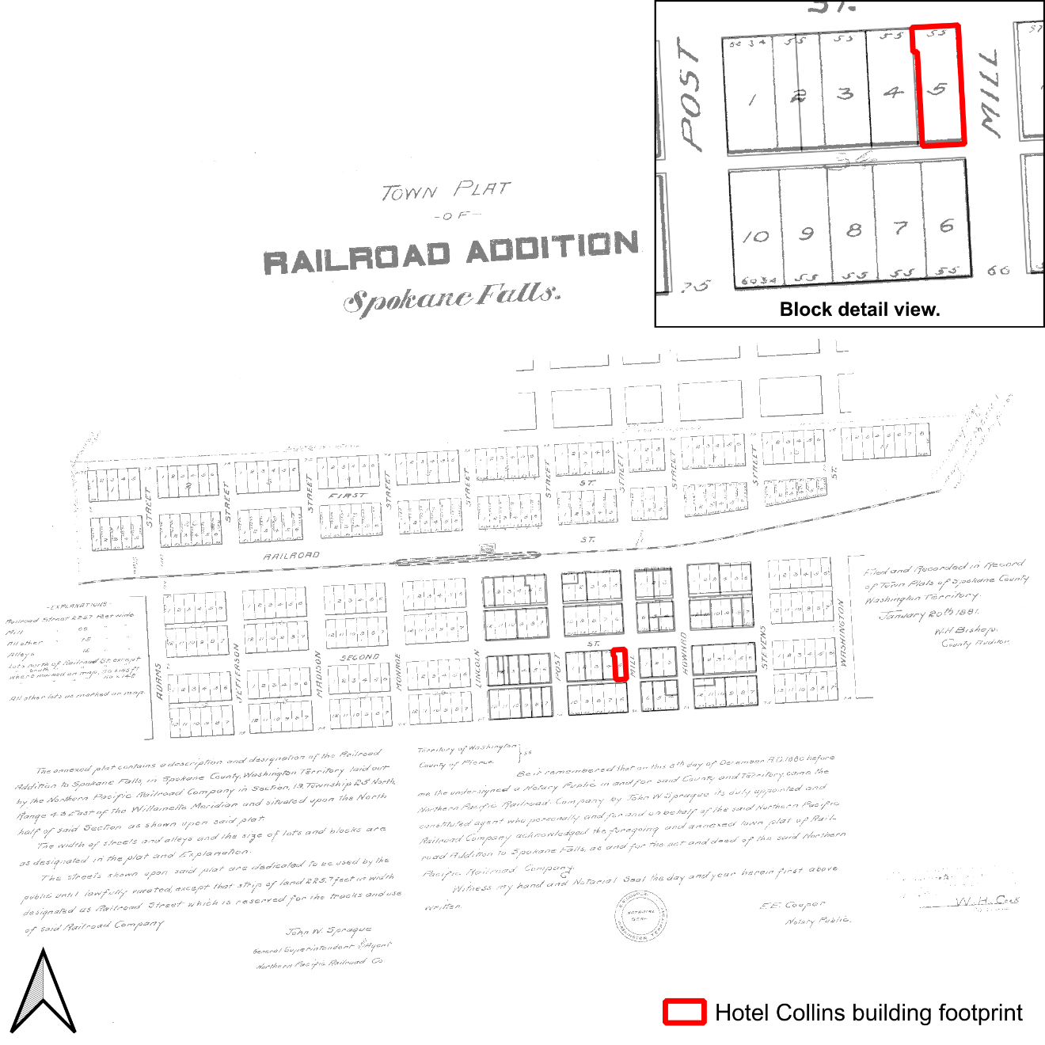
Figure 32. Plat Map
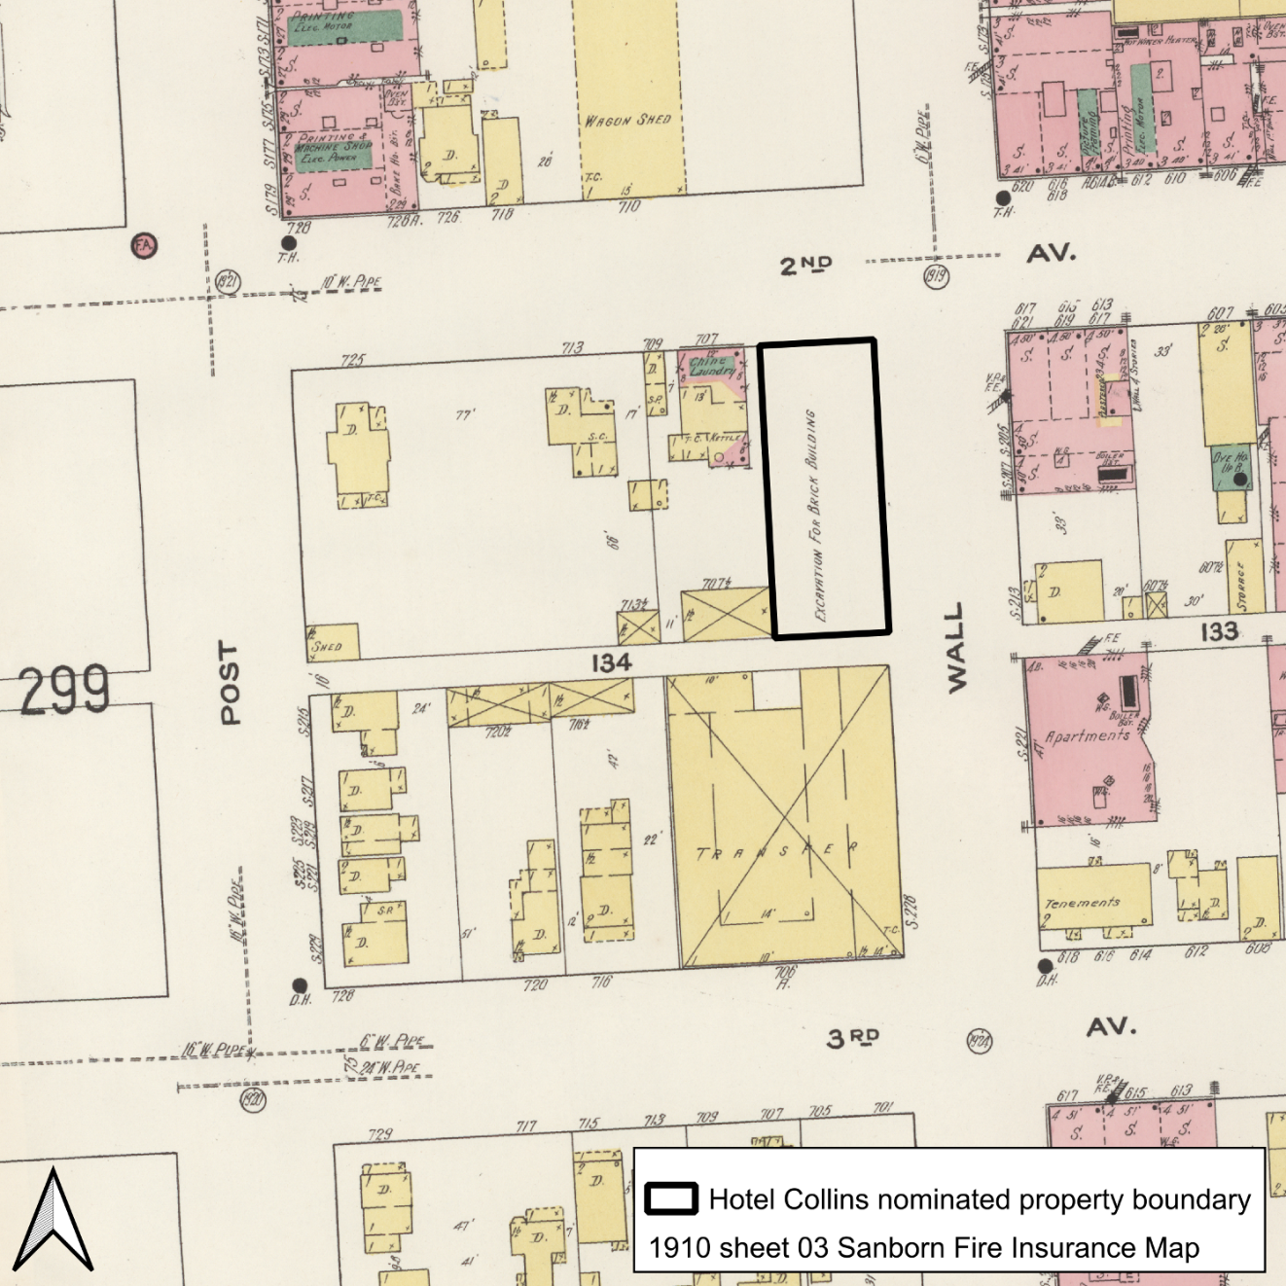
Fig. 33. 1910 Sanborn Fire Insurance Map
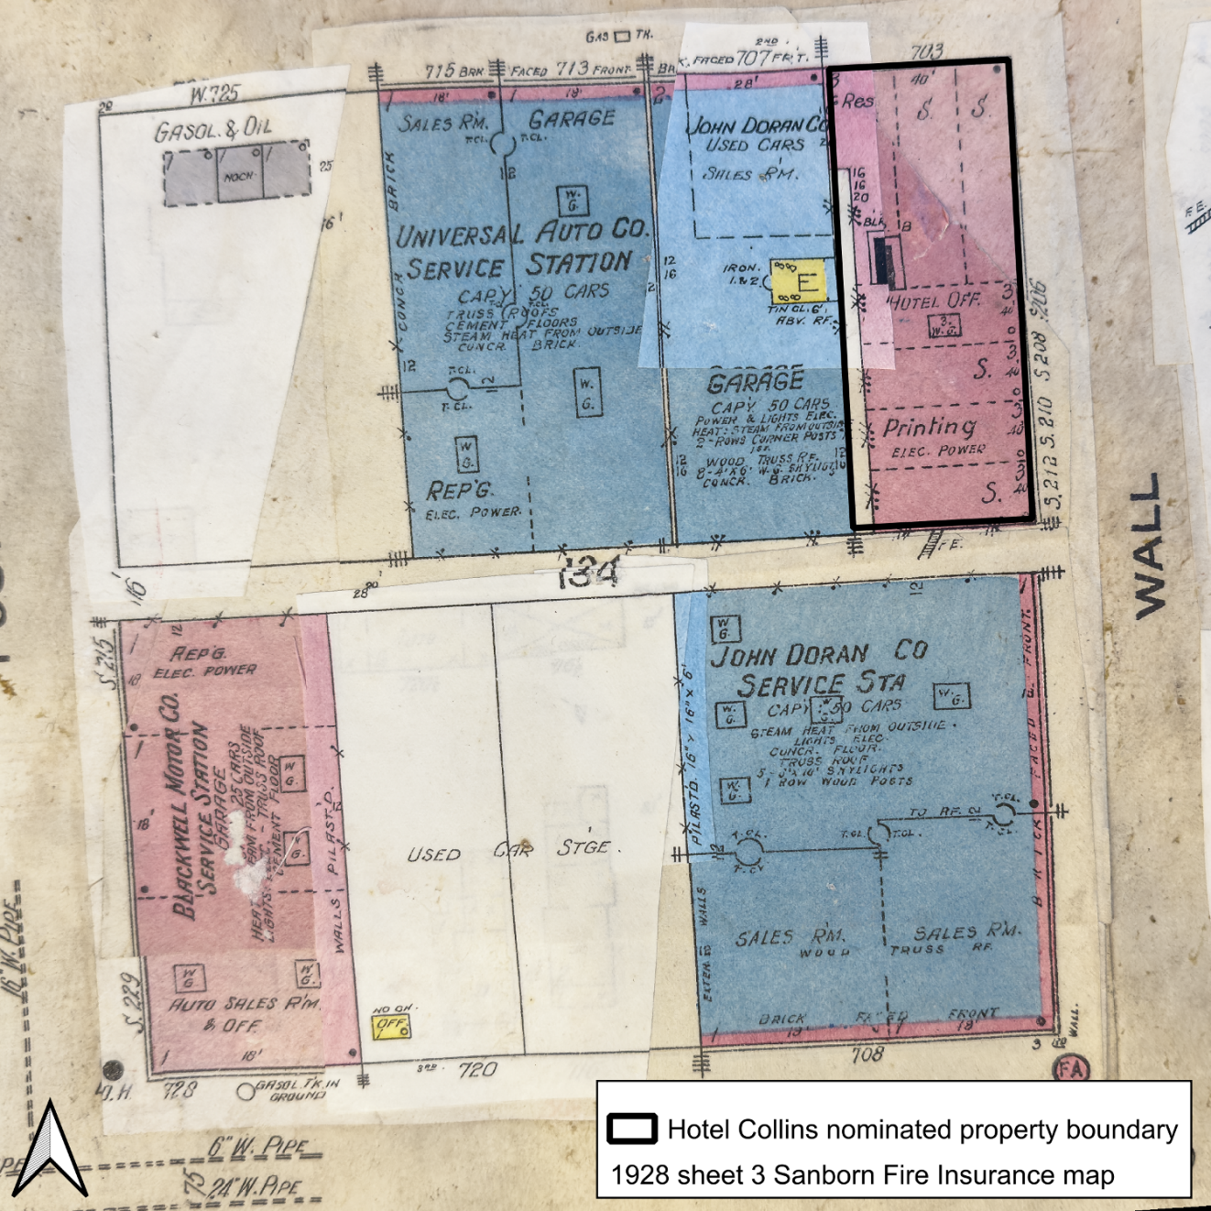
Figure 34. 1928 Sanborn Fire Insurance Map
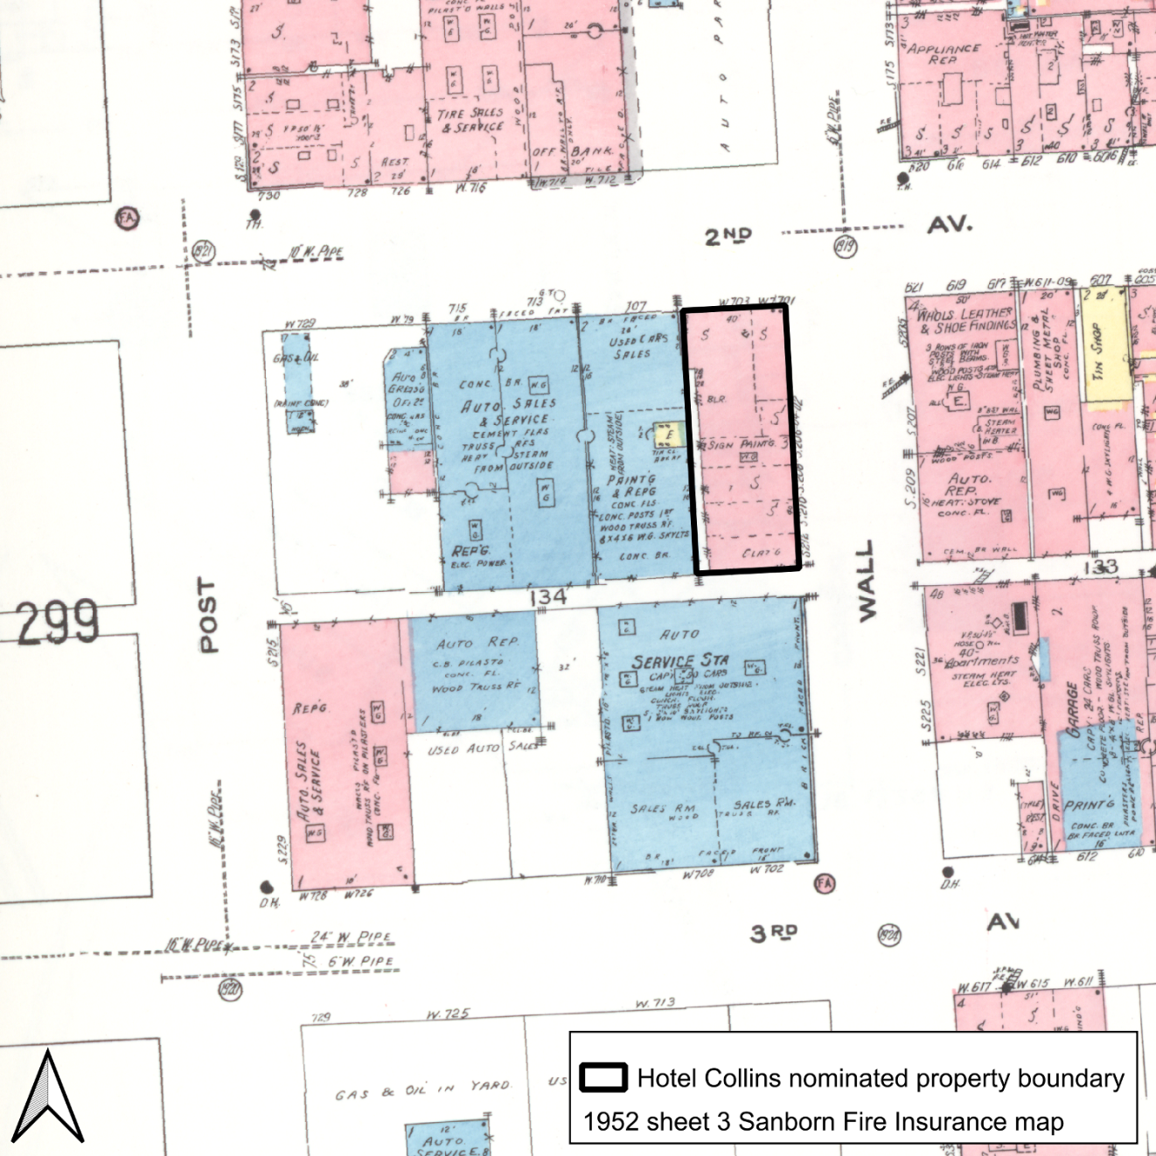
Figure 35. 1952 Sanborn Fire Insurance Map

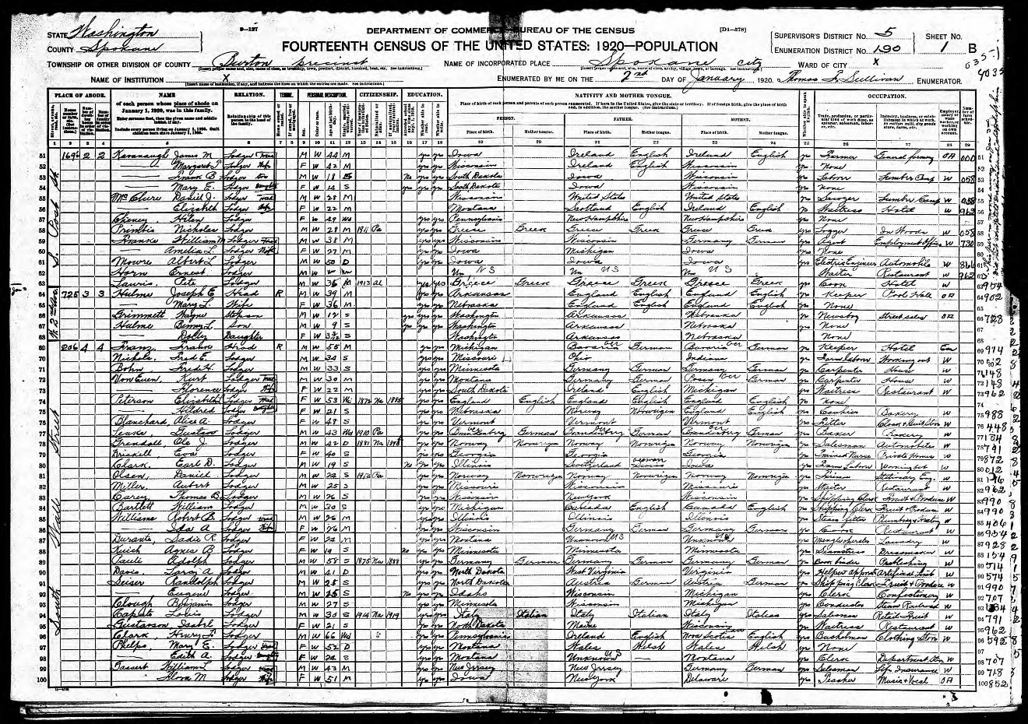
Figure 36. 1920 Census enumeration district card. United States of America, Bureau of the Census.

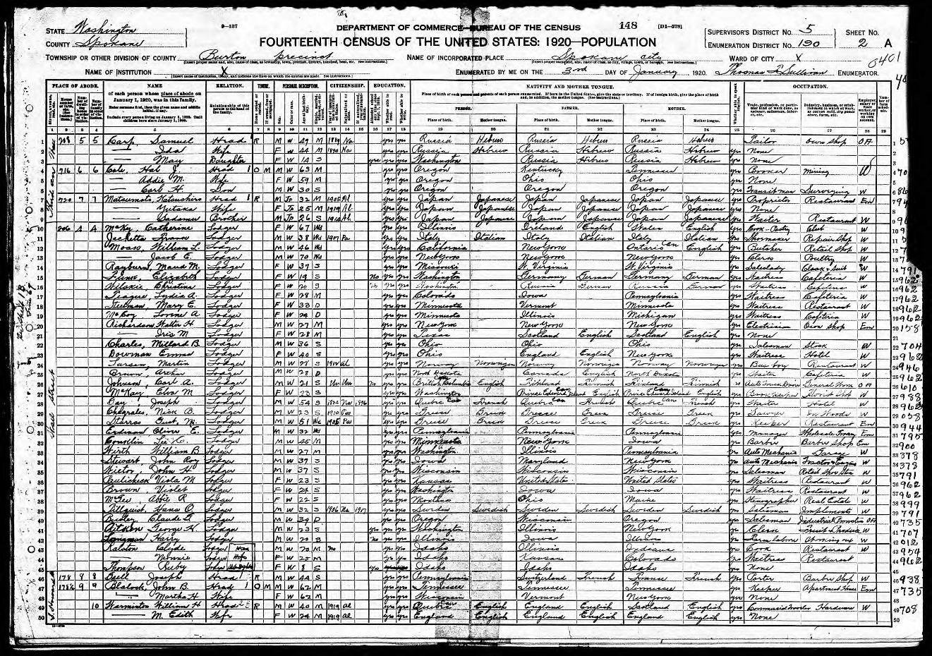
Figure 37. 1920 Census enumeration district card. United States of America, Bureau of the Census.

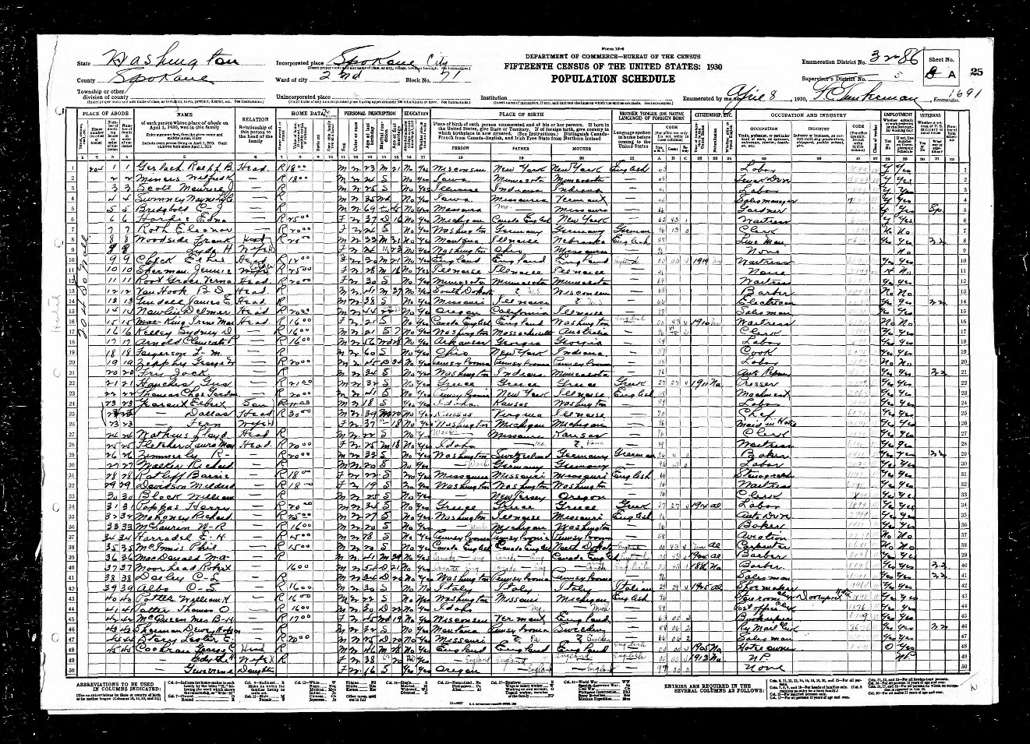
Figure 38. 1930 Census enumeration district card. United States of America, Bureau of the Census.

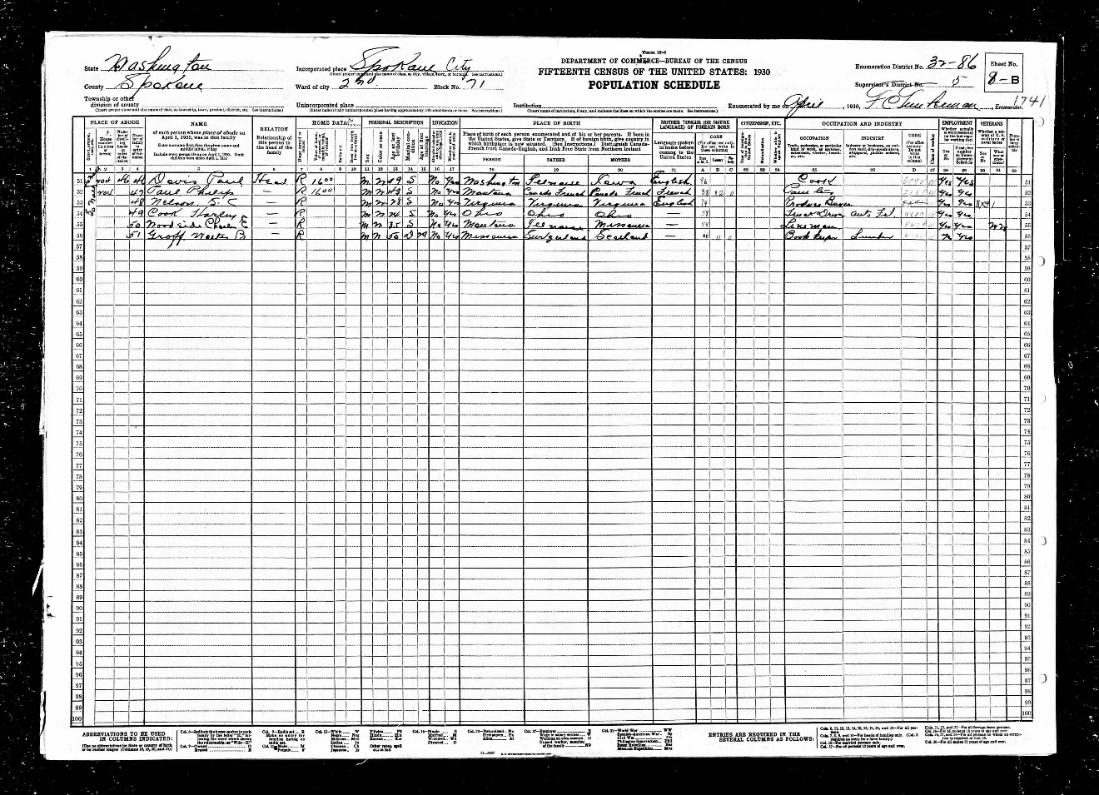
Figure 39. 1930 Census enumeration district card. United States of America, Bureau of the Census.

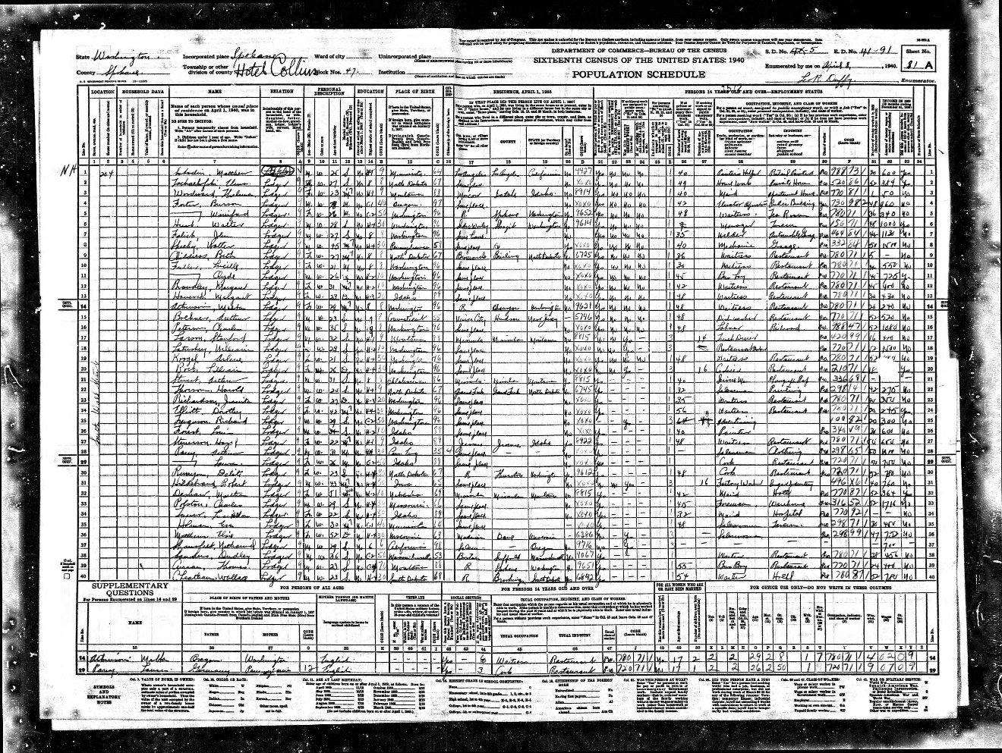
Figure 40.. 1940 Census enumeration district card. United States of America, Bureau of the Census.

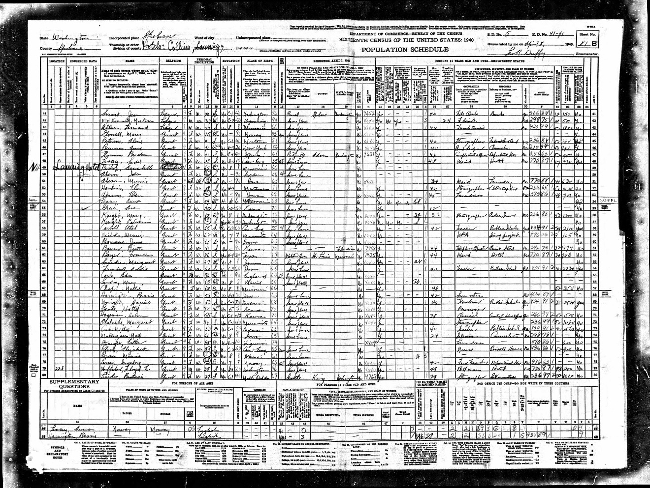
Figure 41. 1940 Census enumeration district card. United States of America, Bureau of the Census.

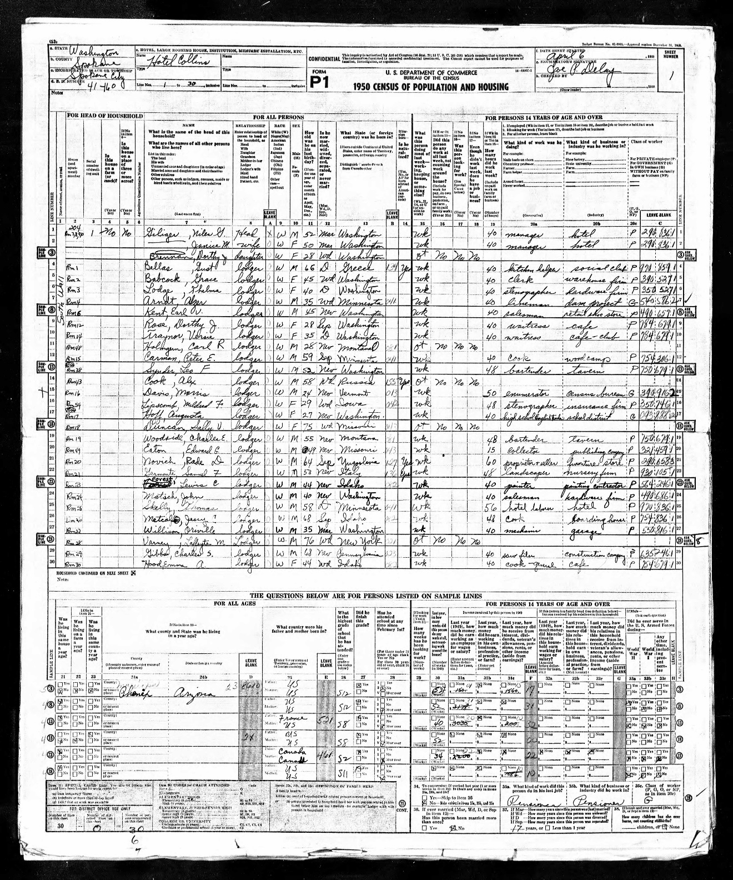
Figure 42. 1950 Census enumeration district card. United States Department of Commerce, Bureau of the Census.

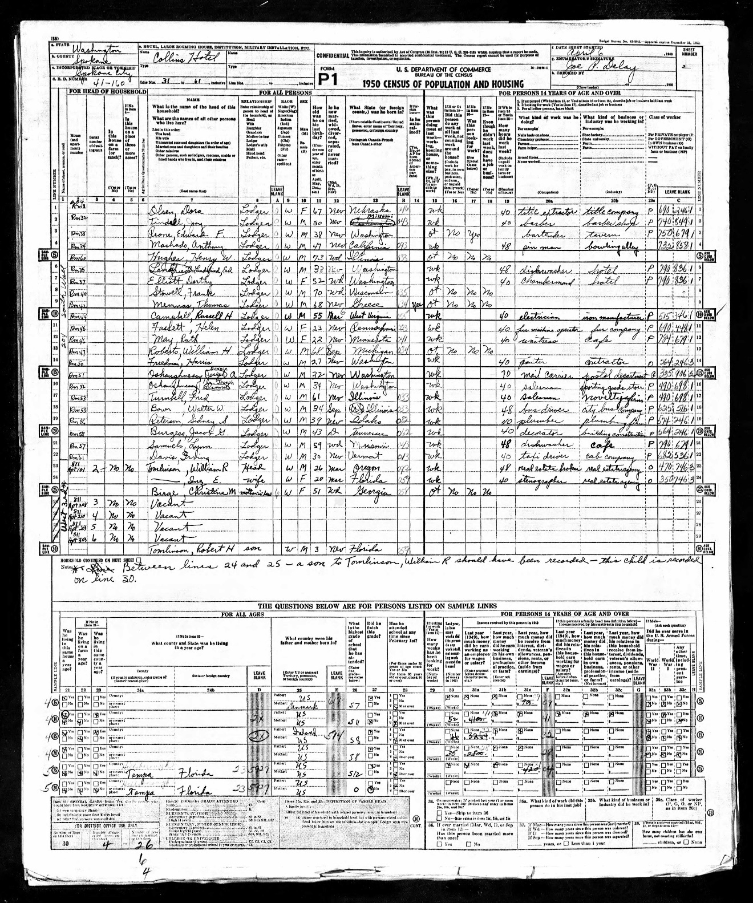
Figure 43. 1950 Census enumeration district card. United States Department of Commerce, Bureau of the Census.

Photographs:
Name of Property: Hotel Collins
City or Vicinity: Spokane
County: Spokane State: WA
Photographer: Spencer Howard
Date Photographed: June 24, 2024

Photograph Keys:
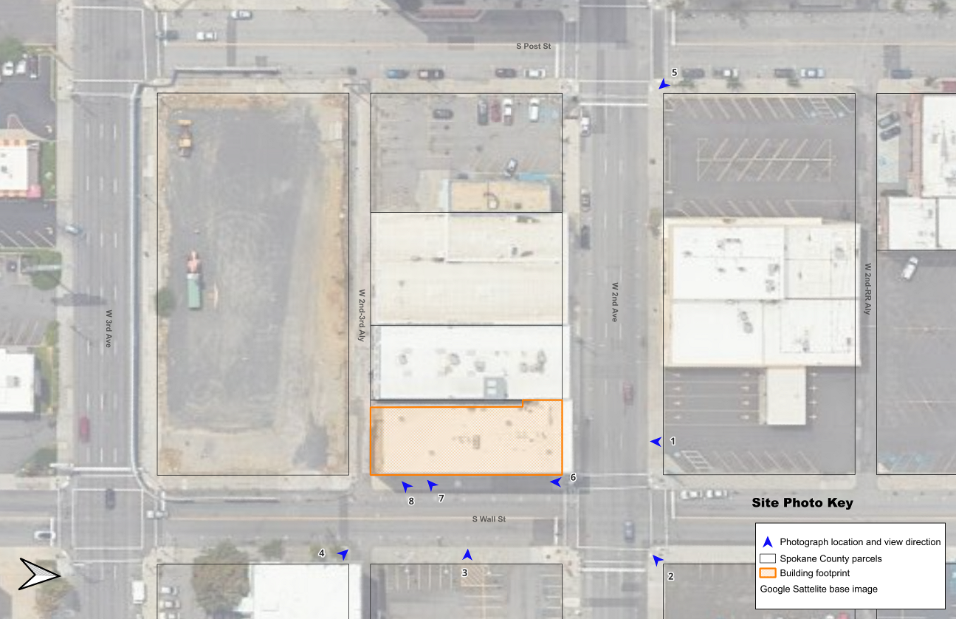
Site Photograph Key
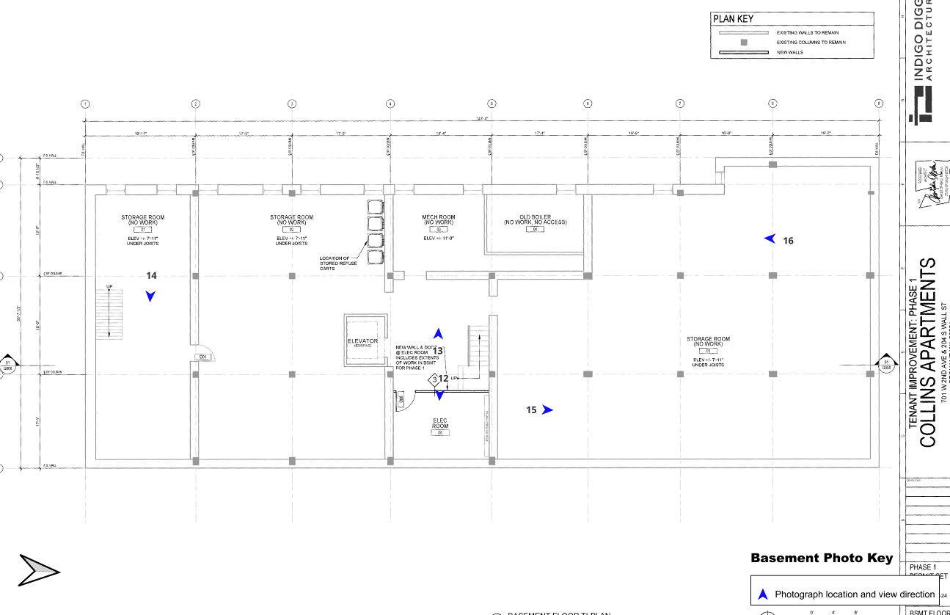
Basement Photograph Key

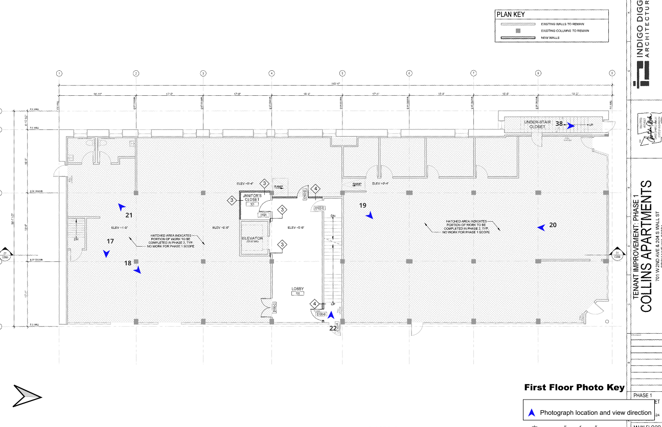
First Floor Photograph Key
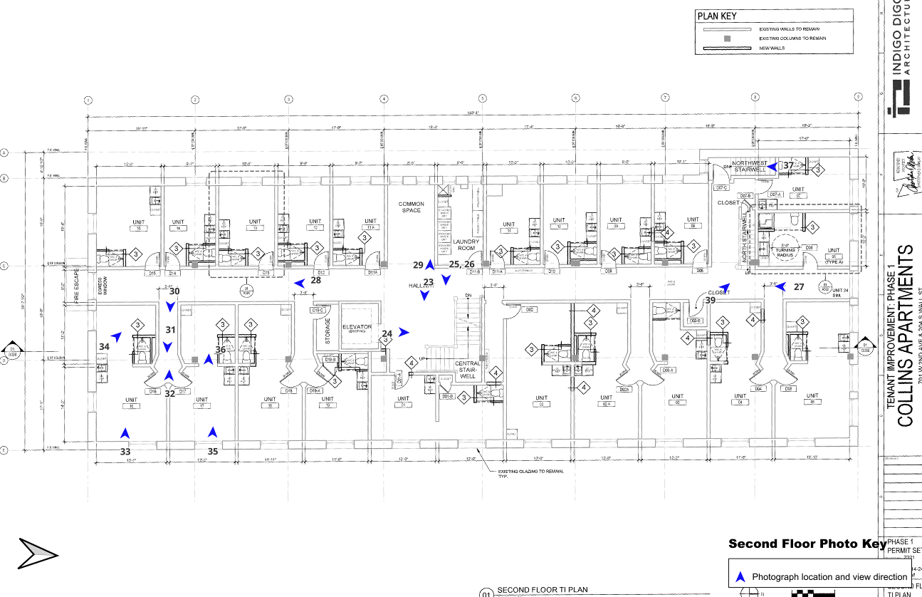
Second Floor Photograph Key

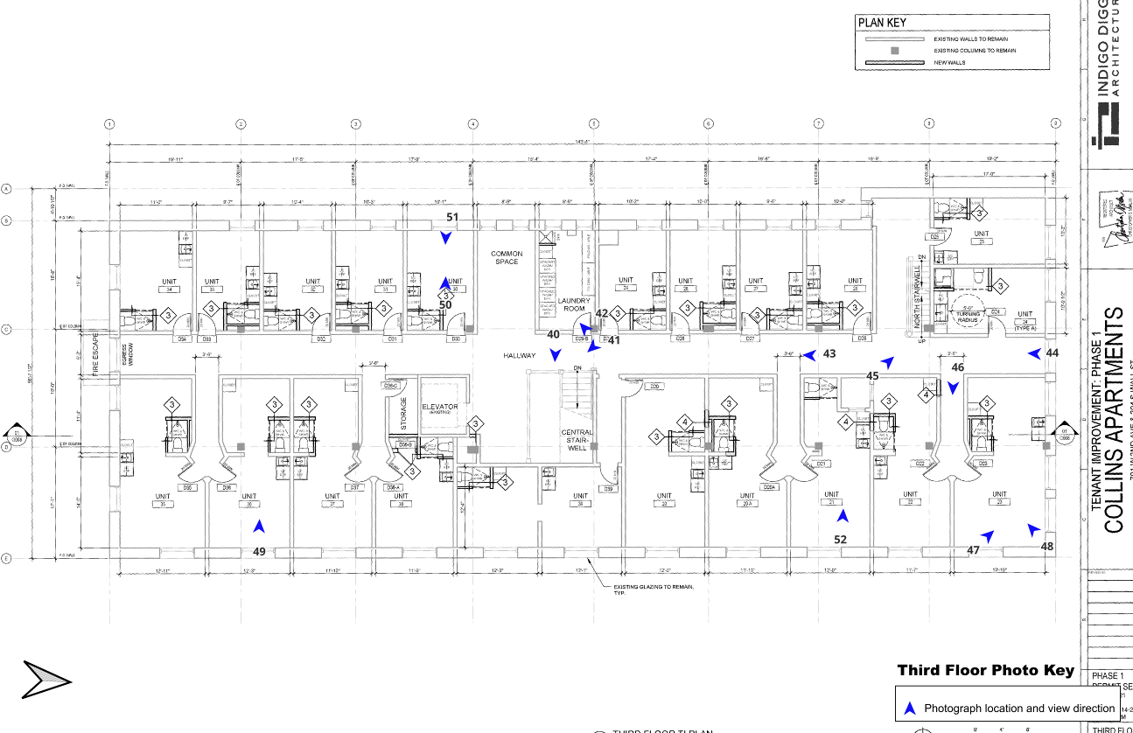
Third Floor Photograph Key
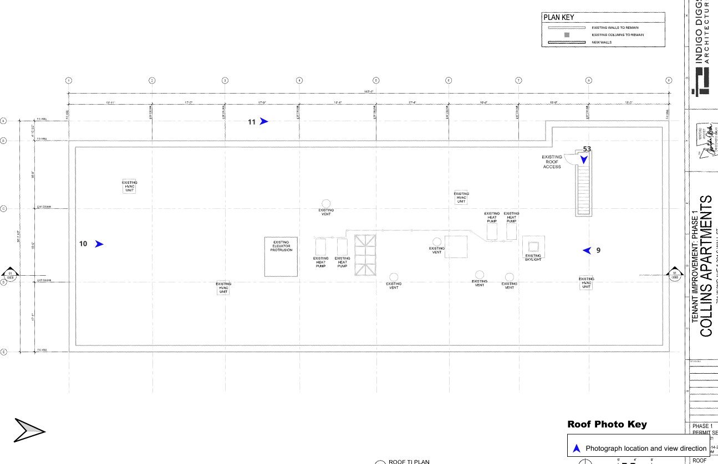
Roof Photograph Key

Description of Photographs and number

Photo 0001. Exterior, front, north facade (West Second Avenue). 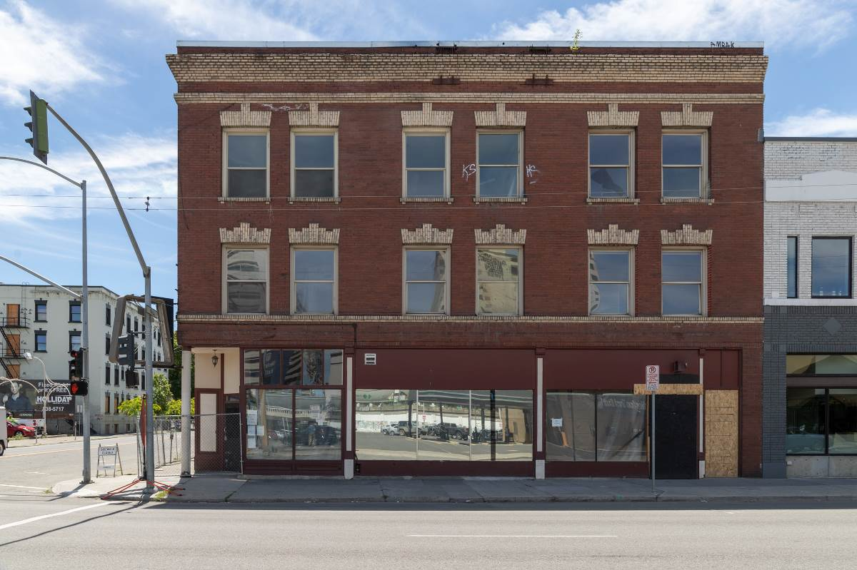

Photo 0002. Exterior, northeast corner, intersection of South Wall Street and West Second Avenue. 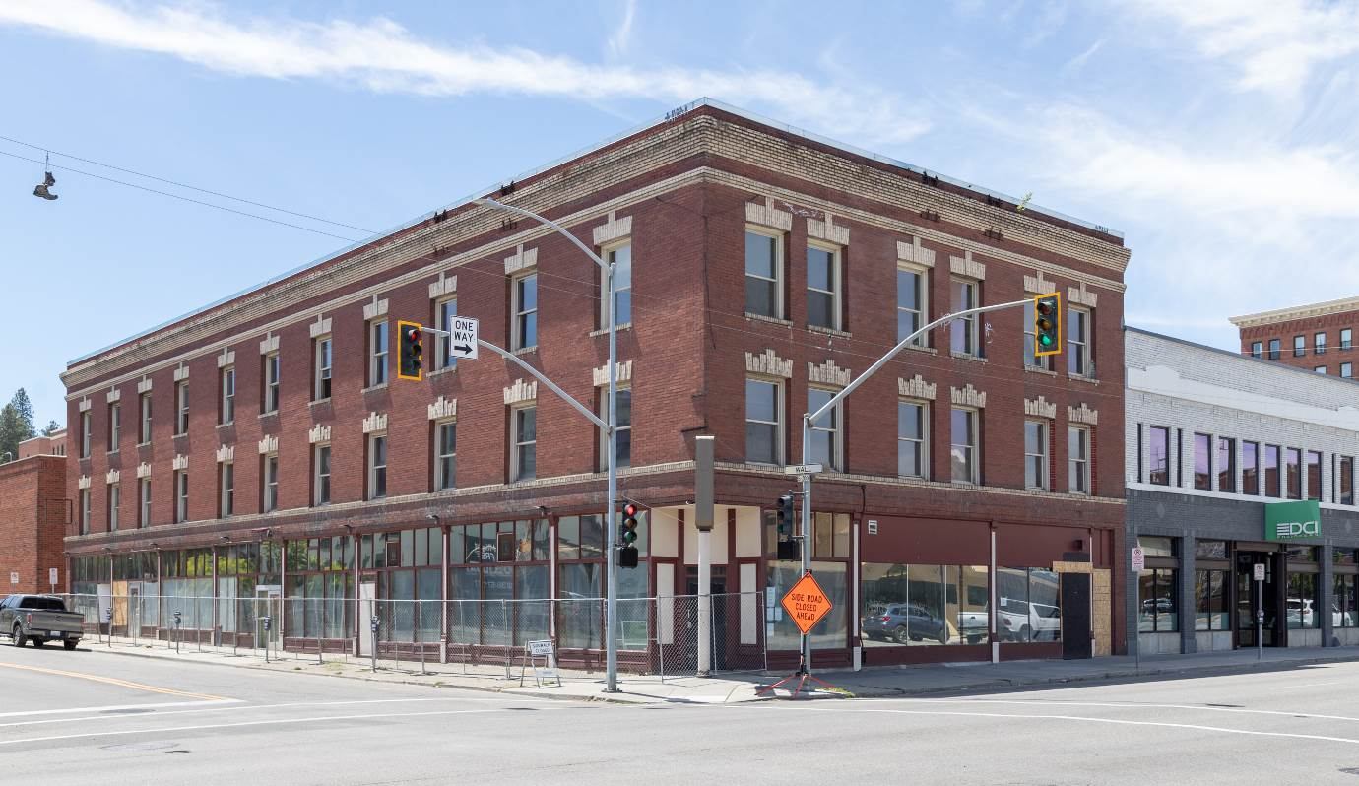

Photo 0003. Exterior, front east facade, South Wall Street. 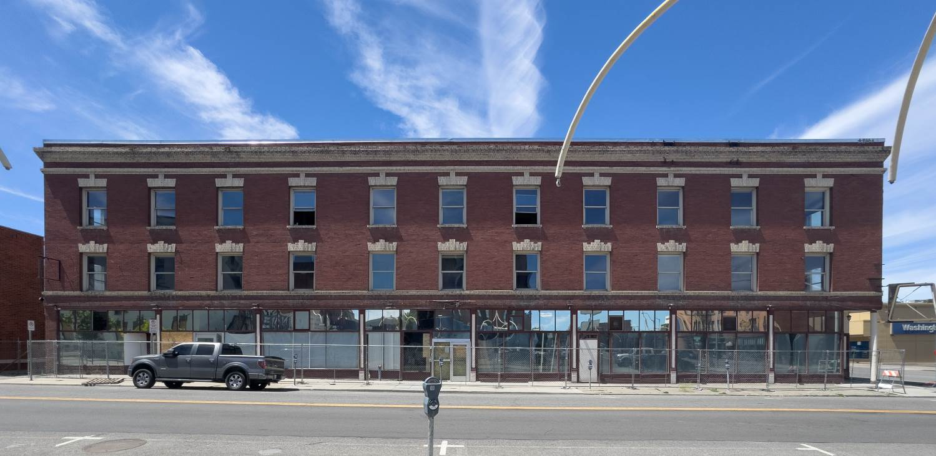

Photo 0004. Exterior, southeast corner. 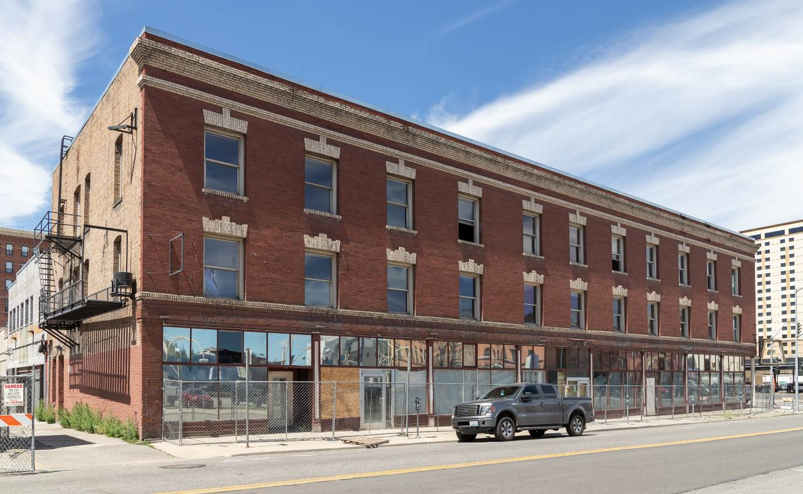

Photo 0005. Exterior, west facade. 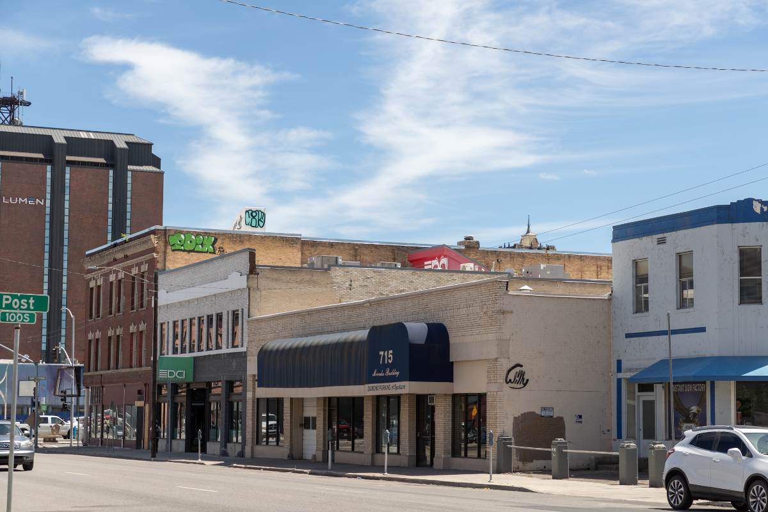

Photo 0006. Exterior, storefronts along South Wall Street, looking south. 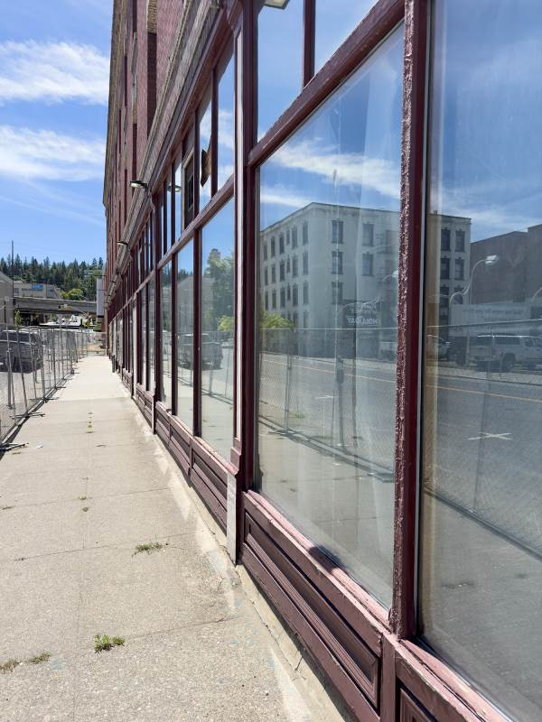

Photo 0007. Exterior, east facade storefronts, looking south. 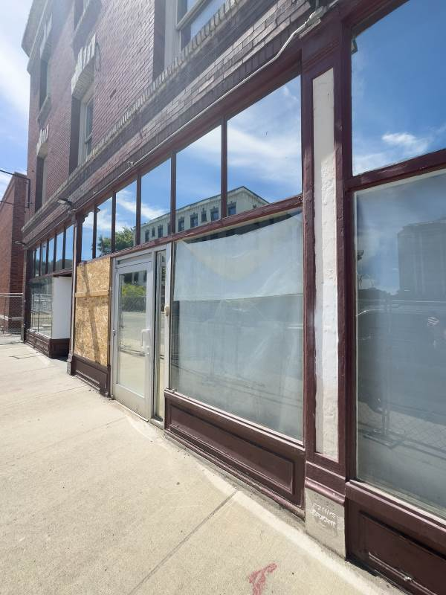
Photo 0008. Exterior, 212 South Wall Street entrance. 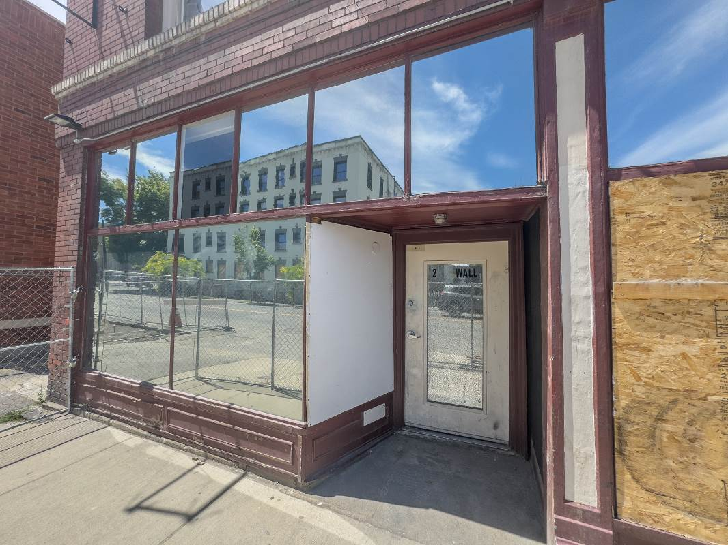

Photo 0009. Roof, looking south. 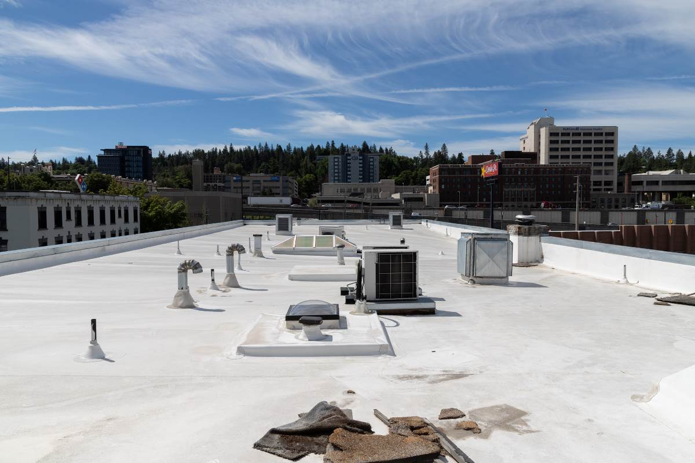
Photo 0010. Roof, looking north. 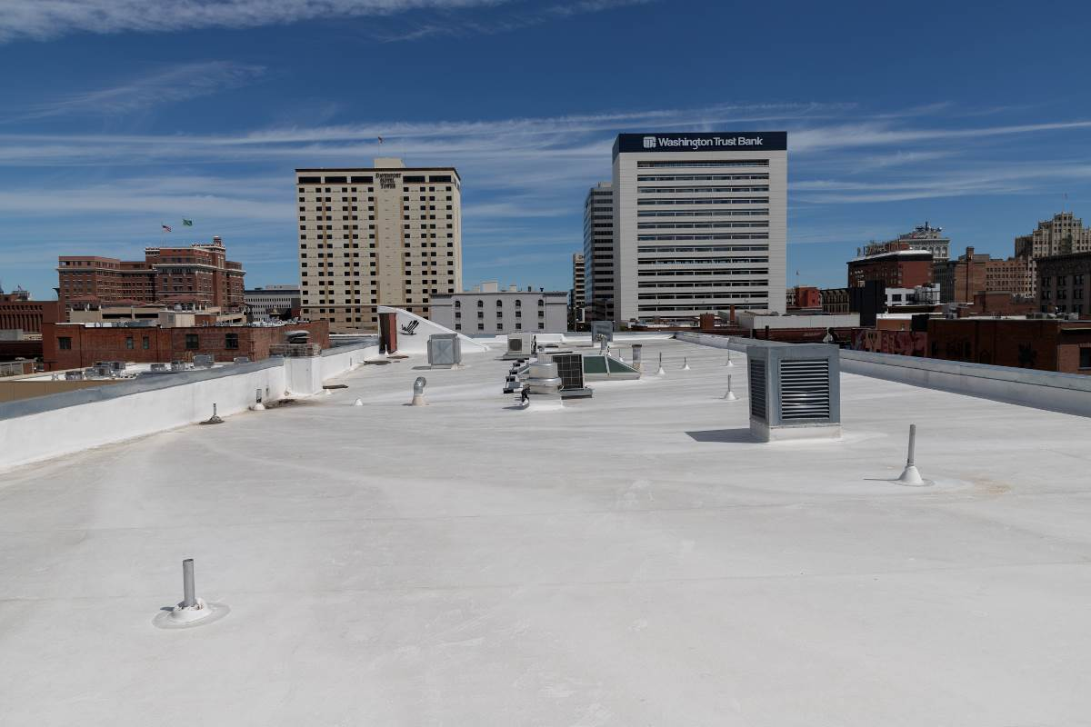

Photo 0011. Roof, light well, looking north.
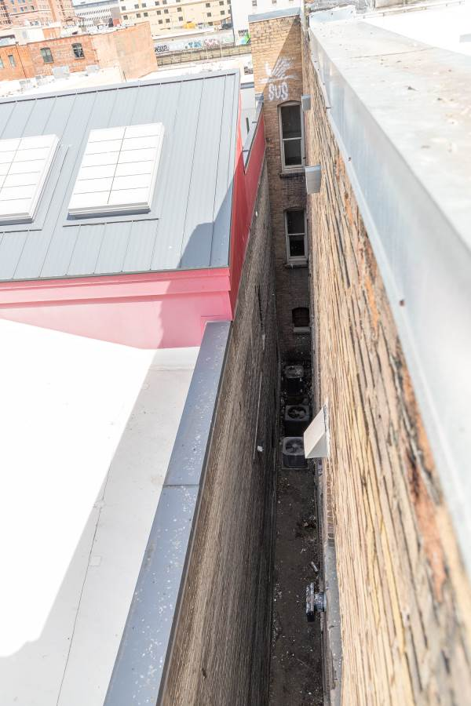
Photo 0012. Basement, electrical space, looking northeast, with the areaway space in the background, right of the electrical panels. 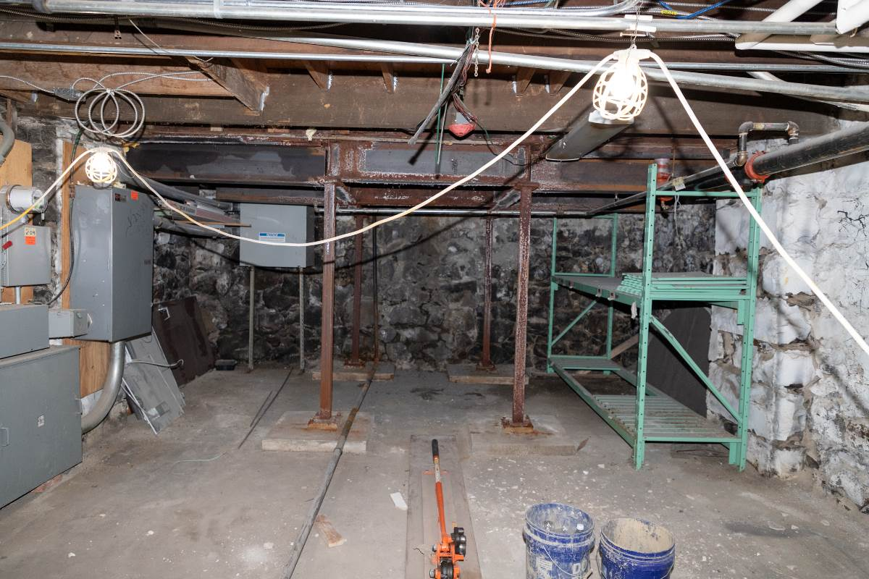

Photo 0013. Basement, looking west towards the boiler room doorway. 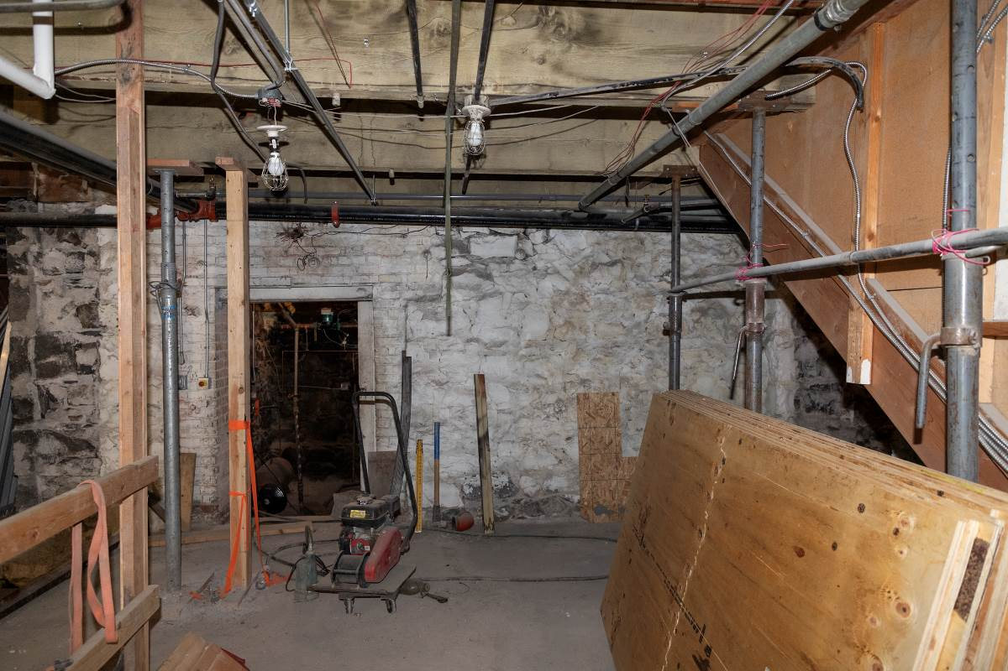

Photo 0014.Basement, below the 212 South Wall Street commercial space, looking east.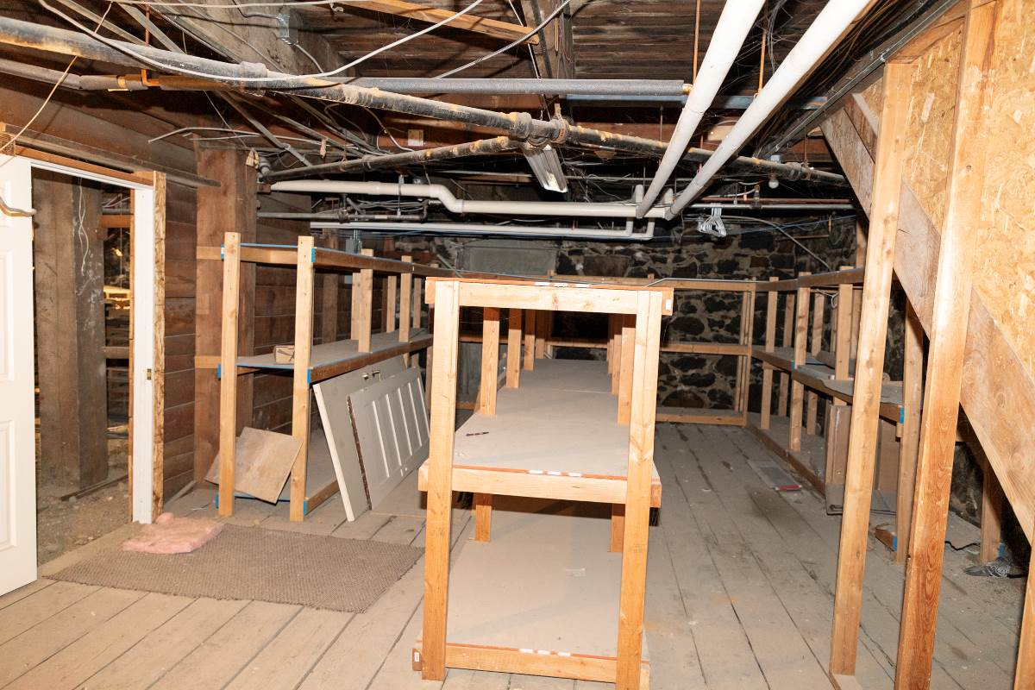

Photo 0015. Basement, looking north. 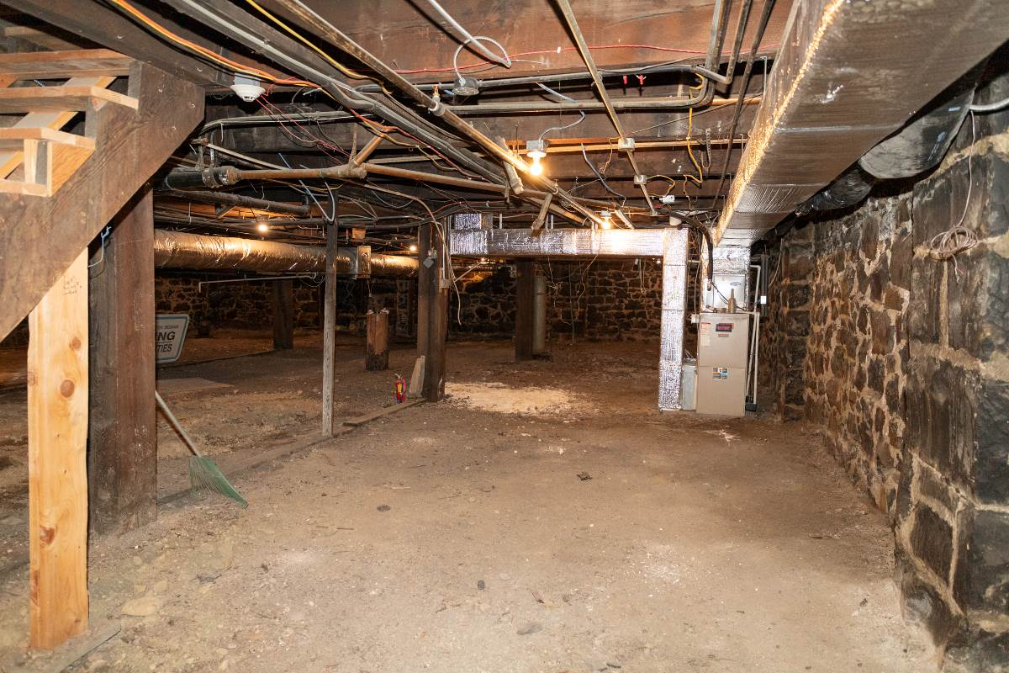
Photo 0016. Basement, looking south. 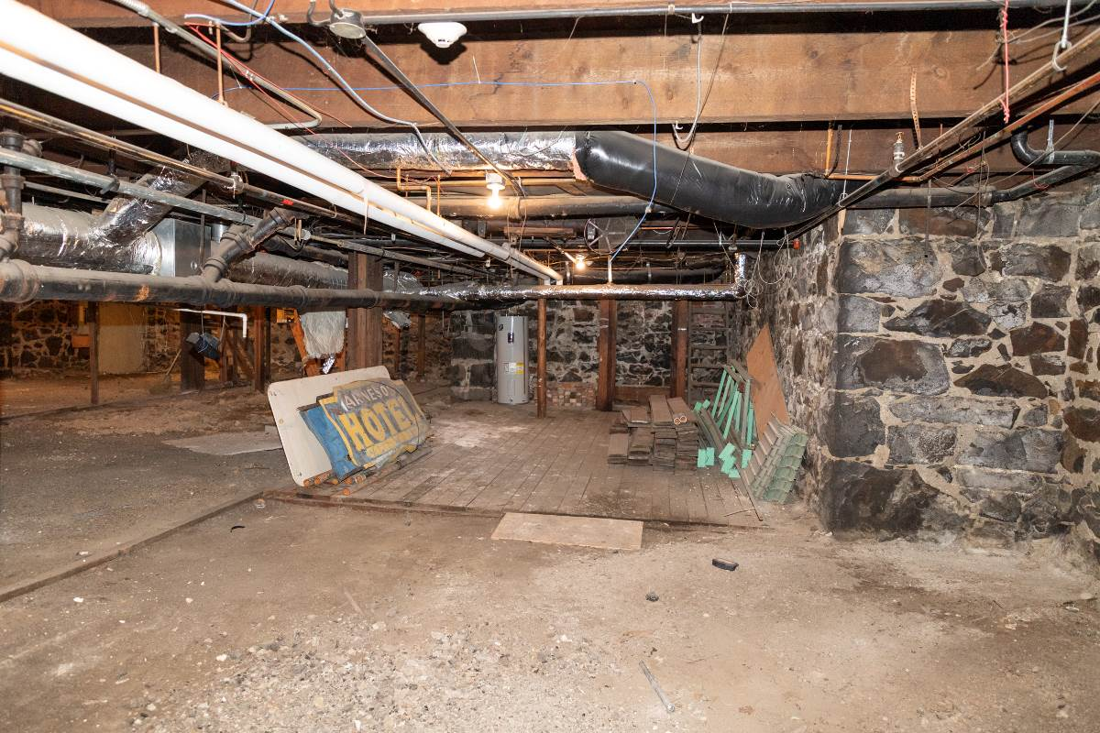

Photo 0017. First floor, looking east within the 212 South Wall Street space. 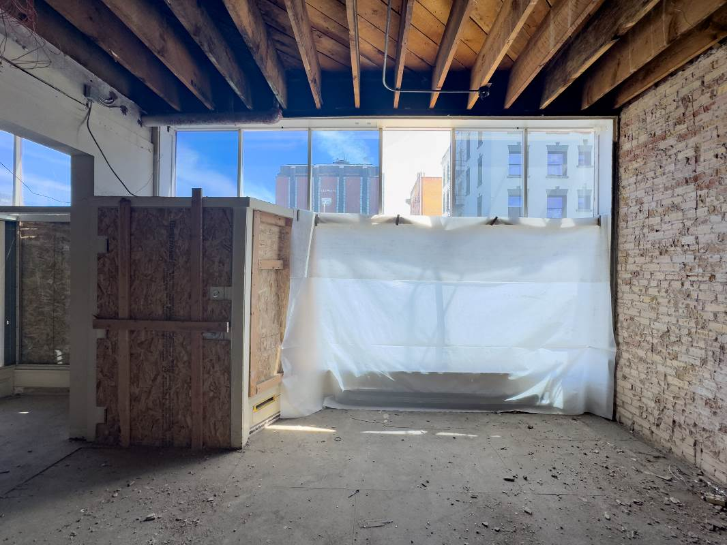
Photo 0018. First floor, looking east within the 210 South Wall Street space. 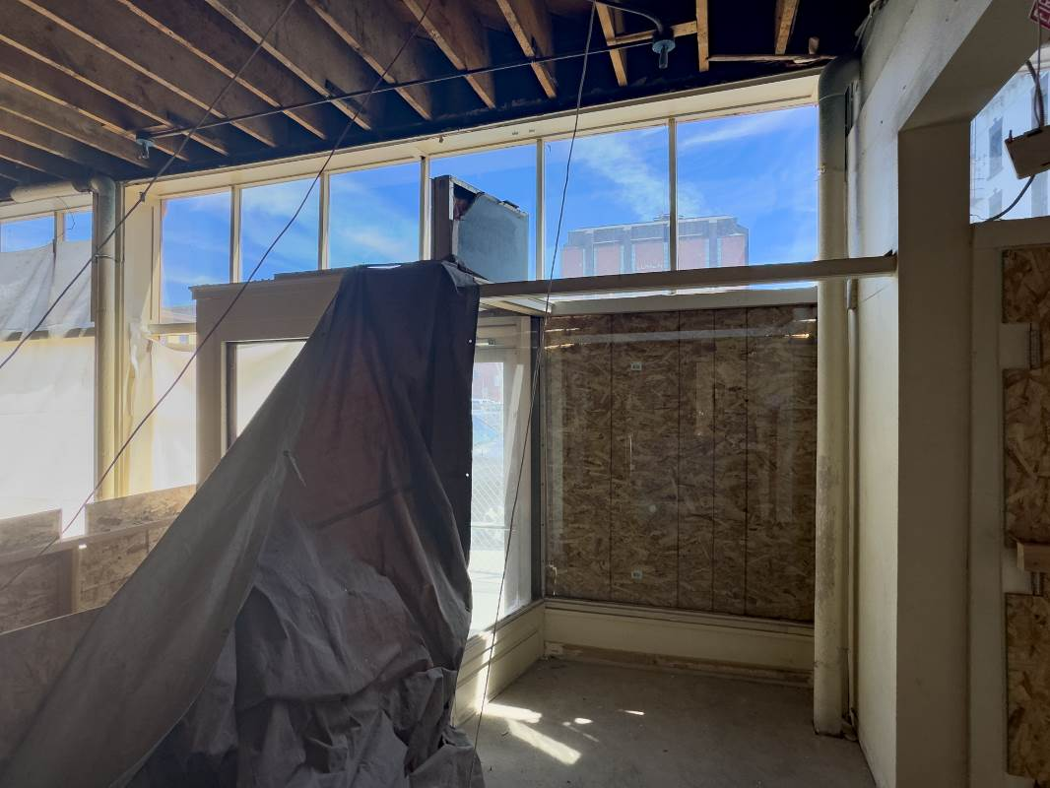

Photo 0019. First floor, looking north east towards the storefronts. 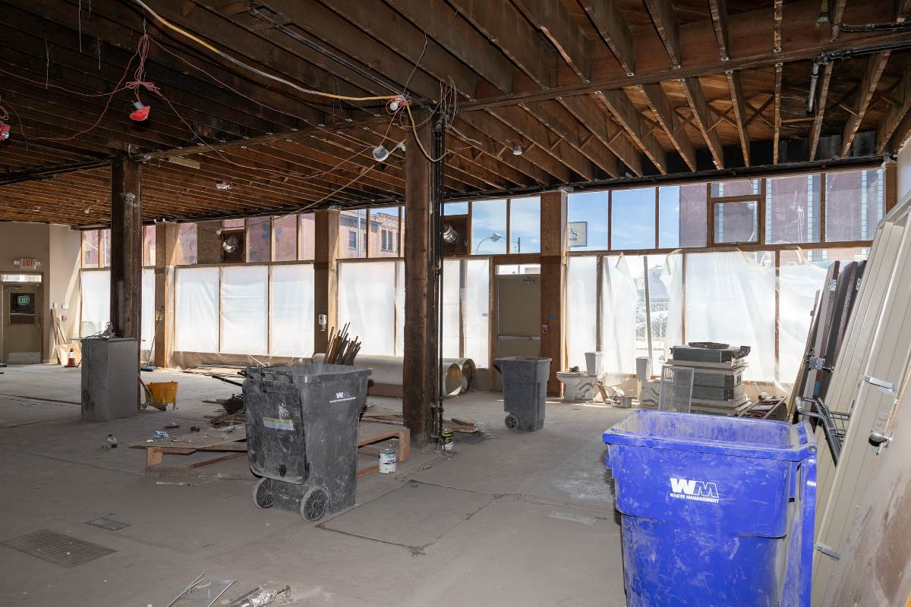
Photo 0020. First floor, looking south. 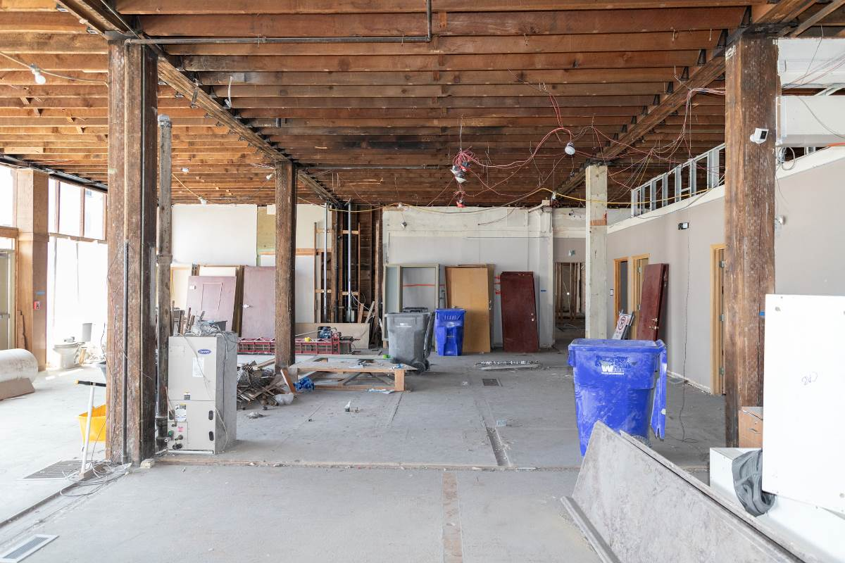

Photo 0021. First floor, looking southeast towards the alley entrance (left doorway) and the two bathrooms (right doorways). 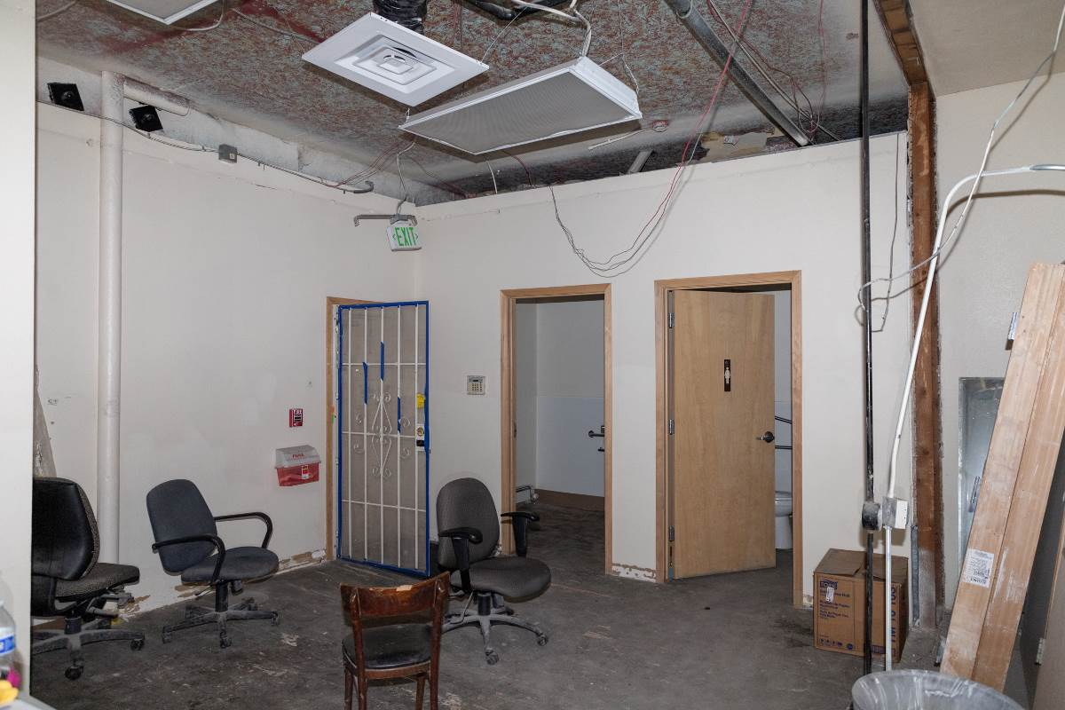

Photo 0022. First floor, central stairway, looking up from the 204 South Wall Street entrance.
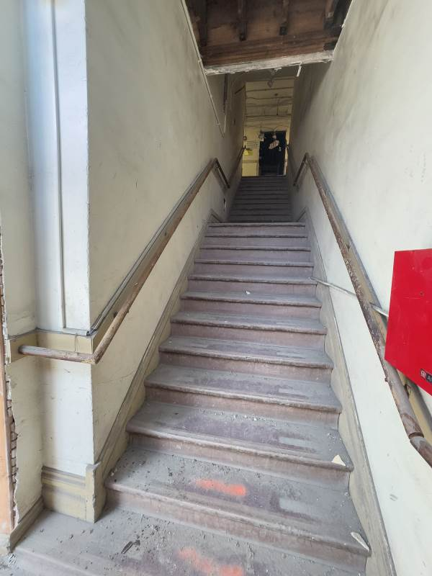

Photo 0023. Second floor, central stairwell, looking east. 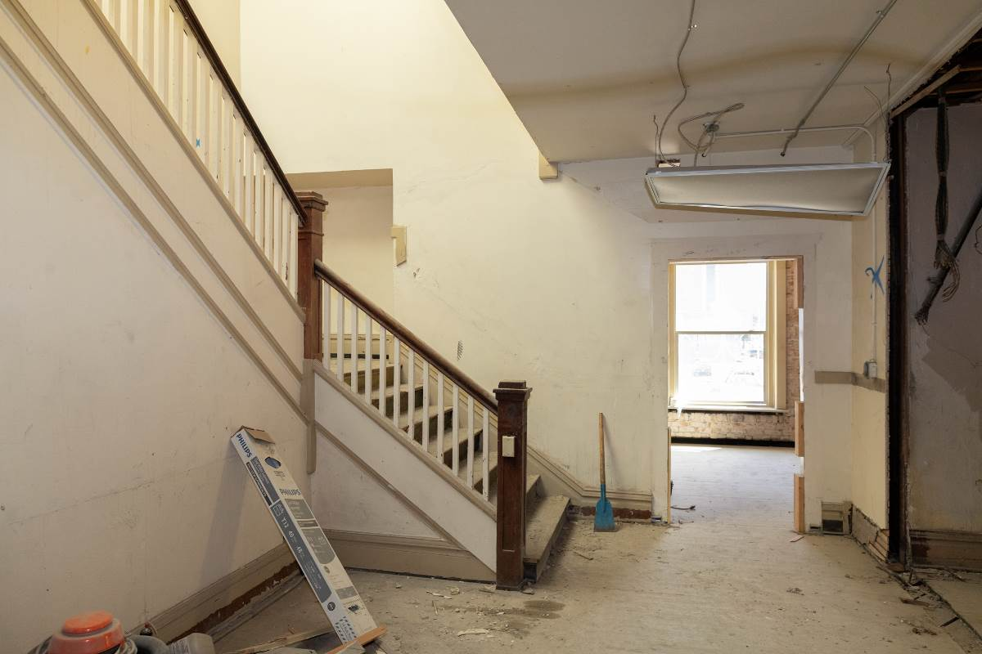

Photo 0024. Second floor, central stairwell, looking north.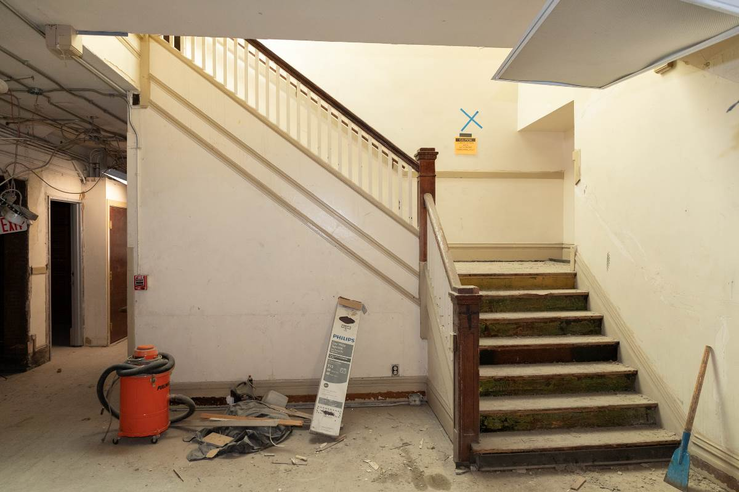

Photo 0025. Second floor, central stairwell, looking east. 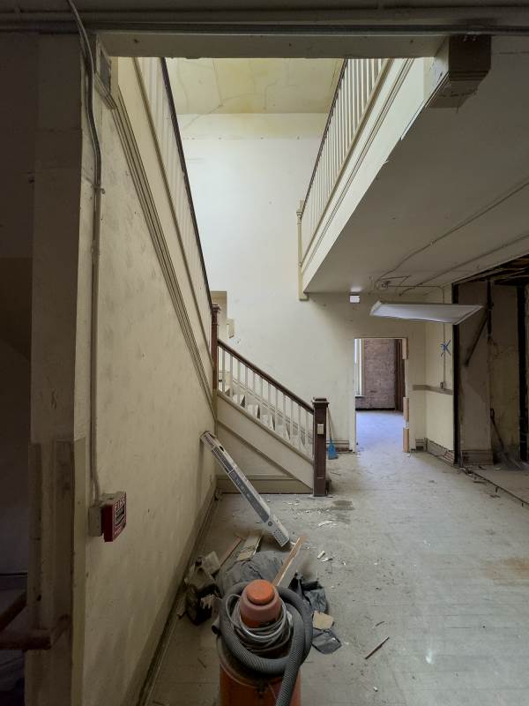
Photo 0026. Second floor, central stairwell, looking east and up.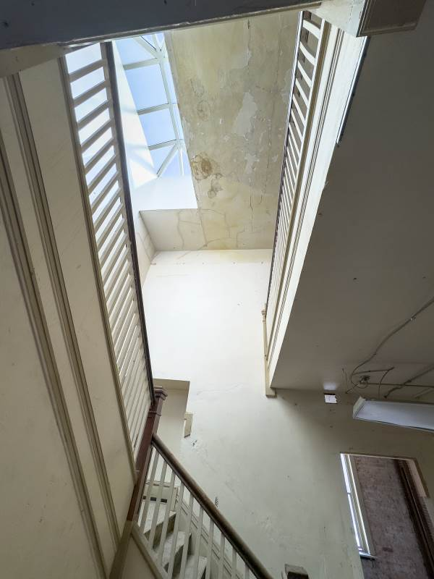

Photo 0027. Second floor, main hallway, looking south. 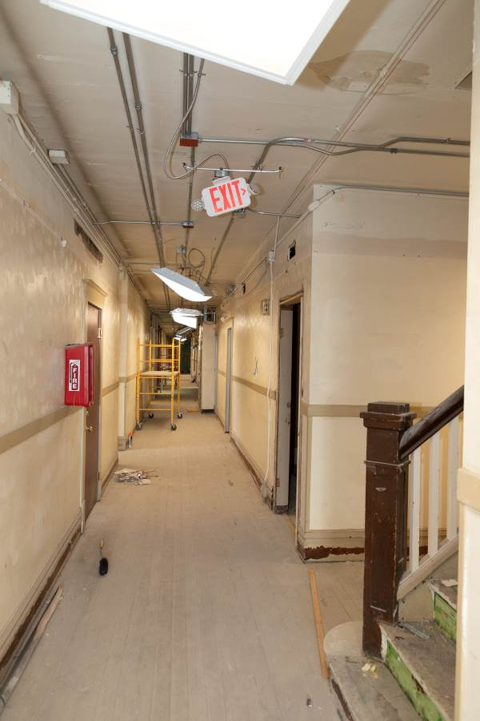
Photo 0028. Second floor, main hallway, looking south. 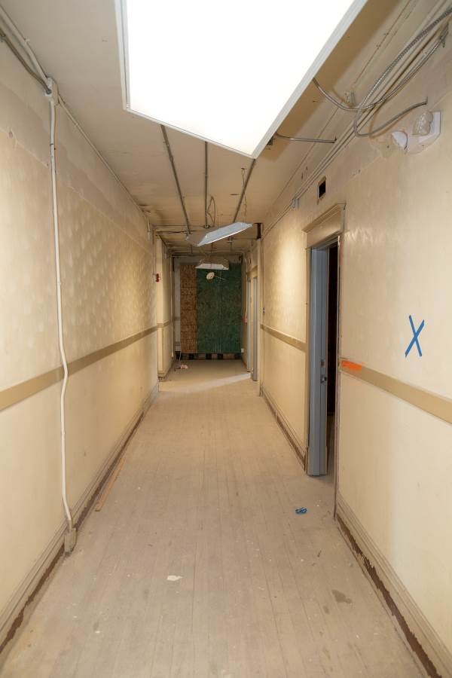

Photo 0029. Second floor, looking west within the former shared restroom and laundry space.
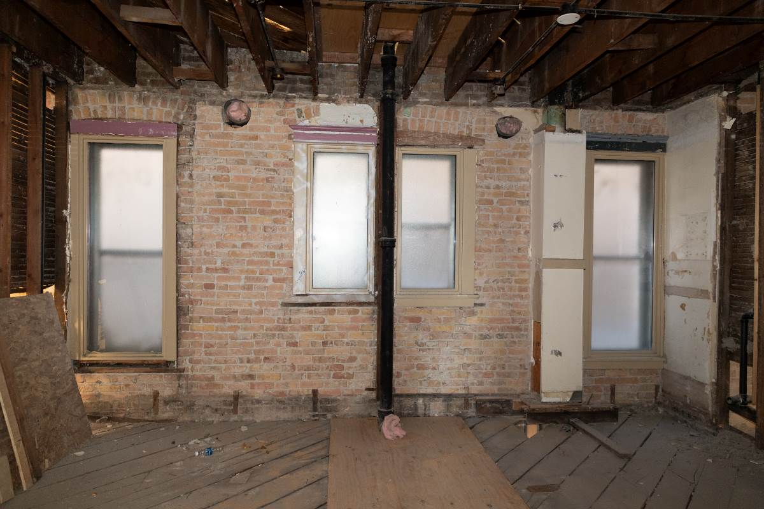

Photo 0030. Second floor, typical branch hallway extending east of the main hallway.
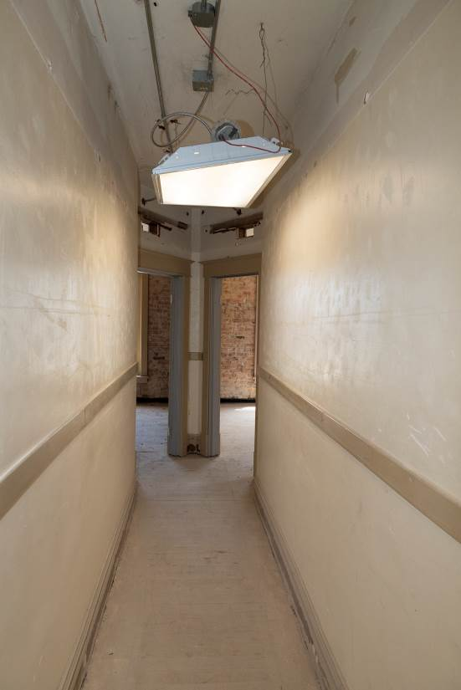

Photo 0031. Second floor, typical branch hallway showing the angled vestibule at the unit doorways, looking east.
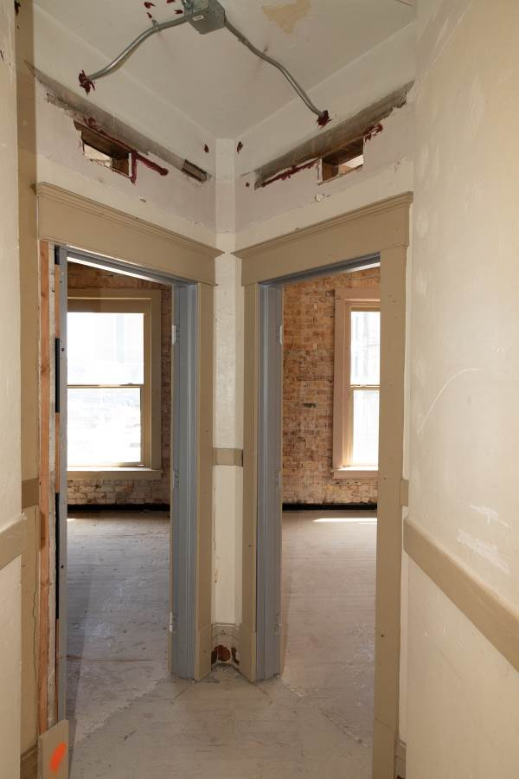

Photo 0032. Second floor, typical branch hallway, looking west towards the main hallway.
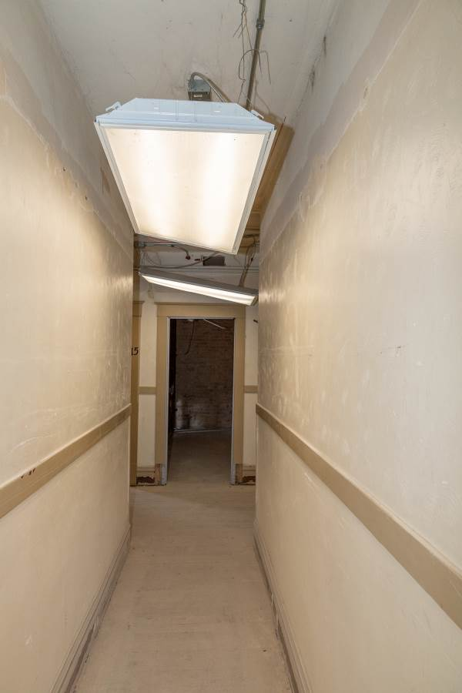

Photo 0033. Second floor, southeast corner unit, looking west. 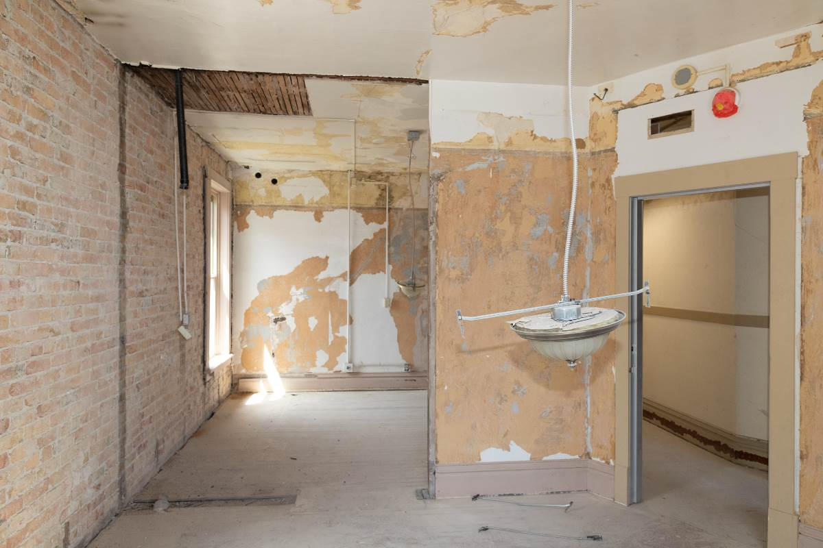

Photo 0034. Second floor, southeast corner unit, looking northwest. 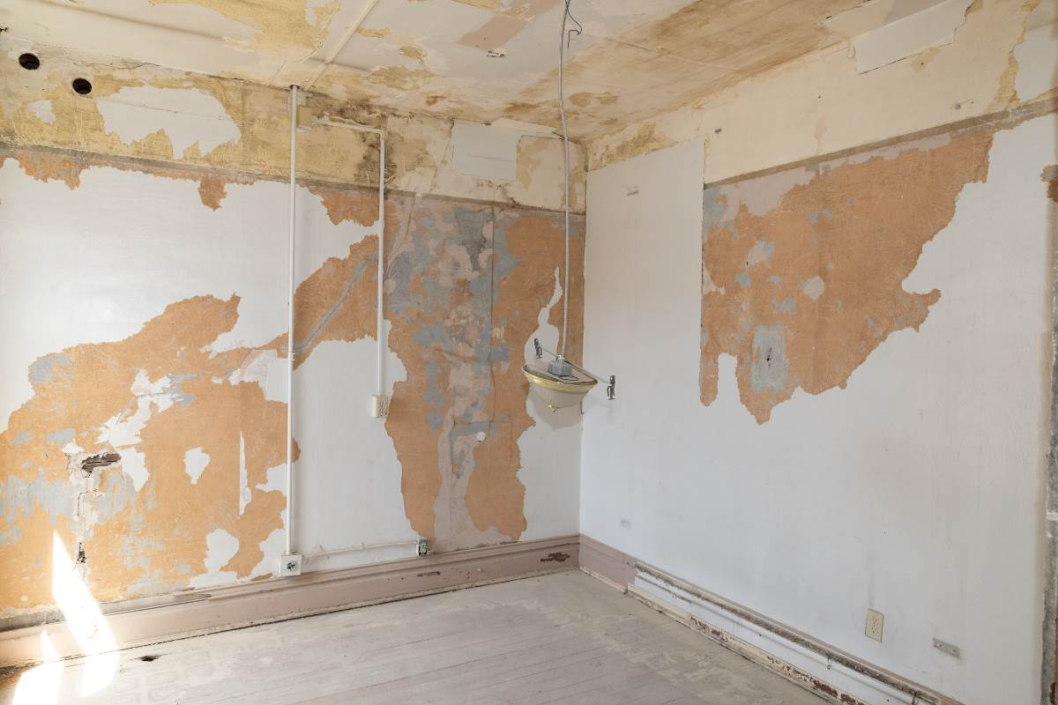

Photo 0035. Second floor, east side unit, looking west. 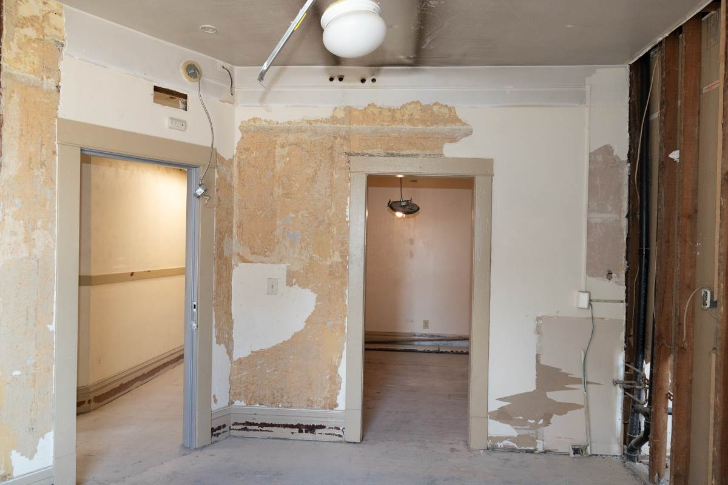
Photo 0036. Second floor, east side unit, looking west. 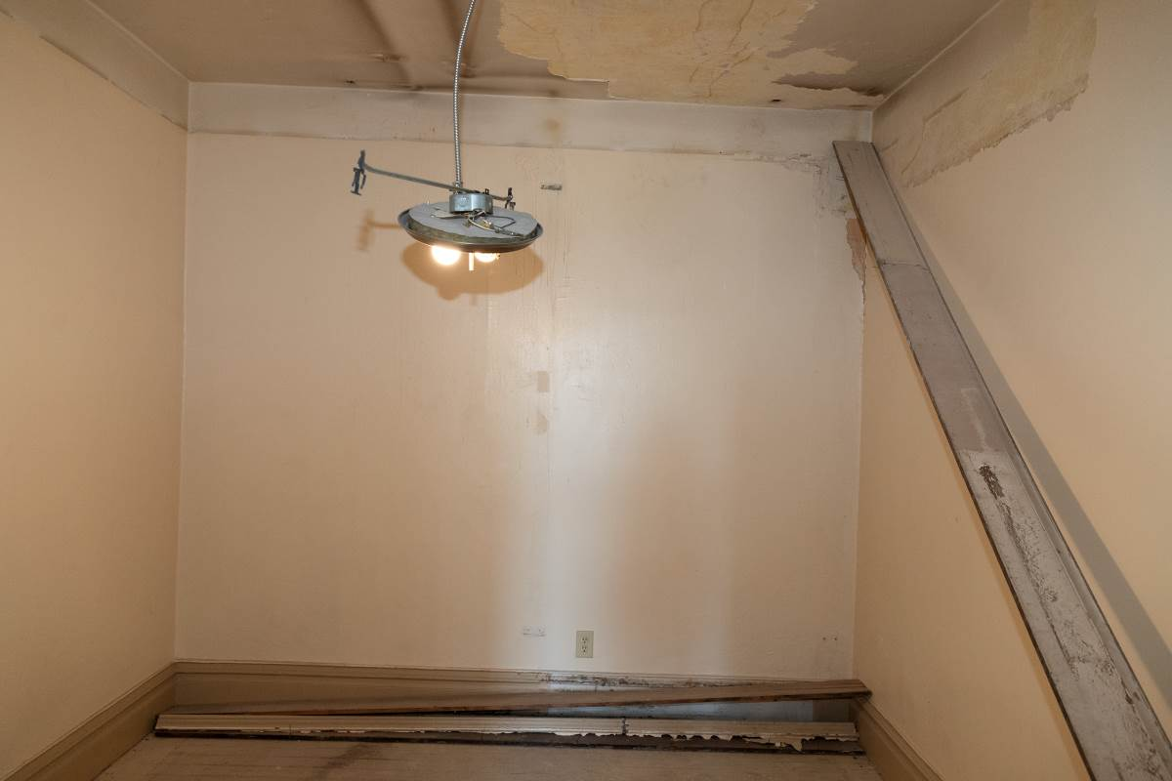

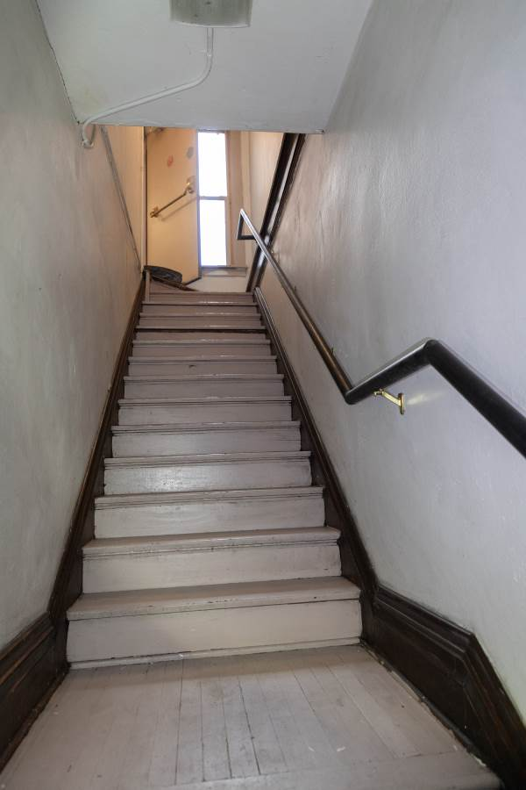
Photo 0037. Second floor, northwest stairwell, looking up from the intermediate landing.

Photo 0038. Second floor, northwest stairwell, down up from the intermediate landing at the 705-1/2 West Second Avenue entrance.
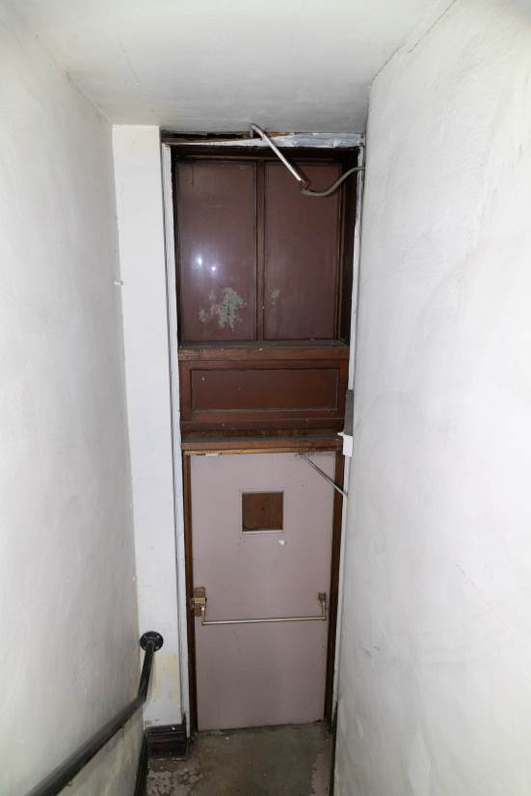

Photo 0039. Second floor, northwest stairway, looking northwest. 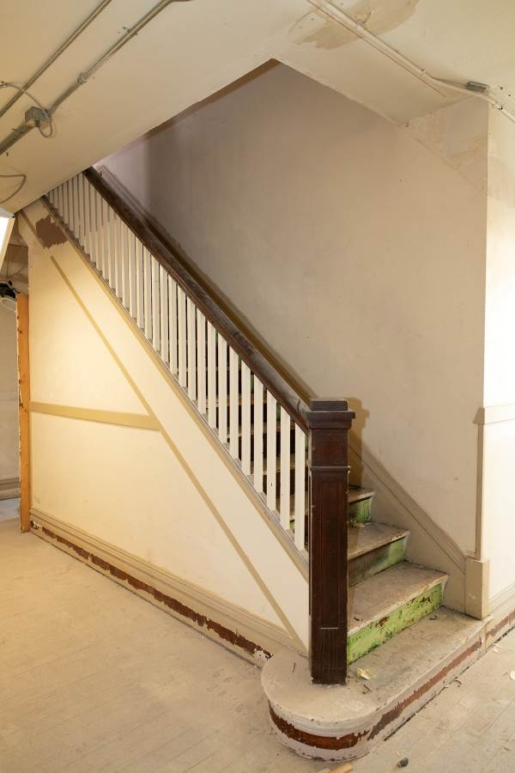

Photo 0040. Third floor, central stairwell, looking east and down. 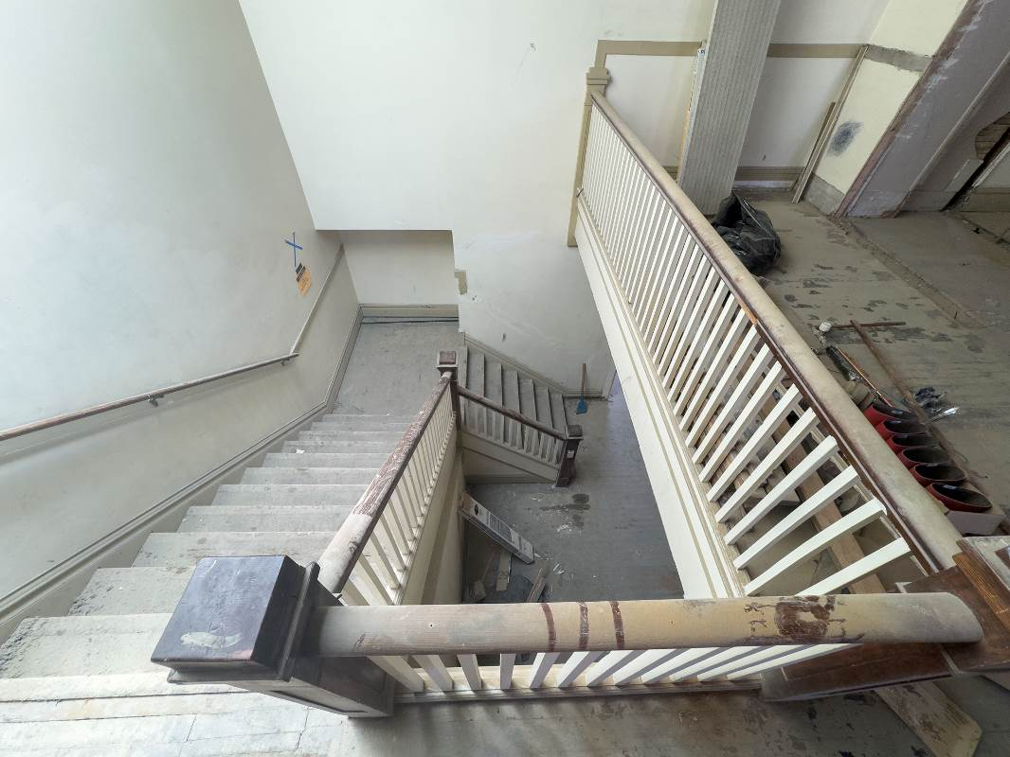

Photo 0041. Third floor, central stairwell, looking southeast. 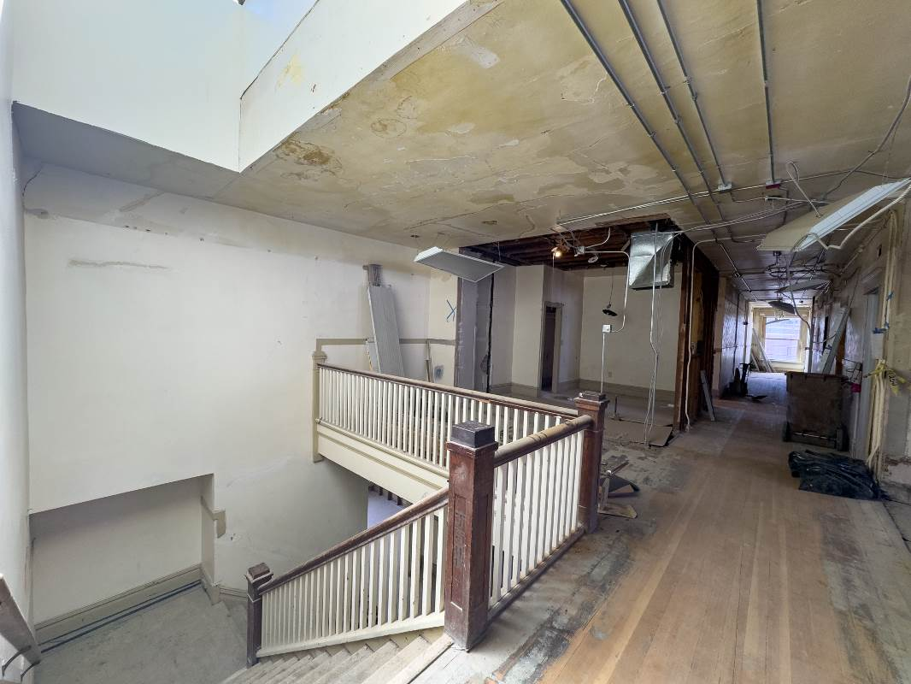
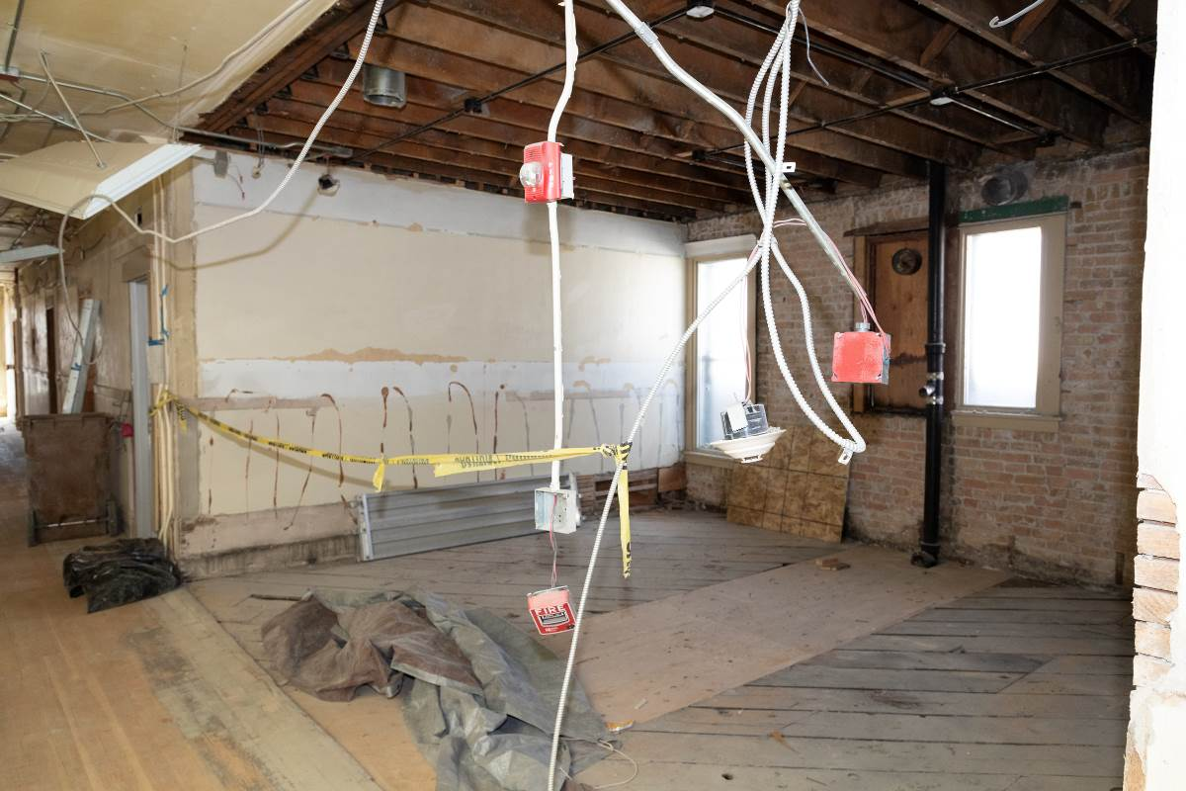
Photo 0042. Third floor, looking southwest through the former shared bathroom space.

Photo 0043. Third floor, main hallway, looking south.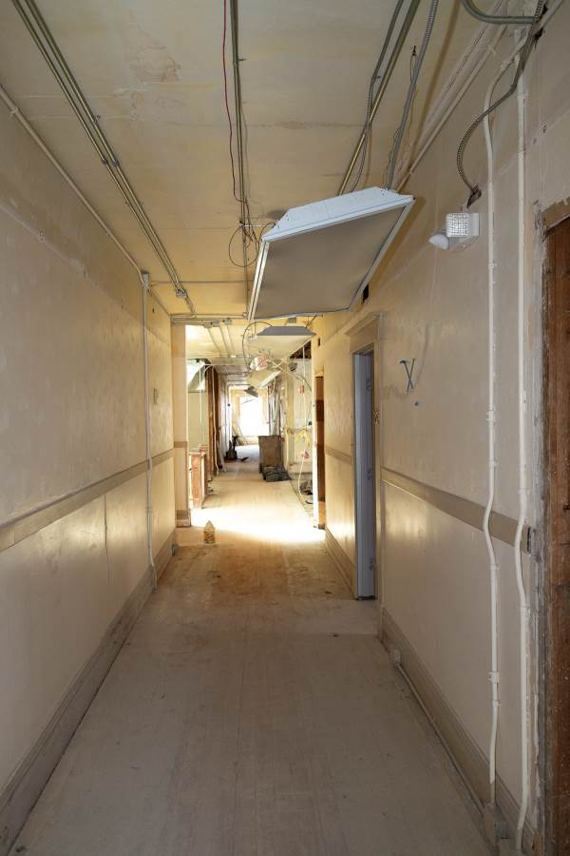
Photo 0044. Third floor, main hallway, looking south. 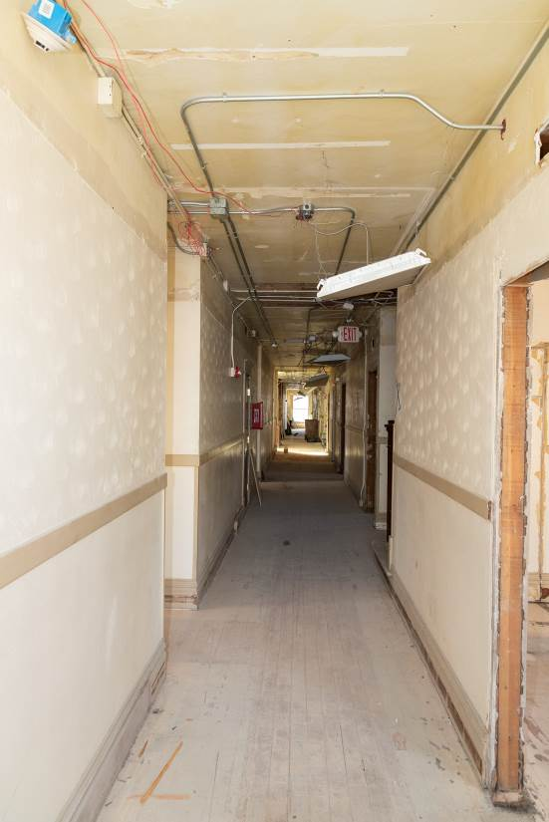

Photo 0045. Third floor, northwest stairway, looking northwest. 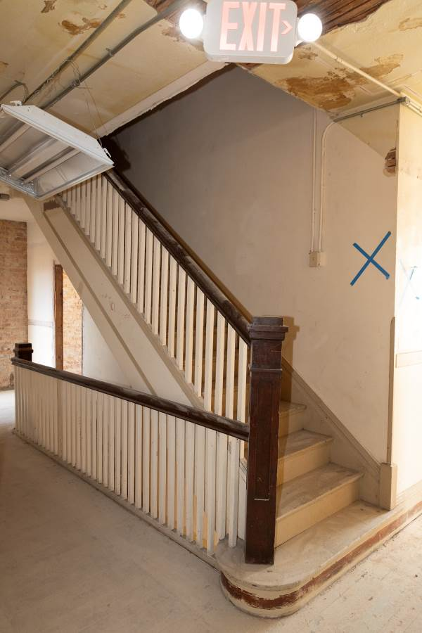

Photo 0046. Third floor, east branch hallway, looking east. 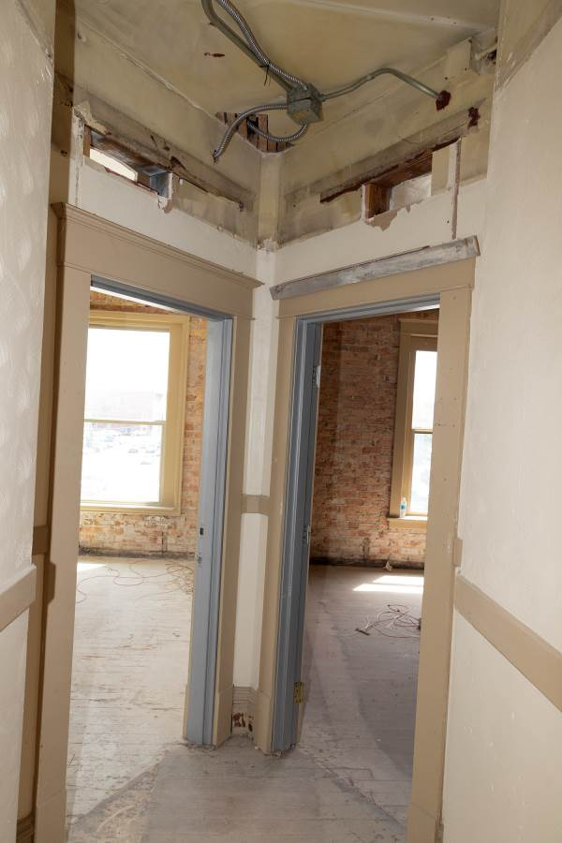

Photo 0047. Third floor, northeast corner unit, looking northwest. 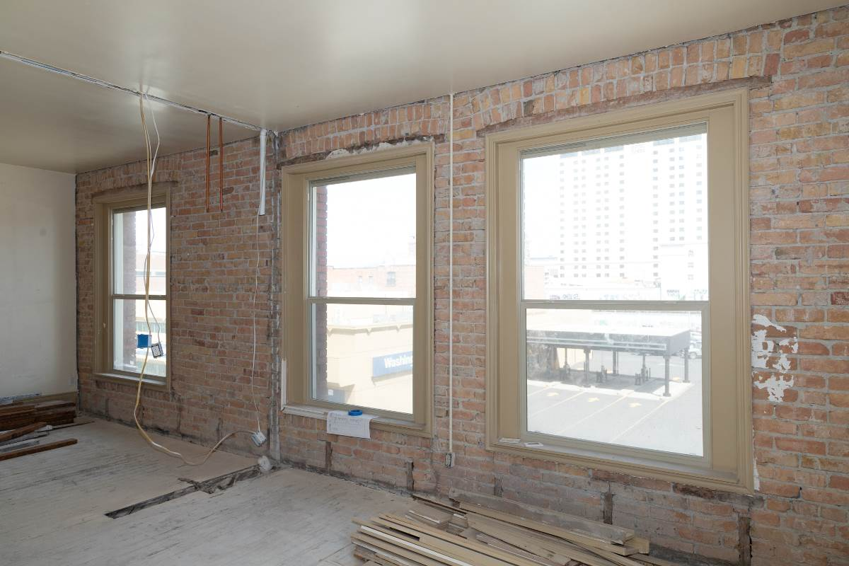
Photo 0048. Third floor, northeast corner unit, looking southwest.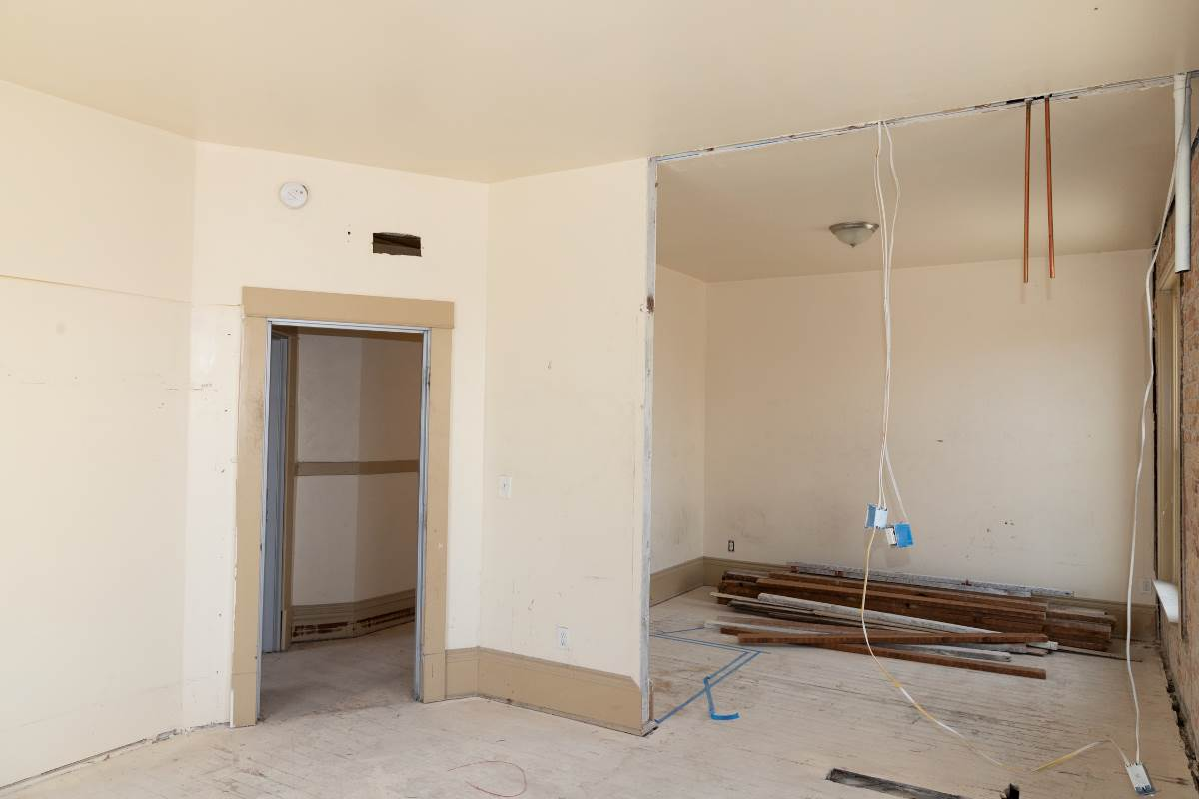

Photo 0049. Third floor, east unit, looking west. 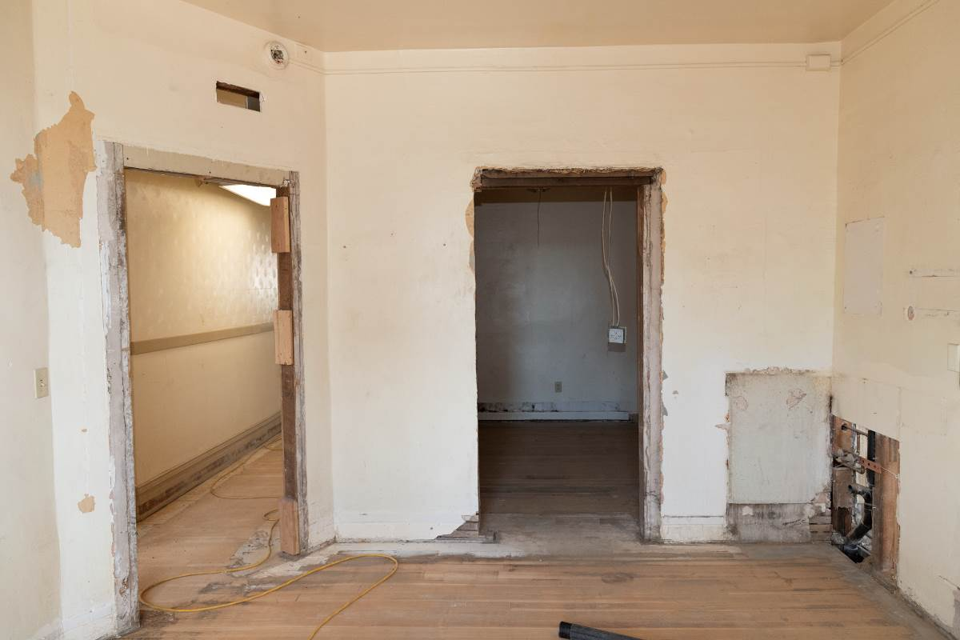
Photo 0050. Third floor, west unit, looking west. 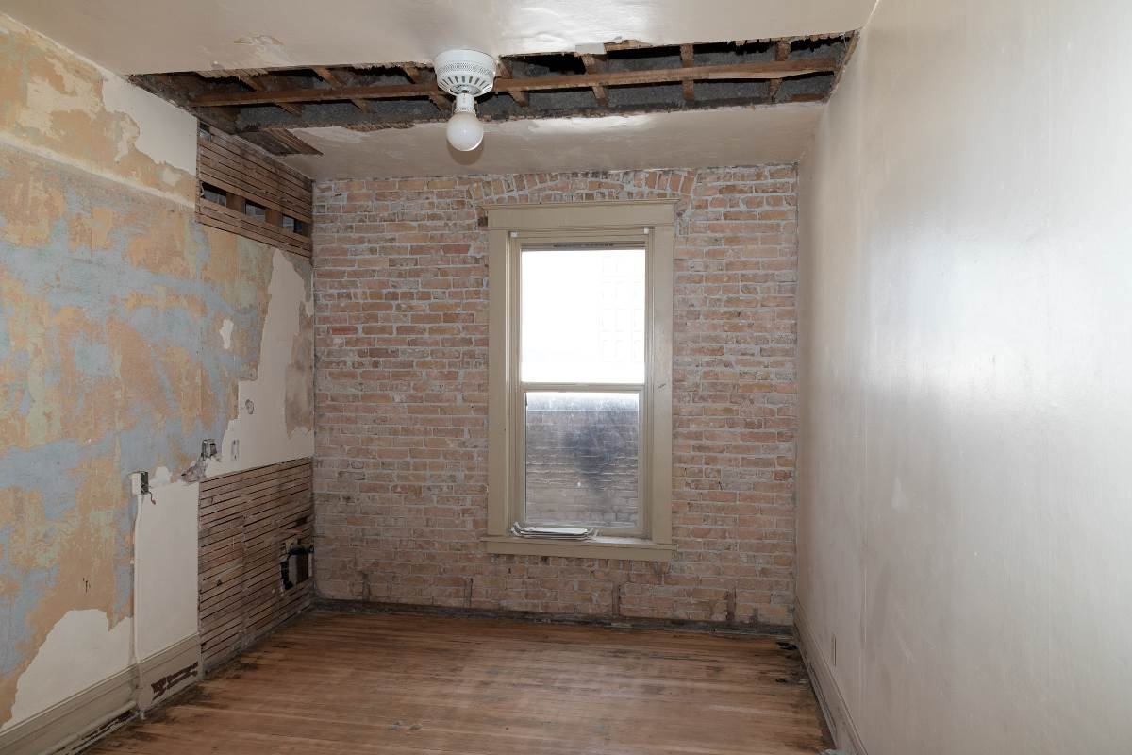

Photo 0051. Third floor, west unit, looking east. 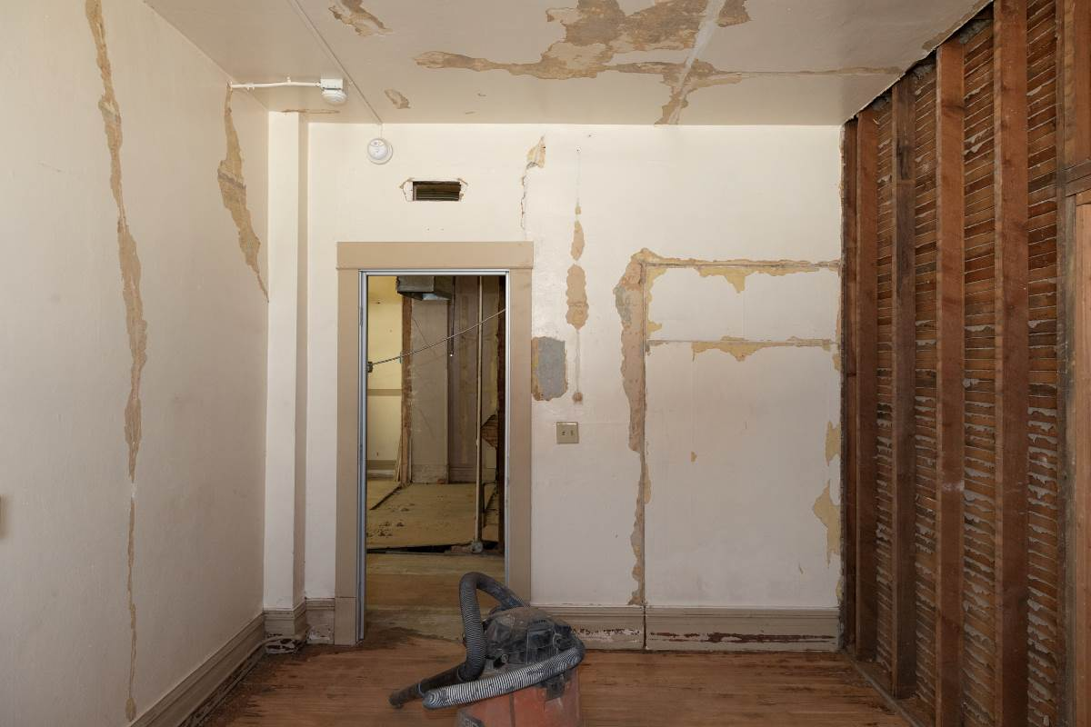
Photo 0052. Third floor east unit, looking west.
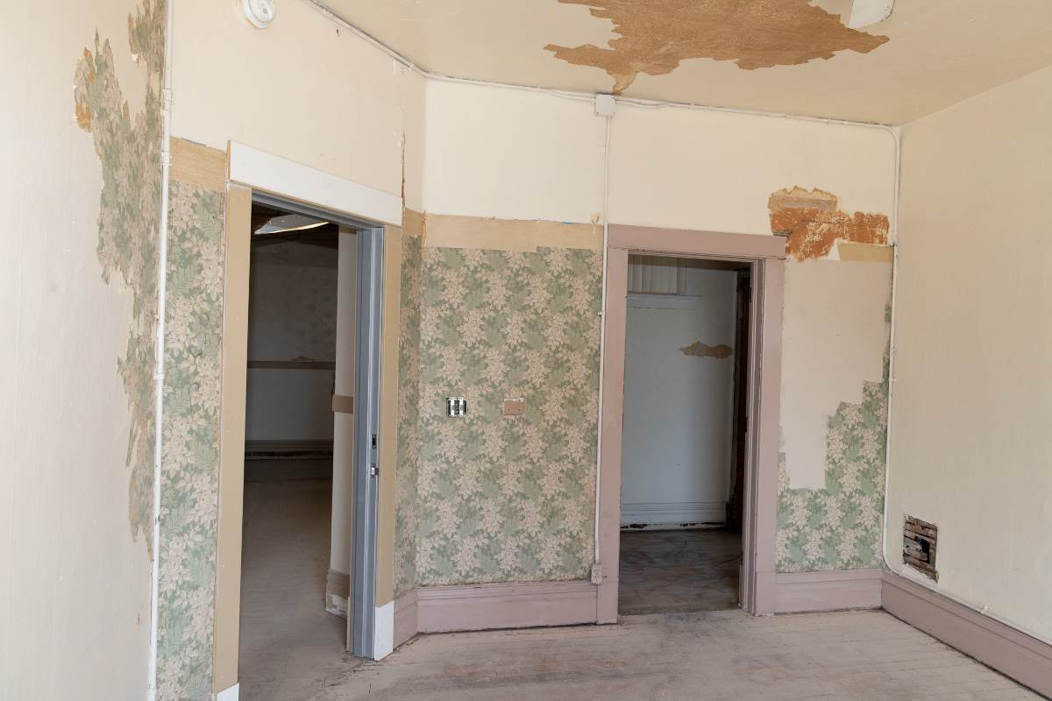

Photo 0053. Roof, stairway down to the third floor. 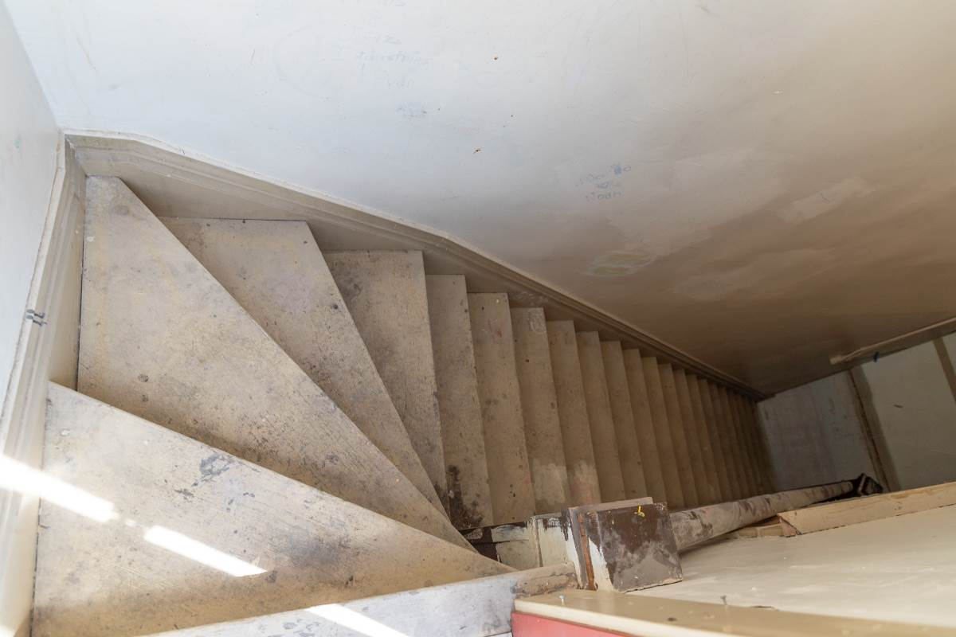

Craig Holstine, “Single Room Occupancy Hotels in the Central Business District of Spokane, WA, 1900-1910,” National Register of Historic Places Multiple Property Documentation, 1993, Section E, page 1, https://npgallery.nps.gov/NRHP/GetAsset/fdabf127-daf0-4116-9773-1eb3a0abbf8f.
Spokane Tribe of Indians Historic Preservation Office, “Spokane Tribal History,” Spokane Tribe of Indians, accessed July 22, 2024, https://www.spokanetribe.com/resources/dnr/preservation/history/.
Jack and Claire Nisbet, “Spokane House, First Fur-Trading Post Constructed in the Future State of Washington, Is Closed on April 7, 1826,” in Historylink.Org, February 22, 2017, https://www.historylink.org/File/20296.
Spokane Tribe of Indians, “The Spokane Tribe of Indians’ Comments on the Proposed Revision to 25 C.F.R. § 151, Fee to Trust Regulations,” July 2, 2018, https://www.bia.gov/sites/default/files/dup/assets/as-ia/raca/pdf/59%20-%20Spokane%20Tribe.pdf.
Laura Arksey, “Spokane -- Thumbnail History,” in Historylink.Org, September 4, 2005, https://www.historylink.org/file/7462.
Linda Yeoman, “Ridpath Hotel,” National Register of Historic Places nomination, 2013, 9-10, https://npgallery.nps.gov/NRHP/GetAsset/9f0bbd56-0e12-4cac-bac1-e50aa9bef7b8.
Holstine, “Single Room Occupancy Hotels in the Central Business District of Spokane, WA, 1900-1910,” Section E, Page 7.
Holstine, Section E, Page 12.
Holstine, Section E, Page 16.
“Daniel Collins Taken by Death,” The Spokane Chronicle, July 19, 1933: 3.
Spokane City Directory, vol. IV (Spokane, WA: R. L. Polk & Co., Publishers, 1893), 247. City directories also list him as a pipeman and foreman.
“A Busy Day,” The Spokane Chronicle, August 12, 1891.
“Mrs. A. Collins Funeral Monday,” The Spokesman-Review, December 20, 1936: 14.
United States of America, Bureau of the Census, “Thirteenth Census of the United States, 1910” (Washington, D.C.: National Archives and Records Administration, 1910), Ancestry.com. Spokane, Spokane County, Washington, Enumeration District no. 201, Sheets 3A and 3B.
“Morsels,” The Spokane Evening Review, August 11, 1885: page 3, column 2.
“Drumheller Site Sells for $50,000,” The Spokesman-Review, February 8, 1910: 8.
Ibid.
Ibid.
“New Three-Story Apartment House,” The Spokane Chronicle, February 18, 1910: 7.
“Modern Building on Landmark Site,” The Spokesman-Review, April 3, 1910.
“Modern Building on Landmark Site,” The Spokesman-Review, April 3, 1910.
“St. Helen to Have $11,000 Addition,” The Spokesman-Review, February 19, 1910.
“Rushing Work on Collins Building,” The Spokane Chronicle, September 10, 1910.
“Three-Story Building on Second Avenue to Be Completed This Fall,” The Spokane Chronicle, August 23, 1910.
“City Briefs,” The Spokane Press, February 18, 1938; “Mrs. A. Collins Funeral Monday,” The Spokesman-Review, December 20, 1936: 14.
“Montanan Buys Hotel,” The Spokesman-Review, February 19, 1938: 6.
Galland & Hagood, Inc., to Richard and Lucille Eoff, “Real Estate Contract” (December 20, 1968), Spokane County Assessor.
Richard Eoff and Lucille Eoff to Anthony B. Arneson adn Monica B. Arneson, “Sale Agreement | Escrow No. 13406” (January 15, 1971), Vol 200, Pages 1309, Spokane County Assessor.
Burya, John S. and Mary, to Pacific National Capital Company, “Real Estate Contract: 7407110281” (June 15, 1974), Vol 200, Pages 1301-1306, Spokane County Assessor.
Census records with personal information are released 72 years after they are collected and, thus, are only available through 1950 at the time of this nomination.
United States of America, Bureau of the Census, “Fourteenth Census of the United States, 1920” (Washington, D.C.: National Archives and Records Administration, 1920), Ancestry.com. Spokane, Spokane County, Enumeration District No. 190, Sheets 1B and 2A.
United States of America, Bureau of the Census, “Fifteenth Census of the United States, 1930” (Washington, D.C.: National Archives and Records Administration, 1930), Ancestry.com. Spokane, Spokane County, Enumeration District No. 32-86, Sheets 8A and 8B.
United States of America, Bureau of the Census, “Sixteenth Census of the United States, 1940” (Washington, D.C.: National Archives and Records Administration, 1940), Ancestry.com. Spokane, Spokane County, Enumeration District No. 41-90, Sheets 81A and 81B.
United States Department of Commerce. Bureau of the Census, “Seventeenth Census of the United States, 1950” (Washington, D.C.: National Archives, 1950), Ancestry.com. Spokane, Spokane County, Enumeration District No. 41-160, Sheets 1 and 2.
Although Kirishian Carpets no longer operates out of the nominated building, it is a legacy business in Spokane, started by Onnig Kirishian, an Armenian immigrant, in 1950 and operated by his son, Richard at 220 E Second Avenue. Michael Guilfoil, “Oriental Rug Business Remains Staple among Spokane Retailers,” The Spokesman-Review, October 27, 2013, https://www.spokesman.com/stories/2013/oct/27/imported-comfort/.
Michael Houser, “C. Harvey Smith,” Washington State Department of Archaeology & Historic Preservation (DAHP), October 2011, https://dahp.wa.gov/historic-preservation/research-and-technical-preservation-guidance/architect-biographies/bio-for-c-harvey-smith.
United States of America, Bureau of the Census, “Twelfth Census of the United States, 1900” (Washington, D.C.: National Archives and Records Administration, 1900), Ancestry.com. Spokane, Spokane County, Washington, Enumeration District No. 68, Sheet 2B; “Charles Harvey Smith (1868–1942),” Family Search, accessed July 23, 2024, https://www.familysearch.org/tree/person/details/LW5B-X6V.
“Hold Harvey Smith Funeral Today,” The Spokesman-Review, May 16, 1942: 6.
He built the Groshoff Apartments in Spokane which are listed as a contributing property in the National Register-listed Peaceful Valley Historic District.
Holstine, “Single Room Occupancy Hotels in the Central Business District of Spokane, WA, 1900-1910,” Section F, Page 18.
Paul Groth, Living Downtown: The History of Residential Hotels in the United States. (Berkeley, CA: University of California Press, 1994), 8.

